AGENT Reminders January 26, 2023

General
- When someone has an S-Corp and they are paying themselves a wage, we must budget the SEI using the worksheets and the income they pay themselves as earned income, not self-employment, as they are performing two separate roles within the company.
- When updating/building absent parent pages, please be sure to create a new AP page for each absent parent. There have been a couple of instances lately where where a pregnancy has ended prior to birth, a new pregnancy has been reported, and this has not been entered in correctly. It looks like the pages have been updated with the new due date for the baby, instead of the first page being deleted and a new one entered. This is causing errors in the referral to child support for the new pregnancies.
- If CC is open and the client reports an address change, remember to request verification using the PN code.
- Rock Valley Community Programs- 203 West Sunny Lane Road, Janesville, WI. 608-741-4510We received clarification that certain individuals at the Rock Valley Community Program in Rock County can be eligible for FoodShare benefits. When these individuals apply, we need to ask what program they are in.There are 3 programs:
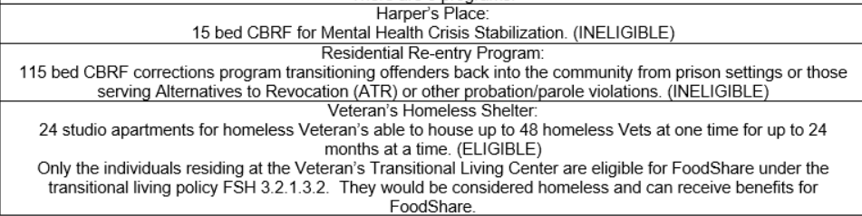
EBD/LTC
- When an individual meets criteria under MEH 22.1.4.1 to require a lien to be filed on their home, we must examine the exemptions. A person can express intent to return home which exempts the home as an asset, but does not exempt them from a lien being filed with estate recovery. Under #3, we must have verification from a physician regarding the diagnosis and prognosis for the member that they will be able to return home to waive the lien filed. See paragraph 2.

