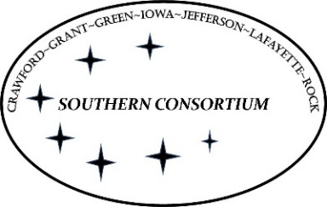
AGENT Reminder February 10, 2022
General

- If customers have questions about the treatment needs question explain that if they answer “yes” to the question: “During the last 12 months, have you used drugs in ways that cause problems for you or those around you, and are you open to getting help?” they will be contacted by their HMO with treatment options that may be helpful to them.
- If you have an issue on a case, please do not email the local office team to take care of it. You should be working with your supervisor to resolve any issues on the case. This includes if something needs to go to the CARES Call Center.
- When you are assigned to Call Center, your break must be taken and over by 11:00 in the morning and 3:30 in the afternoon.
- If customers request to come into the office to pick up documents or a vault card they should be told to contact the local office prior to doing so.
- If OIG has worked on a case and requested verification, workers can move the verification to ECF when it comes in but then must enter a case comment that they have done so and email the OIG worker (contact information will be listed in case comments) letting them know the verification has arrived.
- Customers cannot be given their Quest card number over the phone.
- The Customer’s Surveys for this year’s MER should be going out on or before this Friday 2/11, via email.
  - The email to the customers should include:
    - the Survey link
    - an email link for any questions the customers may have about the survey
  - All Customers who receive the initial Survey email will also get two email reminders to complete it.
    - The reminders will go out to all customers, including those who have already completed the survey.
    - Reminder emails will explain that the survey does not need to be taken more than once.

FoodShare
- When an incomplete SMRF Is received, it should be reviewed and any changes made to the case. Do not just move it to ECF without taking action.

