

**AGENT Reminder March 10, 2022**

**General**

* When a customer calls and reports that they have moved out of Wisconsin, please update the case with their new address in the other state so that they receive their closure letter.
* When an individual completes and marks the below on their authorized representative form, you should check the box on the AR page for the Medicaid Payee as YES.

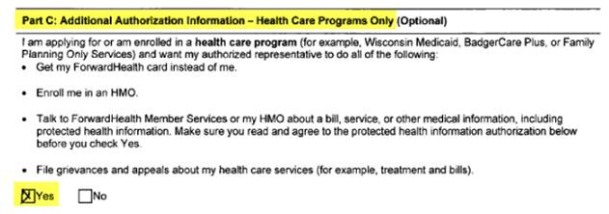

* When an individual is case head and is deceased with other household members in their FS assistance group, do **not** add anyone as AR and mark they are FS payee to have a new card generated.  In cases where this occurs, the original card remains active and nothing is sent to FIS to cancel the card.
* If an individual is requesting a FS payee or Authorized Buyer, the client must submit form F-16004 Form “Add Or Remove An Authorized Buyer or Alternate Payee For Foodshare Benefits” to add someone.
* Only one case should be processed on each call.  If someone calls and more than one person wishes to complete an application, advise them to call the call center separately.  Doing two requests on one call creates the same connection IDs for both cases and causes mismatches and QA issues.
* When a customer calls to complete their Child Care renewal, follow the below process:
* Schedule an appointment with the Child Care Team from the County of Residence. Please schedule the appointment for 5 business days out to allow time for mailing. Document actions in case comments.
* Complete any renewal for other programs that are due for a renewal (HC/FS, etc.)
* If this is a Rock Child Care case, you can ask the client if they would like to be transferred to the Child Care line for an on-demand interview and advise that there may be a wait time

**FoodShare**

* If you reach an individual on a FS only request and they cannot complete the interview, the person should be scheduled for an interview per SCC processes and advised they can call back at their convenience to complete the interview.  If they do not make the scheduled appointment, the application should be processed at that time.  Two attempts must be documented in the contact attempts panel for the case to come off the FSOD and not become past due.