

**AGENT Reminder April 24, 2022**

**General**

* If a customer calls to report a change, and the case is open for multiple programs, including child care, do not confirm the child care. An email should be sent to the child care team letting them know a change was made. They will review the case and confirm appropriately.
* MAID numbers are never to be given out to customers, whether by phone or in person. Providers are able to look up coverage using their SSN.
* When you process an Unemployment ending discrepancy, check for new employment as that is often the reason the UC is ending. This may prevent an EI overpayment from occurring.
* When processing a 289 MAJOR MED INS COVRGE REPORTED please check for new employment. New employment is often the reason that the customer has major medical insurance.
* For income from IRIS or Family Care to be exempt for live-in care providers, we need form F-02193, Verifying Tax-exempt Income for Live-in Care Providers to be completed and returned.  This exempts the income for only BadgerCare Plus programs.  It is countable for all other programs.  If we do not receive the form, we have to count the income.  We cannot use a client statement or the fiscal agent on the check stub to determine if the income is tax exempt.
* When a case has multiple due dates for different programs, remember to align the due dates to the same date and enter that across all fields on the due date page.  These areas being updated are critical as they each tie to different aspects of our system (Verification and Applications/Renewals).  Updating only one area can cause the work item to not update properly.  See below:

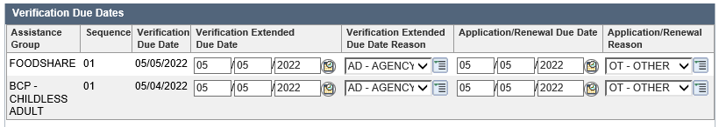

If you come across a case where the due date hasn’t been aligned properly, be sure to check when aligning the dates, that the work item updated correctly.

* If a caller is requesting the status of documents that we are not processing through call center (SEI, ME, Undue Hardships, etc.), please do not refer them to the local office to check the status of processing those documents.  Please advise they are processed in the order received and they will get a notice in the mail with their benefit determination.
* There have been several QA errors relating to FEINs. Remember that it is required to search for the FEIN and update the employment page with this information. Check the quarterly wage matches to assist you in finding the correct FEIN. If you are unable to locate a FEIN, this should be documented in case comments.

**Child Care**

* Address verification is required for Child Care to ensure that the parent’s EBT card and any notices we send arrive at the correct address.  An address requires the complete address, i.e. what the postal worker needs to know to deliver the mail.  (Example:  Apartment number is required to be included)

**FoodShare**

* FSHB 1.2.3.5 Applicants or households already receiving other programs of assistance, such as BadgerCare, have already been determined to be living in Wisconsin.  No further action is required to determine if the applicant is living in Wisconsin – unless questionable.

* FSHB 2.2.1 The certification period for FoodShare eligibility for most food units is 12 months. A certification period should never exceed 12 months. Food units where all members are homeless and food units that include a migrant or seasonal farm worker have a six-month certificate period.    Members must complete an interview ([2.1.3 Interviews](http://www.emhandbooks.wisconsin.gov/fsh/policy_files/2/21/2.1.3.htm#_blank)) and verify current household information in the last month of the certification period in order to be recertified and continue receiving FoodShare benefits. This is called a renewal.