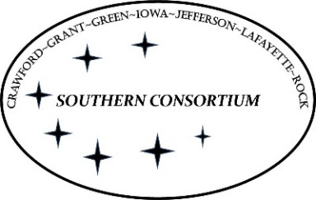

**AGENT Reminder May 26, 2022**

**General**

* Please remember to add case comments after working on a case.
* System Generated Overpayment Notices for Child Care may have the Southern Consortium’s phone number on them.  You may receive calls from customers with questions about their overpayments while you are on SCC.  You should transfer the call to the Child Care line that belongs to the county of residence of that client.
* We have recently received guidance from the DHS CARES Problem Resolution Team (formerly known as the DHS CARES Call Center) on how to handle situations where a member identifies as a different name or gender.

Requests for the member to change their name can only be made when the member has legally changed their name and provides a new birth certificate, SSN card or other legal document to verify the change.

Requests for the member to change their sex in CWW may be made, but the worker MUST inform the member that a member’s gender is sent to Forward Health interchange system and may impact claims.  Some medical services are gender specific and may be denied based on the member’s specific circumstance. For example, if a member is listed as a male in our system, claims for a hysterectomy may not be paid.

If you have any questions about specific situations that arise, please reach out to your supervisor.  As always, please be sensitive to customers and provide the excellent customer service that Southern Consortium is known for.

* To find out whether or not a client who receives online notices has read/received their notice or not, use the following steps:

Under Worker Tools, click on Check My Benefits Worker View (near the bottom of the list).

CWW will open a new pop-up window with the title—Access Worker View.  Under Recipient Information, enter the client’s Social Security Number and click Next.

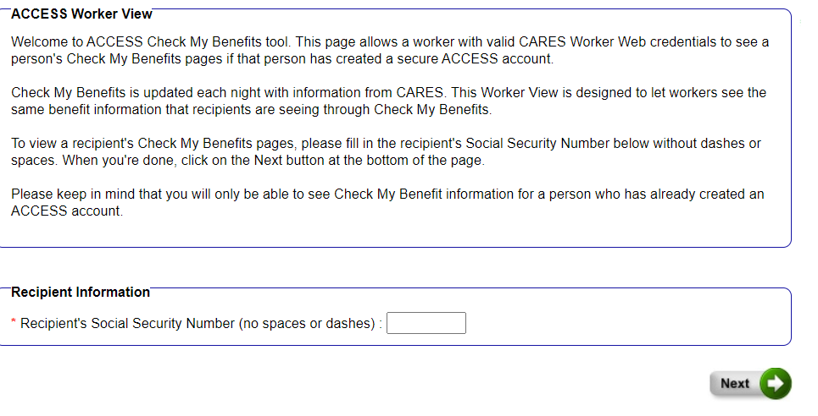

Choose the first option on the left--View My Letters.

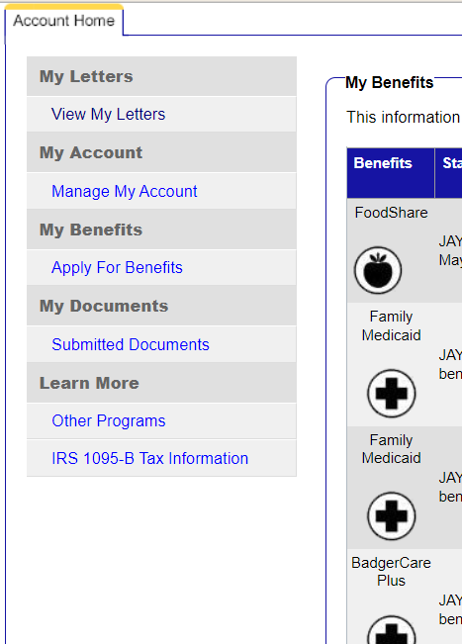

Choose the date range you want to search.  The system will pull up all of the notices emailed in the specific time period.  In the example below, you can see that the client never opened any of her notices.  If the client has opened their notice, the Read? Status will say “Read”.

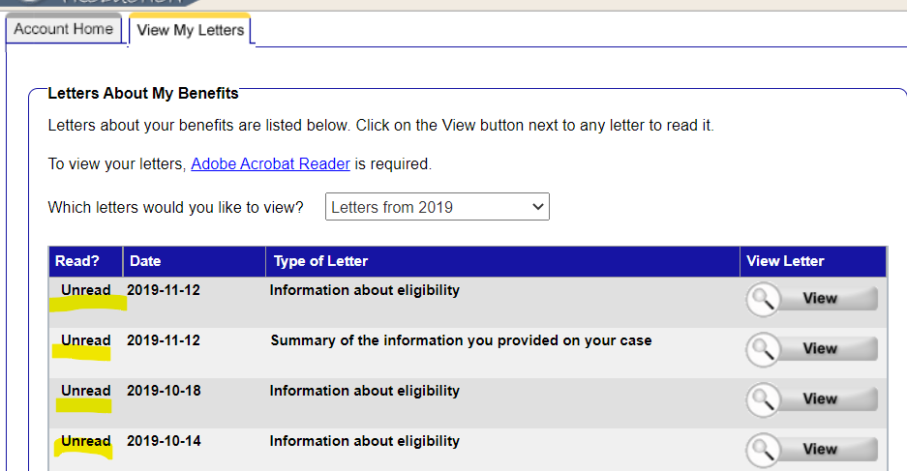

If there are no notices to show, it will give you a message that there are no letters found.

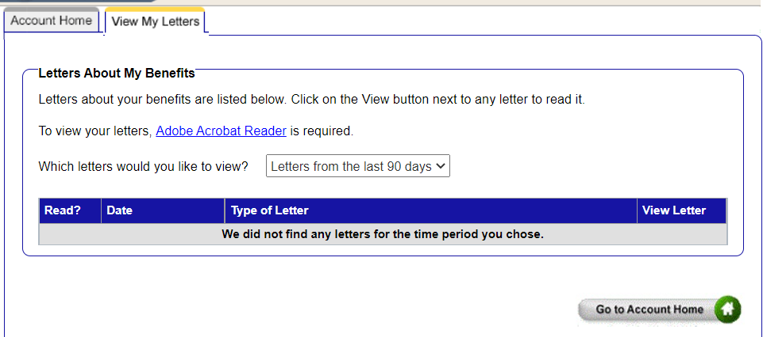

**EBD MA**

* If a spouse has activated Healthcare Power of Attorney and we have certification of the incapacitation, we can accept one signature for both spouses when they apply for Long Term Care programs under the policy related to someone acting responsibly on behalf of an incapacitate or incompetent individual (MEH 2.5.1.1).  However, we still do not add the HC POA to the case.

**FoodShare**

* There are still issues related to the SMRF signature coming up for the telephonic piece.  Please remember the state guidance has been to do the following: “Workers must read “I will now read a summary of the information you have provided and record your verbal signature. This is done to confirm what you said, and make sure you understand everything we have discussed. Please listen carefully and let me know if any of the information needs to be changed.”  Read the summary.  Document the ID in case comments and that this was the workaround for the Telephonic SMRF.  This is slated for a fix with the June Cares Release.