AGENT Reminder June 23, 2022
General
- The Southern Consortium has received a report from the state listing cases that have employment pages with incorrect FEINs. This report will need to be worked and CWW EI pages with incorrect FEINs should be updated with the correct FEIN or deleted if the page is no longer applicable.
The below are a few reminders:
- Always search for a FEIN, this is a mandatory part of the employment page. FEINs are used by CWW to pull up health insurance access information for the member.
- Use data exchange to help you locate the correct FEINS. You can use new hire matches, SWICA matches and FDSH.
- If you are unable to locate a FEIN this MUST be documented on the screen level comments on the employment page.
- Old screens that have been end-dated and no longer apply to the case, should be NL deleted after they have been end-dated for one-year. If you are working on a case and come across old pages, please delete them.

- If a member calls requesting an assessment for SSI-E, they should be referred to the ADRC in most circumstances. If they are open for Family Care, they should be referred to their care manager as they complete the assessment.

- Please remember to request contracts for customers who have contractual income. This is common with customers who work for school districts. Depending on how the contract is written and if they have other income, their income may still be budgeted over the summer months even while they are not working.

- When there is a minor parent, the absent parent page should reflect that they are the parent/caretaker and the case should be referred to child support. When child support requests the referral be ended, we would update the page to reflect No referral and Minor Caretaker. Set an expected change to refer when the parent turns 18. The only time a different adult would be listed is if the adult HH member has custody of the minor child’s child/children and we have the order to verify that.

- Supervisors are completing the Genesys mismatch reports weekly. We’ve been noticed that some agents are still using the ATS recorded line. As a reminder, we are not using anything but ATS Other and reading the script until issues with Genesys have been resolved. The ATS lines have been having frequent issues with recording errors and dropped calls, which can contribute to a higher number of mismatches. If the recording stops prematurely, please continue to read the script and the full call will be uploaded.

- If a customer contacts the agency because they have been locked out of their access account and wish to have their access restored, the worker should take the following steps:
  - The worker verifies by the Check My Benefits Worker View through CWW that this is a situation where the account access has to be restored
  - If a message displays which indicates that the customer’s information is no longer available to be viewed through ACCESS (see next slide), the worker should inform the customer they need to provide proof of ID at their local agency
  - The worker asks the local CARES coordinator to send an e-mail to the DHS CARES Call Center requesting that viewing privilege be restored. The DHS CARES Call Center will forward the request to appropriate staff to restore the viewing privilege
  - The DHS CARES Call Center will notify the IM Agency when access to Check My Benefits is restored
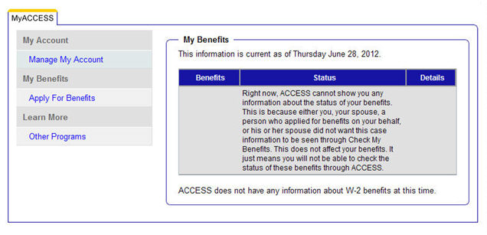
Note: If the message above does not display, this may be a situation where the customer needs to create an account or reset their password

- We are seeing an influx of calls being transferred to the Spanish queue from the General Queue. There is an overflow set for the Spanish queue. This means that when you get a call in the General queue that is from that queue, it’s because there wasn’t an agent available. Please do not transfer them back as they often abandon and call back since they end up waiting even longer. Please use the language line to assist the caller.
- Agents should not research individuals on the internet or Facebook unless they have information that is conflicting that was received elsewhere. Example: A client reports no self-employment. You received a report that they were self-employed. You search and find a business online and it shows on Facebook their business name.

If you find information questionable, it should be clearly documented where/how we received the information that prompted the search and why it is questionable in case comments.

