

**AGENT Reminders October 13, 2022**

**EBD/LTC**

* When you have a spouse that is allocating income to a community spouse and the budget is not coming out right, please review PH [11.5.3.1](http://11.5.3.1).  We may need to do another entry on the community spouse page to adjust the budgets for the allocating spouse by entering a court order/fair hearing allocation amount.  See below:

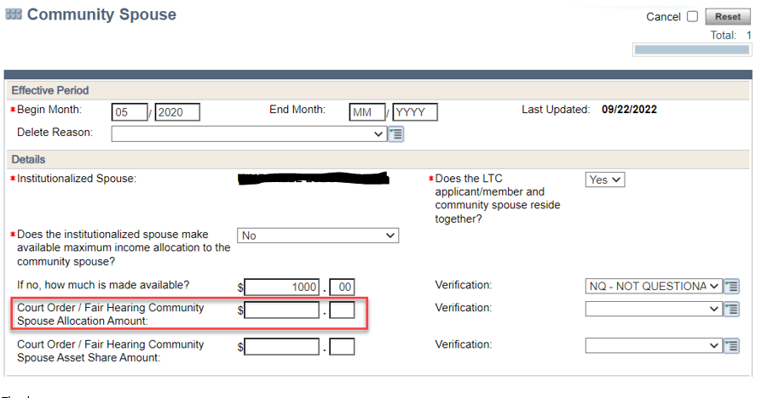

* If an application comes in and the person indicates LTC needs, review the case for any disability or elderly status.  If the individual has a disability status or is elderly, please attempt to contact the customer to refer to ADRC and clarify the information.   In the event you cannot reach them, pend the gatepost question below:

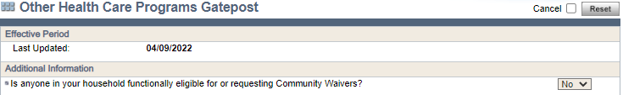

* HELOC policy has changed and they are being treated the same as reverse mortgages.  The HELOC payments received are assets in the month received and thereafter.  However, the available balance is not an asset that is available to them.  The balance owed can be used to offset equity value in the homestead.

**General**

* When a page one application is received for healthcare, either written or telephonic, an interview needs to be completed and a second signature must be collected if the interview is not held the same day that the filing date was set.
* When a customer calls and needs to have TPL removed from their account, please refer them to Member Services. Workers should no longer call TPL or Member Services themselves on behalf of the customer. Let the customer know that they should 1) Call the TPL insurance to obtain the exact date that their coverage ended. If this step is not taken, the TPL will continue to repopulate on their case 2) Call Member Services with this information and to have the TPL removed. Note: if the TPL is showing on a medical coverage page in CWW, the worker should update the page to show the coverage has ended.
* One Touch philosophy of the Southern Consortium means that we process the case from beginning to end with the client on the phone. This includes the following:
  + Completion of all Discrepancies on the Case:
  + Completion of ALL action items (alerts) on the case
  + Completion of any requests or renewals for Medical Assistance and/or FoodShare, as well as Telephonic Signature for SMRF
  + Completing CTS application/Renewals
  + Completion of all documents on the case
  + Agents are NOT expected to process any Self-Employment including SEIRFs during Call Center hours
  + Agents are NOT expected to process any Medical Expenses documents during Call Center hours
  + Agents are NOT expected to process any LTC Undue Hardship during call center hours
  + Those documents will be processed by the local county agencies. Please advise the client that their documents/verifications will be processed in the order they were received within a 10 day period.