AGENT Reminders October 27, 2022

EBD/LTC
- For the purposes of evaluating divestment, there has been a change in policy related to the child needing to have a disability determination. The child being divested to is only required to meet the SSA definition of disability or blindness. This can be documented by a medical professional.

General
- Remember to delete action items when working on cases.
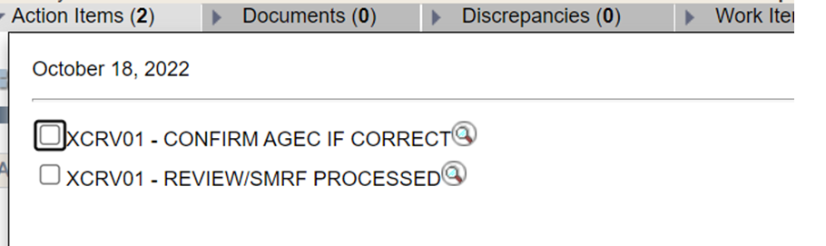

- When customers report a new address, remember to transfer them to the new, correct county of residence. If the case is pending and cannot be transferred, enter a flagged case comment that the case needs to be transferred when the verification is processed.
- Remember to read case comments when processing verification as additional action may be required on cases (example: transferring to new county of residence, generating a case summary, etc.)
FoodShare
- Please remember to review dependent care expenses at renewal to make sure that they are still accurate.

