**Hardship Procedure**

Currently, when a request for a second authorization in the current month is denied due to not being considered a hardship, a parent receives a *verbal* denial of the second authorization.  The parent should receive a *notice* denying the authorization that includes rights to a fair hearing.

Below is a screenshot of the Free Format Letter template in CWW and the language that needs to be entered into each highlighted field in order to manually generate a denial notice to the parent for not meeting a hardship situation.  The instructions start on page 9 of Operations Memo 18-J2.

**It is extremely important that you *do not* change any of the language provided below (page 2).  When this notice is automated, the notice will have the same language.**

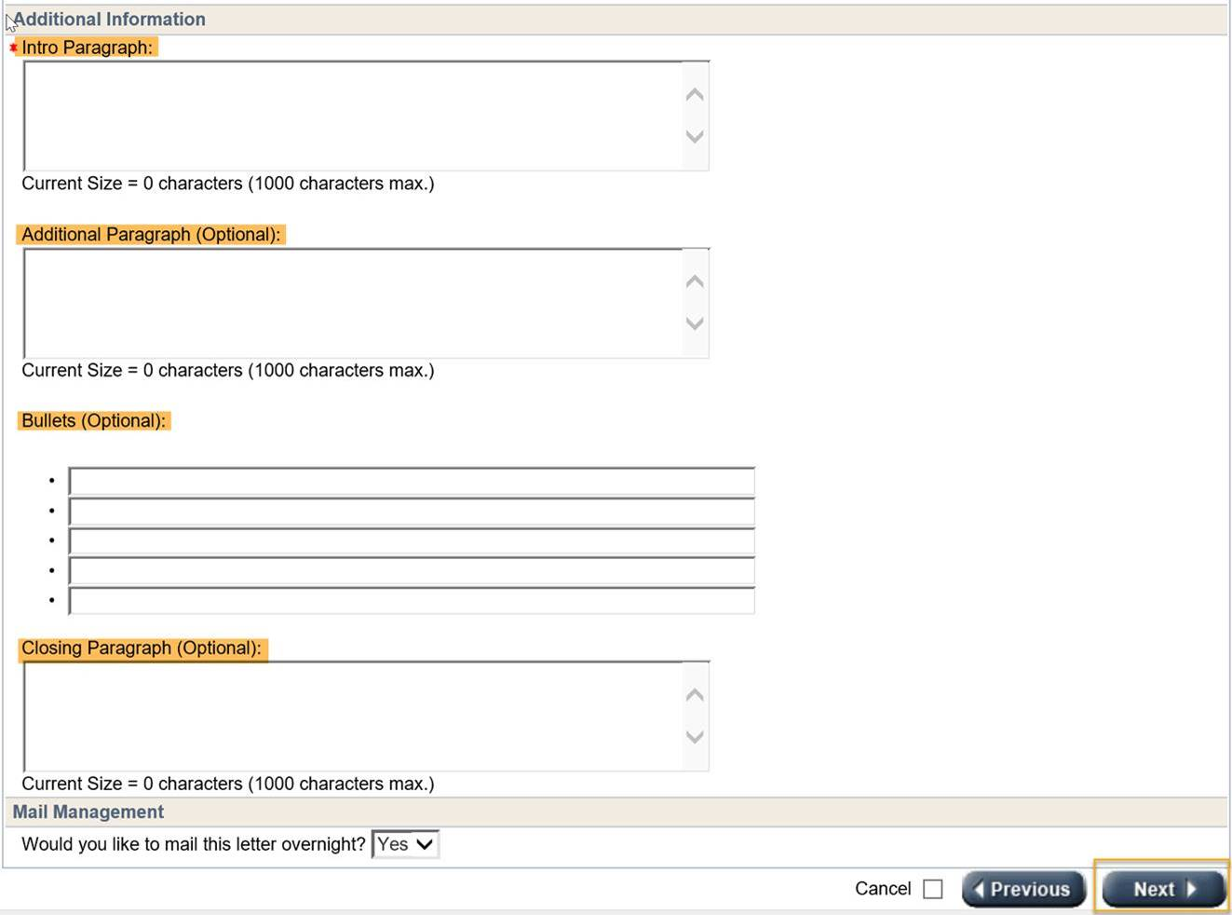

**Intro paragraph**:  Add in the below language.

* Parent Notice – Authorization Request Denial - Families experiencing unforeseen circumstances that are no fault of their own and that prevent them from utilizing the originally authorized child care provider during the current month, may be eligible for a new authorization to a different child care provider location during the current month, if utilizing the original child care provider would cause an undue hardship for the family as determined by the authorizing agency.

**Additional Paragraph (Optional)**:  The language in this field will depend on whether the request for the second authorization is denied due to not being a hardship situation **OR** if the request is untimely.

* If the request does not meet a hardship situation use this language: Your request for a second authorization during the current month due to (Primary Reason from Hardship Page) was received on (Received Date from Hardship Page).  However, it has been denied because it does not meet the requirements of the Wisconsin Shares Child Care Subsidy program.  To change your child care provider beginning next month, you will need to submit a request to your child care agency before the last day of the current month.
* If the request is untimely use this language: Your request for a second authorization during the current month due to (Primary Reason from Hardship Page) was received on (Received Date from Hardship Page); however, it has been denied.  Your request was reported to the local agency more than ten (10) calendar days after the first date of the change and is considered untimely.  To change your child care provider beginning next month, you will need to submit a request to your child care agency before the last day of the current month.

**Bullets (Optional)**:  There are 5 bullets and the language that will go in this section will be the child care appeal rights below:

* Child Care Appeal Rights: If you disagree with this authorization decision on your case contact the agency to resolve the difference.
* If the issue is not resolved to your satisfaction you may request a fair hearing through the Division of Hearing and Appeals.
* Send your request via U.S. Mail:Division of Hearings and Appeals, 5005 University Avenue, Suite 201, PO Box 7875, Madison, WI 53707-7875
* Hand-Deliver your request:Division of Hearings and Appeals, 5005 University Avenue, Suite 201, Madison, WI 53707-7875
* Send your request via fax:Division of Hearings and Appeals, (608) 264-9885

**Closing Paragraph (Optional)**: Use the below language:

* A fair hearing request must be a written request and must be filed with DHA within 45 calendar days of this notice.  You may represent yourself or be represented at a hearing by an attorney, friend, relative, or anyone else you choose.

**Viewing the notices**: The following day, you can view the notice in ECF, ACCESS and CWW Client Correspondence.  An example of the notice in CWW, is below.



**Hardship Page Privileges**

Currently, when the status of a hardship request entered on the Hardship Page is approved or denied, it cannot be changed.  Effective March 3rd EBT CSAW was enhanced to allow some users the ability to change the status of a hardship request.

If a hardship request has been incorrectly approved or denied, I am able to change the status of the request to pending, please email your supervisor to contact the Child Care Help Desk.