How to Save Genesys Contacts as Favorites (Updated 12/7/21)
Step One – Click the Team Communicator icon highlighted below.
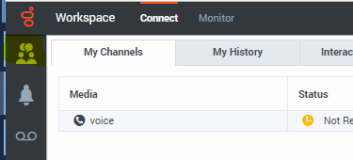
Step Two – Type the name of the person you want to add and results will display.
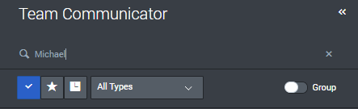
Step Three – Hover over the name of the person and a star with a plus sign will display. Click it.
Step Four – You can type a category name to add an individual to a group or just click add to have them show in favorites. It is recommended you use the category feature for easier access to your favorites.
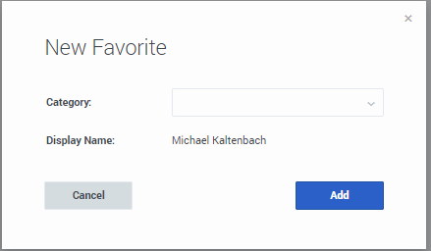
Step Five – When you search, select the star to see your favorites. Results display alphabetically. You will still want to use type a partial name or name to find results.
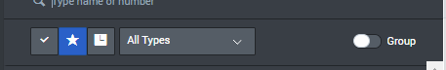
Step Six – If you type a category name, you should select the “Group” button and change all types to “agents”.
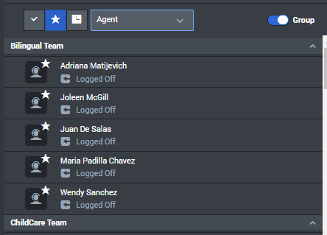
This will display each agent group you have designated, and you can see all your favorite people.

How to Save External Contacts as Favorites
Step One – Click the Team Communicator icon highlighted below.
Step Two – Enter the number for the external contact
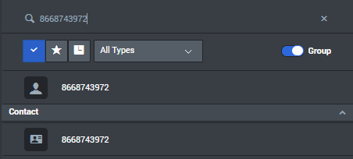
Step Three – Select add to favorites by clicking the Star Icon under the number.
Step Four – Select an existing category or create a new category by typing the name in.
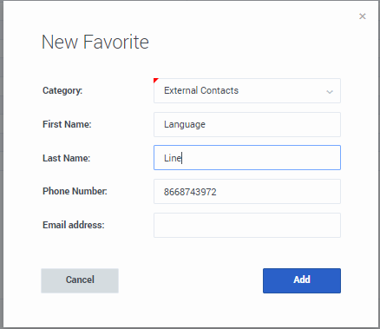
Step Five – When searching for numbers, click the favorites star and select Directly Dialed.
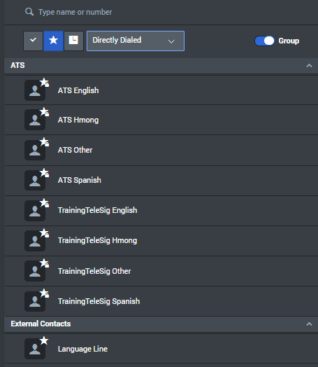

Note: If you have the “group” button selected, the categories you have created will show. If this is not selected, it will show a list of directly dialed numbers and contacts you’ve created. It may not show you all the contacts as it limits the number viewed on a page. You might have to search by keywords as needed.

