Genesys Signature Steps (Updated 12/7/21)

Step One – While on a call, select Instant Conference.

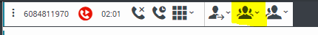

Step Two - Click the star button.
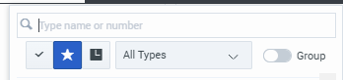

Step Three - Type ATS in the Search Bar. The list of Automated Telephonic Signatures will Display.
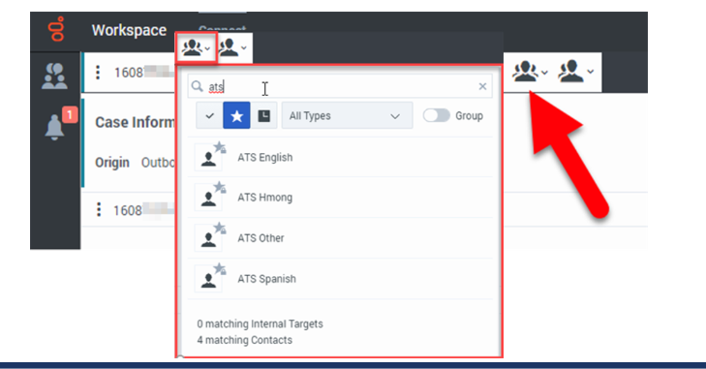
Note: Language choices are English, Hmong, Spanish, and Other. When selecting Other, you will have the option to select the preferred language of the individual. However, the recorded prompt is not read until you trigger it manually at the appropriate point in the call.
Step Four – Select P – Telephonic in CWW on the Generate Summary Page or RFA Complete Request page. Copy and paste the Connection ID into the field.

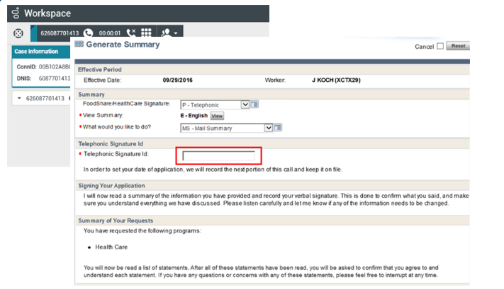
Note: The connection ID is only present for outgoing calls when you conference the call to the appropriate ATS selection. It will always be present for incoming calls.

The Connection ID shows below:

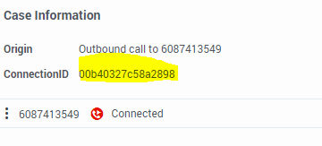

Step Five – Read the sections instructed under Telephonic Signature ID, Signing Your Application, Review/Read the Summary, and Summary of Your Requests.

Step Six - Using the keypad in Genesys or on your phone, dial the correct prompt for the programs requested. You can find the keypad in Genesys by clicking the icon.

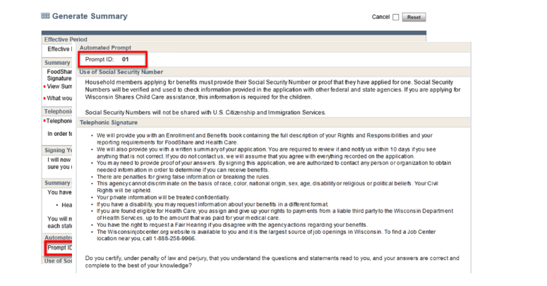

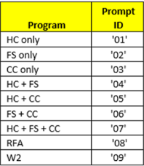

Note: Selecting the prompt will display the appropriate prompt ID at the top. You can use the following to navigate during the ATS reading:

# will pause the recording, click # again to start the recording again
*Will back up the script 10 seconds
9 will end the telephonic signature

Step Six – After the ATS is finished, read the Completing the Signature portion. Once finished, press 9 on your keypad to end the signature process. This completes the Automated Telephonic Signature process.

Note: English, Spanish, and Hmong ATS calls have a time limit of 15 minutes, with the ability to extend an additional 15 minutes. When selecting “Other” for the language, the calls have a 30-minute time limit, with the ability to extend an additional 15 minutes. Customers pushing buttons on their end of the line can potentially interfere with this process.

Below is the ATS Navigation Process
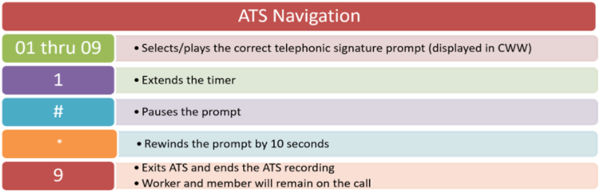
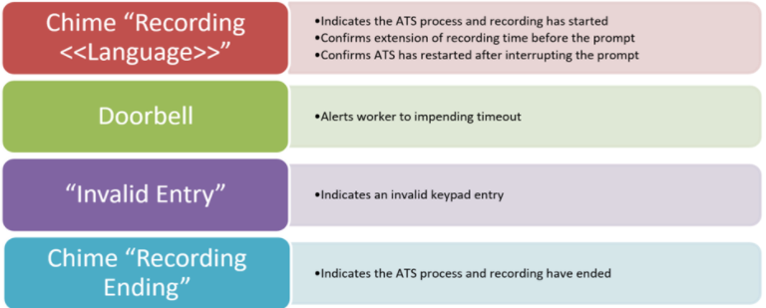

Manual Telephonic Signatures
If you are unable to use the automated signature for any reason and need to just read the Telephonic Signature, you will need to select ATS – Other. Once selected, you can begin reading the signature to the customer.
This is critical to complete this step for manual telephonic signatures or the recording isn’t stored in ECF and this can cause a QA error.

SMRF Telephonic Signatures
If you are doing a telephonic SMRF, please select ATS – Other and read the script. There is no ATS for SMRFs.

