Using the Language Line (Updated 12/7/21)
Step One – While on a call, select Consult.

Step Two – Type the Language Line Number – 866-874-3972

Step Three – Enter the Client ID, 531347. Select one for Spanish or two for Other.

Step Four – Explain the reason for the call to the interpreter. While on the call with the interpreter, select Instant Conference.
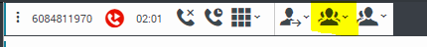

Step Five – When you select the Instant Conference, the active consultation will display.

Step Six - Click the Phone Icon to combine the calls.
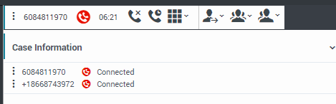

Using the ATS process with Language Line

Step One – While the interpreter is on the line, explain that you will be using an automated signature process that requires their assistance to translate portions of the telephonic signature.

Step Two - While on the call, select Instant Conference.

Step Three - Click the star button.
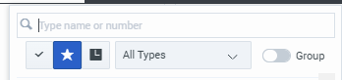

Step Four - Type ATS in the Search Bar. The list of Automated Telephonic Signatures will Display.
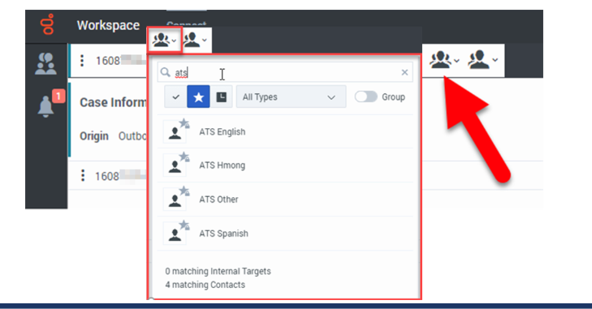
Note: Language choices are English, Hmong, Spanish, and Other. When selecting Other, you will have the option to select the preferred language of the individual. However, the recorded prompt is not read until you trigger it manually at the appropriate point in the call.
Step Five – Select P – Telephonic in CWW on the Generate Summary Page or RFA Complete Request page. Copy and paste the Connection ID into the field.
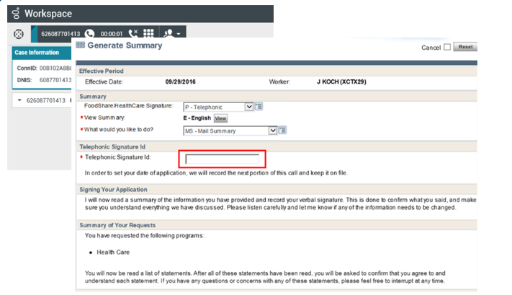
Step Six – Read the sections instructed under Telephonic Signature ID, Signing Your Application, Review/Read the Summary, and Summary of Your Requests with the interpreter.
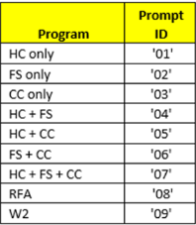
Step Seven - Using the keypad in Genesys, dial the correct prompt for the programs requested.
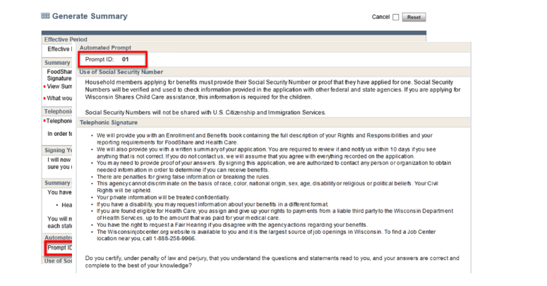

Note: Selecting the prompt will display the appropriate prompt ID at the top. You can use the following to navigate during the ATS reading:

# will pause the recording, click # again to start the recording again
*Will back up the script 10 seconds
9 will end the telephonic signature

Step Eight – After the ATS is finished, read the Completing the Signature portion with the interpreter.

Step Nine - Once finished, press 9 on your keypad to end the signature process. This completes the Automated Telephonic Signature process.

Step Ten – Complete the call with the interpreter and the client.

