Escalated Calls to a Supervisor (Updated 12/7/21)

Step One – While on a call, select Consult.

Step Two – Enter the name of the person you are trying to reach. Click the phone under their name.

This places the original call on hold while you complete the consultation.

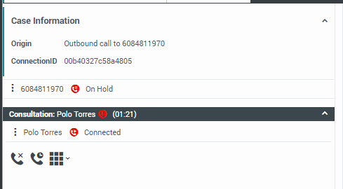

Step Three – Consult with the supervisor regarding the case/escalated individual. If the call needs to be transferred, proceed to Step Four.

Step Four – Select Instant Conference, the active consultation will display. Click the Phone Icon to combine the calls.

Note: Please be sure the supervisor is in a Not Ready - Supervising status prior to consultation. If the supervisor is in any other status or unable to be reached, please inform the customer an email will be sent and a return call will be made. Please follow up with a detailed email to the supervisor including the case number, any updated contact information, and the reason for the call.

