**What Can You Purchase with FoodShare?**

<https://www.dhs.wisconsin.gov/foodshare/fsspending.htm>

<https://www.fns.usda.gov/snap/eligible-food-items>

|  |  |
| --- | --- |
| What Can I Buy? | What Can’t I Buy? |
| Breads and Cereals  Fruits and Vegetables  Meats, Fish and Poultry  Dairy Products  Seeds and Plants to grow food for your family | Nonfood items (pet foods, paper products, soaps, household supplies, grooming items, personal care items, cosmetics, etc.)  Beer, Wine, Liquor, Cigarettes or Tobacco  Food that will be eaten in the store  Hot Foods (food cooked and served hot at the store)  Vitamins and Medicine |

**Cards for Accessing Benefits:**

**Quest Cards are EBT cards** on which FoodShare is deposited. When someone opens for FS for the very first time, they are mailed a Quest Card. If they close and later reopen, they are not sent a new Quest Card. They are expected to use the card that they were previously issued. In some instances, such as lost or stolen cards, clients can be issued another card. They are to call the toll free Quest Card phone number and report the lost or stolen card and a new one is issued, by mail, to them. It can take 5-7 business days for the card to reach them.

Sometimes, clients do not want to wait for the card to arrive in the mail or they have extenuating circumstances where they might need a replacement/temporary card immediately (a battered person who has fled the home leaving their Quest card behind or a house fire where their card has perished in the flames). In those instances, see the directions below.

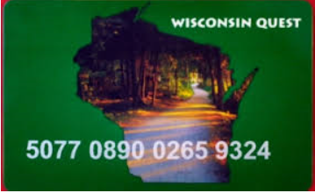 1-877-415-5164 is the number to call regarding Quest Cards & FS balances.

**Issuance of Temporary FoodShare Quest/EBT Cards is strictly enforced with specific criteria.**

Also known as vault cards because they are stored in the safe. ☺

Also referred to as emergency FS cards.

**If you are speaking to a client and they want a temporary FS card, you are to direct them to call the main phone number of the county in which they live. Supervisors make the decision on whether or not someone can be issued a temporary FS card. The supervisor speaks to the client and based on specific criteria, they determine if a temporary card can be issued.

If a client is requesting a replacement FS card, direct them to call the toll free Quest/EBT phone number. If they insist that they need one now and want an emergency card, see above **

Temporary cards are only valid for 30 days. They do not contain the name of the individual and have an “89” in the 6th & 7th digit respectively. Whereas, permanent cards contain an “85”.

**Forward Cards** are issued to an individual the first time they are opened on Medical Assistance. If a customer reports that they have lost their Forward Card the ESS must request a replacement be sent to them by using the icForward Health computer system.

**Processing Oddities:**

**Applications: Receipt of only a Registration Page or Page One**

If you receive a BC or FS Registration Page or Page One without a phone number, first check CWW using the clients name or SSN, to see if there is a phone number for them on another case. If no phone number is found, schedule an appointment and an appointment notice will be mailed. Please keep in mind mailing time when scheduling.

**Reviews: FS only review with an EBD program open**

When processing a FoodShare-only review on a case open for FS/QMB/MS and it is not time for the review on the QMB or MS,

* Do not pend assets unless the client reports a change.
* If you request assets and they are not verified that will shut down the EBD HC programs, possibly prematurely.
* If you request verification of assets and they are not required to be verified at this time, this would be considered over-verifying in the eyes of the State.

**Absent Parent Page: Claimed Father (CFR) becomes Legal Father (FTR)**

When you update a case and a claimed father becomes the legal father, you will need to update the Absent Parent page**. If the father is in the home**, update the Household Relationships page to Legal Father. Then navigate to the AP page; change the referral to “no” and the reason for not referring to “Absent Parent in the Home”. Next, enter the date of the current month as the Delete Month using the delete reason of “Other”.

**Error Banner to ‘Click the Verify Button’ on the Employment Page:**

Sometimes we receive an error banner when running a case thru eligibility determination. The error prevents us from completing the process. The banner tells us to click the verify button on a specific employment sequence. Workers often repeatedly go back and hit the verify button and continue to get the error.

The Tip to get past this:

1. Go to that employment sequence.
2. Remove the FEIN, making note of it because you will be re-entering it.
3. Click the Verify Button.
4. Hit Enter until you are off of the page.
5. Go back to that Employment Sequence page.
6. Re-enter the FEIN.
7. Click the Verify Button.
8. You should now be able to run eligibility to the end.

**Error Banner MCI**:

**“MCI did not process the request. Please call the help desk and provide the MCI error code ‘xxxxx’’”**

This banner will sometimes appear on the Household Members page. You do not need to call the help desk as it instructs. Follow the below steps to resolve the error.

1. Write down the Social Security Number.
2. Delete the Social Security Number.
3. Hit enter, twice.
4. Go back to the Household member page for that individual.
5. Re-enter the Social Security Number.
6. This should resolve the error and you can now continue processing the case.

**Error Banner SSN Already Exists**

 AE201: **An individual with the same SSN already exists in the system.**



If you get this error while processing a case:

1. Make a note of the SSN that is on the page and for which person and keep track of it as you will need it later
2. Send an email to your supervisor. Include a copy of the error message along with the case name and number and what you were doing on the case when the error came up.
3. Your supervisor will look at the case and if need be, will send it to the Call Center. The State will remove the SSN and send the case to Systems. The State will send a response back when it is okay for you to finish what you were doing on the case. They will include instructions on how long to wait before you re-enter the SSN.

**FFM Applications-parents & 19 year old adult child living in the home**

Note: People older than 19 years old must always apply separately from their parents or caretakers, irrespective of their living arrangement or tax dependency per BCP Handbook 2.2.6.

However, FFM applications are different--If a parent files an FFM application and includes an adult child *who is living in the home* on the application, we can use the parent’s signature to create a separate case for the adult child. A separate application is not needed. BCP Handbook 25.5.4

[Adult child = 19 yrs. or older]

**What to do When an Application is received for a Deceased Person**

1. If the application is filed within the same calendar month as the date of death or within the three months after the date of death, the application should be processed as if the applicant were alive.
2. Do not enter the date of death until after you have confirmed the MA pass/fail. Then go back and enter the date of death as a change.
3. If the application is filed more than four months after the date of death, they are not eligible.

**Heath Insurance Access Verification codes**. (Found on the bottom section of the Employment Page)

When a case is pending for current and/or past access of health insurance, a verification request letter (VCL) is sent to the client informing them they do not have to do anything. The State sends a notification to the employer asking for this information.

A--If the employer provides the information, the CWW case is electronically updated with the data and a verification code is auto populated.

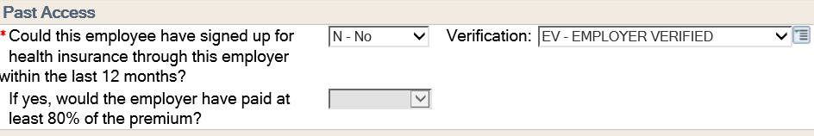

B-- If the employer does not provide the verification and the due date for this information arrives, we do not take a negative action against the client. Instead, we will use a verification code of “PO-Process Override”. We choose this code in the drop down of the verification field.

*While pending*

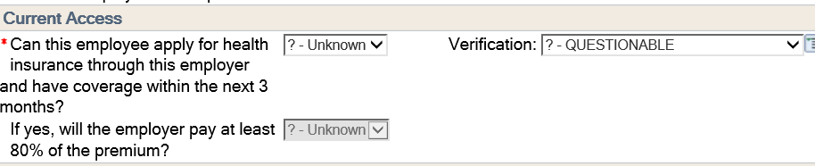

*After entering the PO Code*

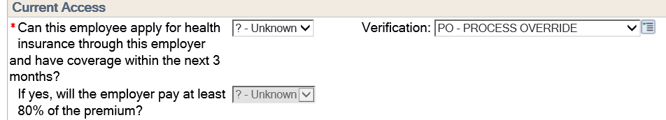

*Note that we leave the “?-Unknown” on the page. With the PO code entered, CWW will allow an eligibility of pass or fail to be determined.*

**Wise Workers- -Title V, Older Americans Act, Wise Program**

Wise Worker’s earned income does not count for Food Share if the money is paid from the above program. It does count for Health Care. You would enter the Employment Type as “I-Workforce Innov & Opp Act” so that CWW will count it appropriately.

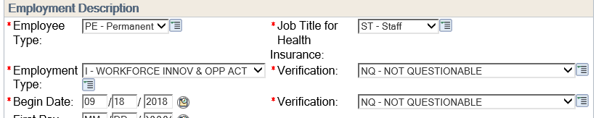

The above is a screen shot of how to code Wise Worker income from a qualifying employer.

**When to update Begin Dates and Program Filing Dates on the Program Request Pages**

1. Only update Begin Months when you are entering new data on a page.
2. Program Filing Dates should be updated at

* Application or Program Add
* Person Add
* Late Renewal (MA Only)
* Late Verifications submitted after the 30 day denial notice is sent for a Food Share Application (See 60 Day Verification Policy for FS Applications)
* At renewal, do not update the filing date for the program being reviewed if the renewal is timely.

**Day To Day Items/Helpful Tips:**

**Alert Code Help Text can found by going to:**

* Navigation Menu > Reference Tools > Alert Code Help Text Search

**Find Matching Cases button on the General Case Information page**. Process Help 48.2

If you click on this button on a particular case, any other case(s) that have the same household and/or mailing address will appear in a list. You can use this information to help determine household composition.

