Running with Dates for Health Care programs
Changes in health care cases may impact the current benefit month. Because of this, there are times that running with dates is needed. Some examples of these changes are:
- Non-financial changes that may open MA,
- Decrease in income they may open MA without a premium or decrease current premium,
- Adding a person or newborn.
Confirming eligibility for health care while running with dates will certify the eligibility within Forward Health.
***If the case is also open for FS, do NOT confirm the FS. FS changes impact the next benefit month not the current month. If you accidently confirm FS, suppress the notice so that the client does not receive a notice showing the incorrect benefit allotment.
Running with Dates for FoodShare
Because changes in FS cases do not impact benefits until the NEXT benefit month, there are very few cases where we may need to run with a date for FS. Some examples are:
- To calculate a supplement (see PH 31.1.4),
- To calculate a supplement after adverse action due to
  - If this supplement is a replacement of benefits, see 7.1.1 of the FoodShare Handbook.
  - For changes that cause an increase in benefits, including person add see 6.1.3.3 of the FoodShare Handbook.
  - For changes in expenses see 4.6 of the FoodShare Handbook.
  - For benefit under-issuance see 7.4.1 of the FoodShare Handbook.
- When determining overpayments and using simulation.
Reminders
- When running with dates, run and confirm current month. Then run and confirm months in reverse chronological order. Exception: For a baby add, first run eligibility with the newborns DOB and then run future months, if applicable. You must run without dates at the end to put the case back into Ongoing Mode.
- When running with dates, if FS is accidently confirmed in error at an increased amount, a notice will issue to the client, but CWW will NOT issue the adjusted FS. The client can request that the benefits on the notice be issued to them which would then result in an overpayment to recoup the incorrect benefits. If you accidently confirm FS when running with dates you MUST suppress the notice the same day as confirmation. Note: customers with ACCESS may see the increased amount confirmed in error through their ACCESS account.
- If a supplement is needed, the worker must enter this either manually or through the “Determine Potential FoodShare Supplement” option in CWW. When issuing a supplement, case comments are required to include the supplement amount and how the supplement was determined. Example: FS supplement for April 2021 requested for $140 due to baby add. Food unit was previously due to receive $200 in FS for April and is now eligible for $340 in FS for April following the addition of the newborn. No offset indicator selected.

How to Issue a FS Supplement:
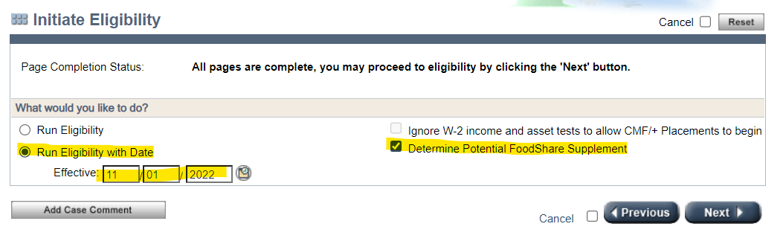
- From the Initiate Eligibility screen, you will select to Run Eligibility with Date, enter the date and select Determine Potential FoodShare Supplement as indicated below. Then click Next.
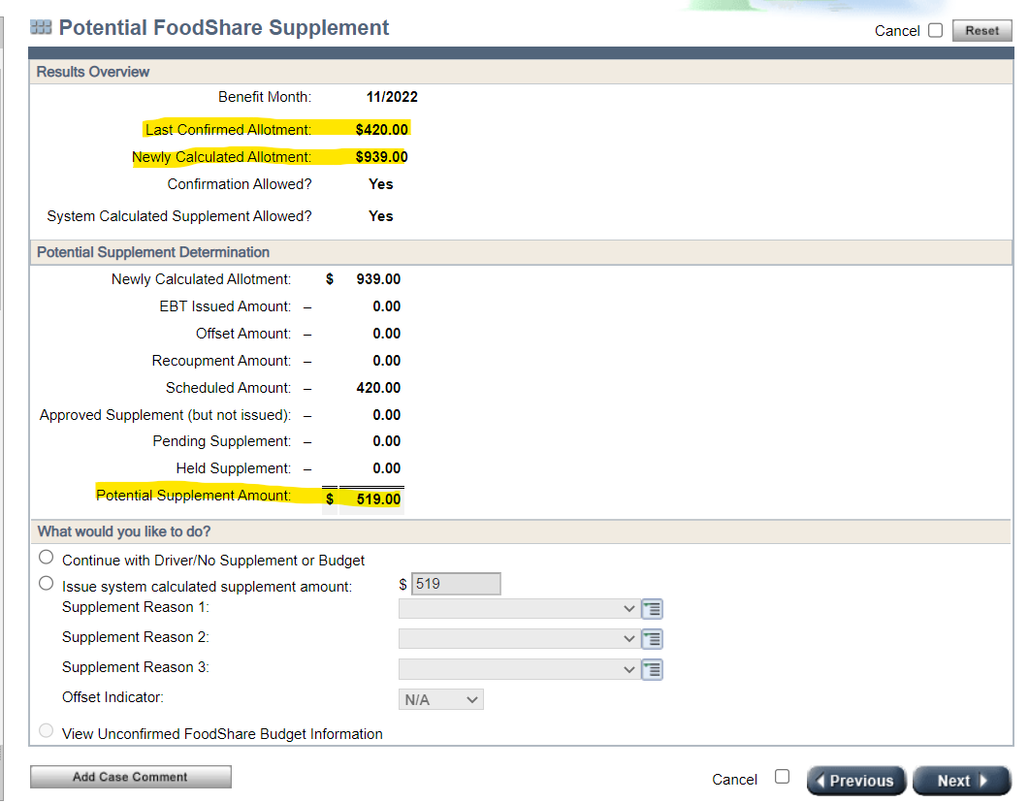
- Then you will go through each of the running eligibility screens, including the budget screen, make sure to review the budget. After the budget you will see the following screen:

PLEASE NOTE: The Last Confirmed Allotment Amount, Newly Calculated Allotment Amount and the Potential Supplement Amount, these amounts will need to be in case comments and should be checked for accuracy.

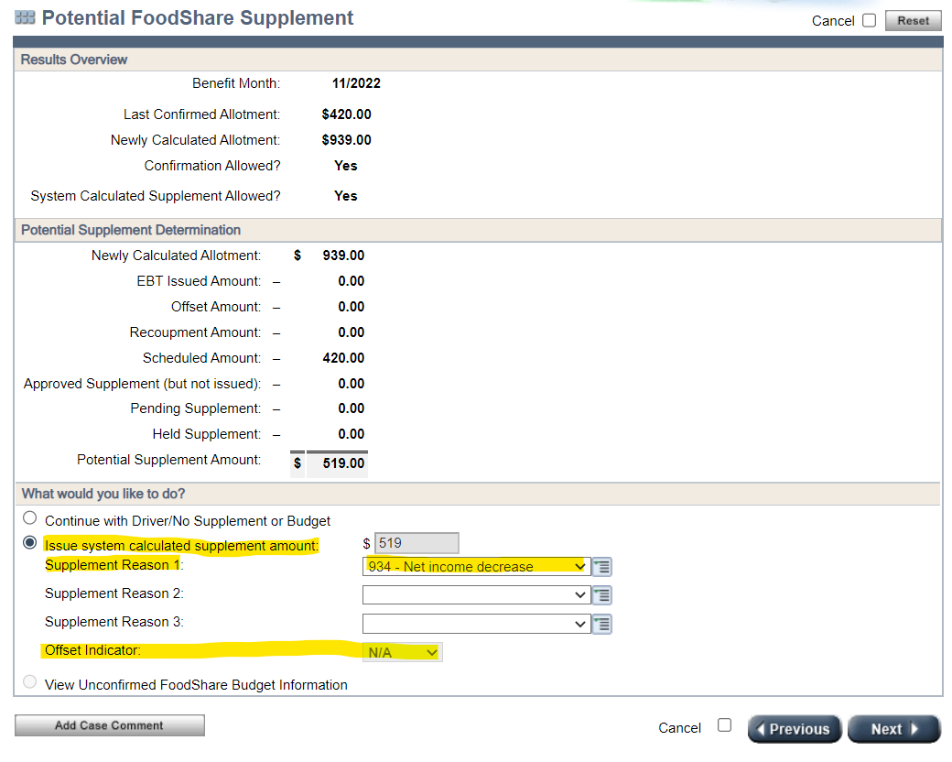
- On that same screen, you will select: Issue system calculated supplement amount. Next you will enter a Supplement Reason, for example: person add, net income decrease, etc. You will need to check the Offset Indicator, if it is greyed and N/A as indicated below, no action is required. If the Offset Indicator is able to be changed, you will change it to yes. Then click Next.

- Next is the Confirm Eligibility screen, change the confirm for FS to YES and click Next.
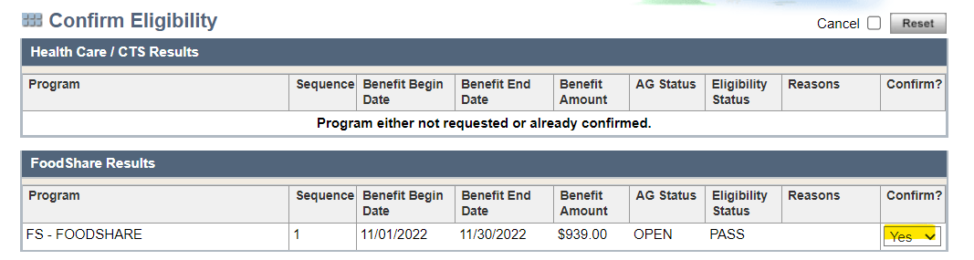

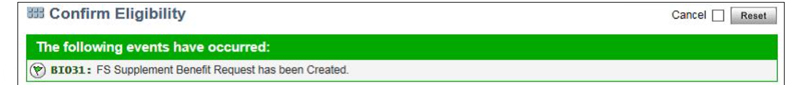
- After clicking Next, you should receive this below banner. The FS Supplement has been requested.

How to Issue a Manual FS Supplement (per PH 31.1.5):
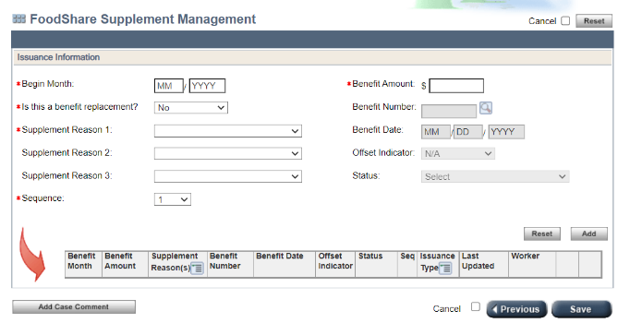
- From the Navigation Menu, click on FS Benefit Issuance, then click on Supplement Issuance. This will bring up a FoodShare Supplement Management Screen.
- Enter the month for which the supplemental or replacement benefit is being requested in the Begin Month field.
- Enter the FoodShare supplemental or replacement amount that is being requested in the Benefit Amount field.
- The Is this a benefit replacement? field will default to No. Select Yes if a benefit replacement is being requested. If a benefit replacement is being requested, click the magnifying glass next to the Benefit Number field to open the FoodShare Benefit Issuance Payment Period page. The FoodShare Benefit Issuance Payment Period page will display benefits issued during the benefit month entered on the FoodShare Supplement Management page. Click the benefit number for the benefit that is being replaced. The FoodShare Benefit Issuance Payment Period page will close and the Benefit Number and Benefit Date fields on the FoodShare Supplement Management page will populate with information. (Note: If the request is for a FoodShare supplement, the Benefit Number and Benefit Date fields will be read-only.)
- From the Supplement Reason menu(s), select a reason code(s) indicating why the supplemental or replacement benefits are being requested. At least one reason code, but no more than three, must be selected.
- If an outstanding claim exists, the Offset Indicator field will be editable. Select Yes from the menu to use the FoodShare supplement amount to offset the balance on the claim. If an outstanding claim does not exist, the field will default to N/A and will be read-only.
- The sequence field will display 1 by default if a case has only one FoodShare assistance group sequence number.
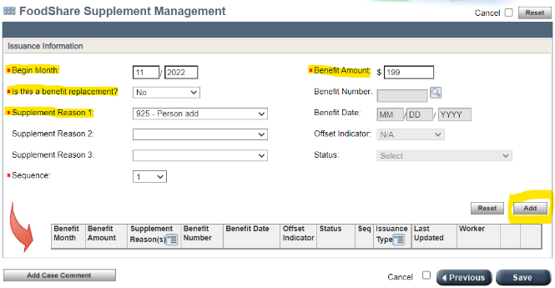
- After completing all applicable fields, workers should click Add to add the request to the Dynalist at the bottom of the page.

- After adding all requests as applicable, click Save to submit the request(s).
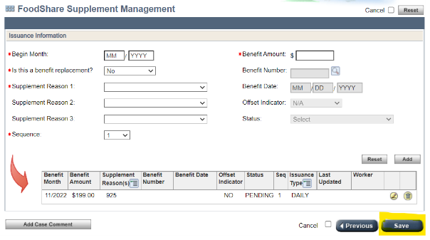
PLEASE NOTE: Supplements that are pending, held, or have been approved but not yet issued will display in the Dynalist. Approved supplements are issued overnight and once issued, will be removed from the Dynalist, and will display instead on the FoodShare Benefit Issuance History page.

