The following scenarios are to be used for practice in determining when to run a case with a date.
- All case examples and names are fictitious.
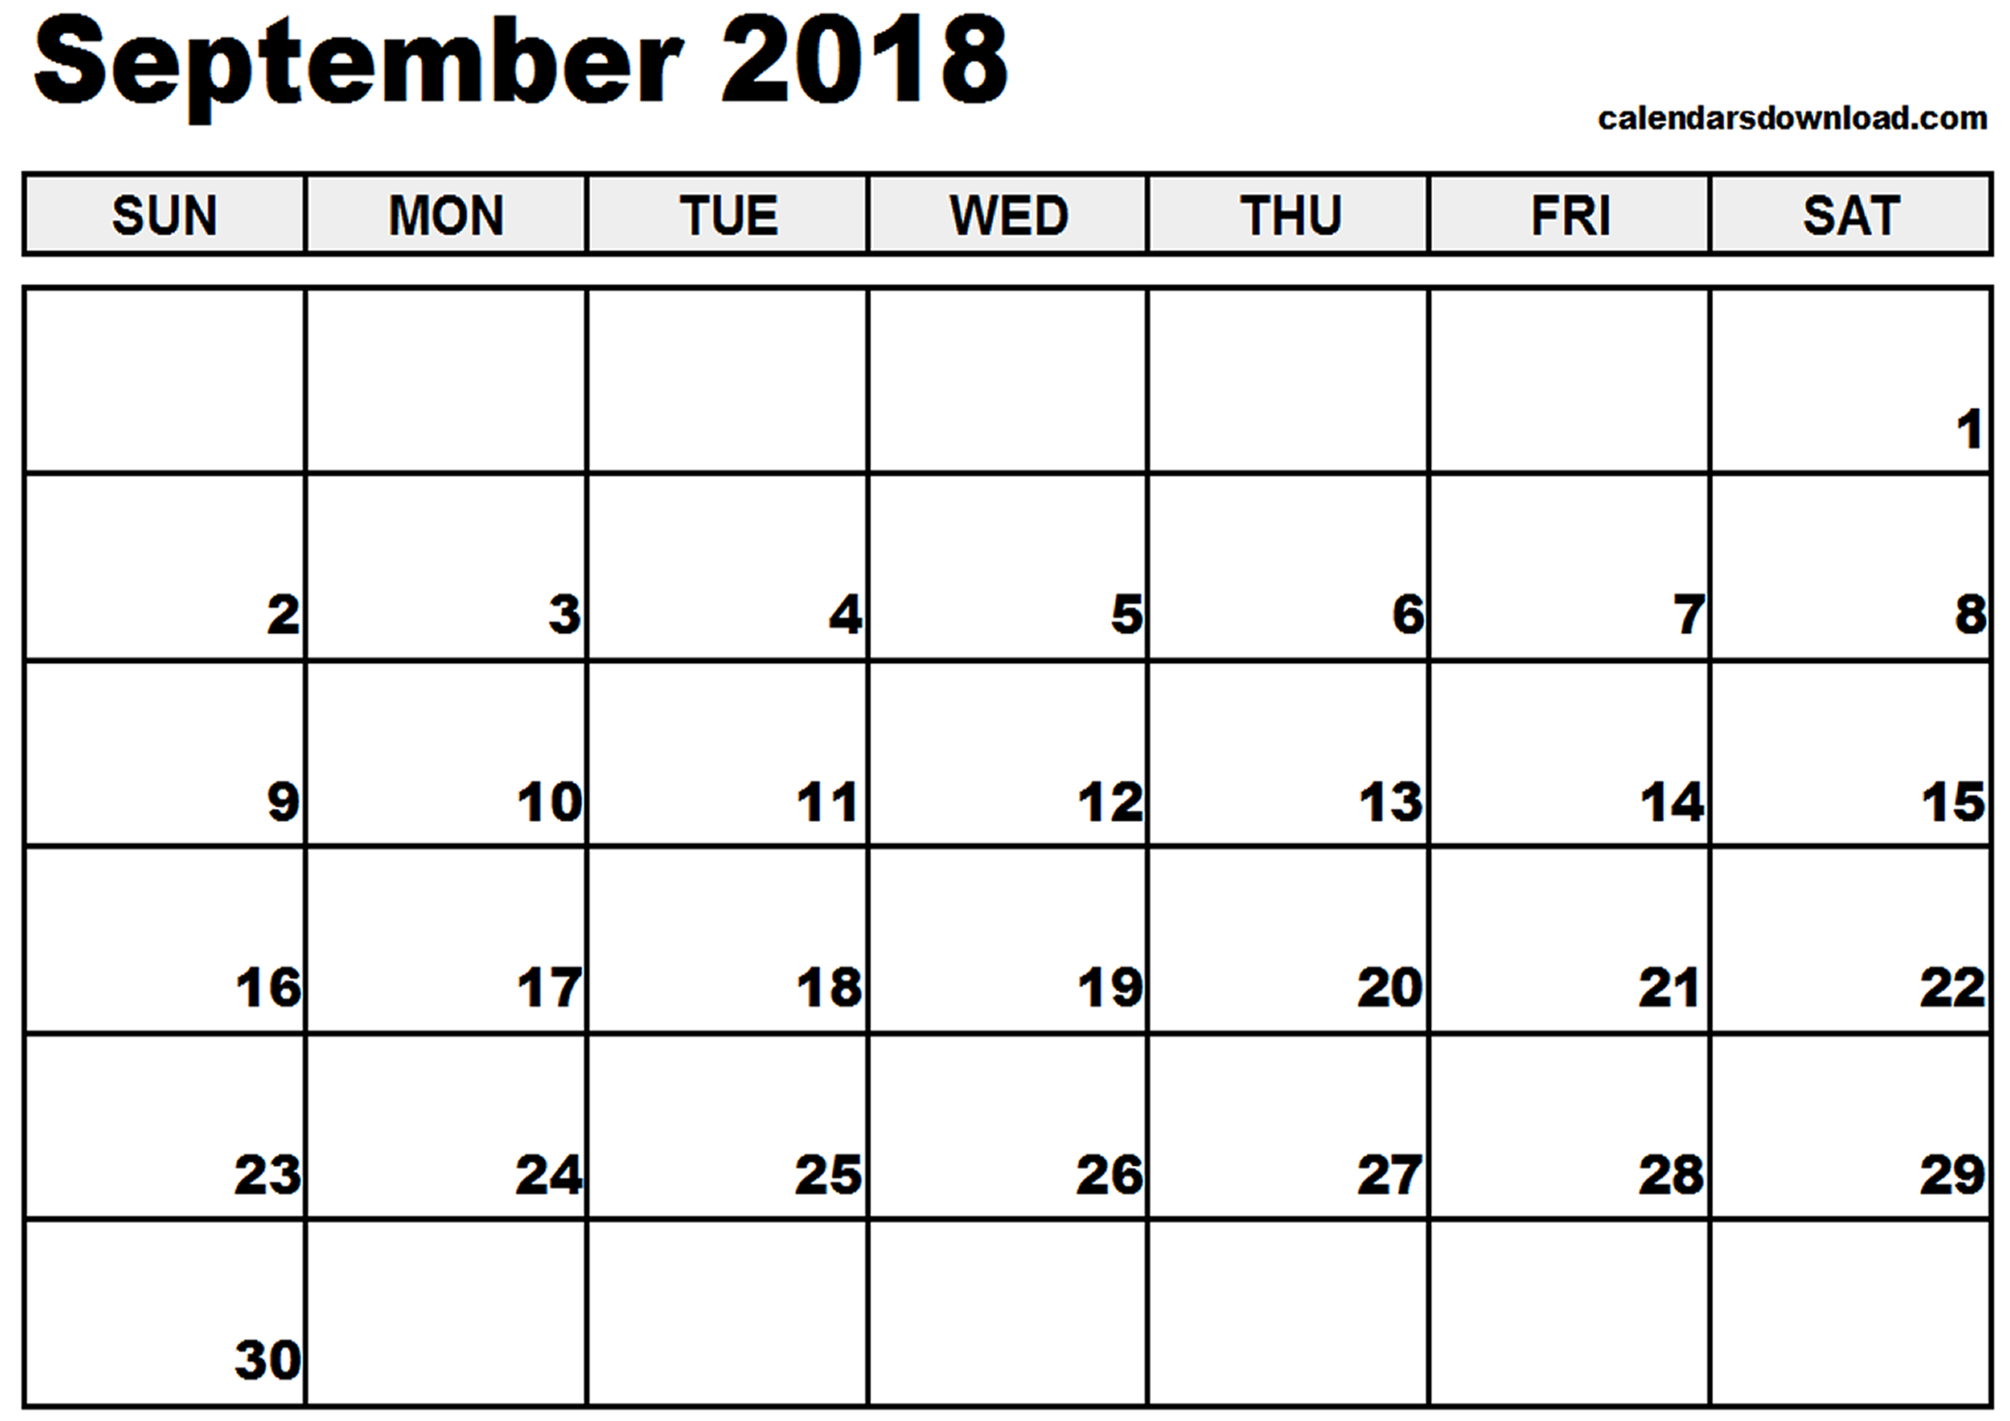
- In all scenarios, Adverse Action is September 17, 2018.

Scenario 1: Mary is a household of one and is open for FS only. Mary reports on 9/14/18 that her job at Dog Zone ended 9/11/18 and she expects to receive her final check 9/21/18. Mary does not expect to have any income (earned or unearned) in the month of October.
- Would you need to run this case with a date?
  - Why or Why not?
  - If you do run with a date, what month(s) would you use?
Scenario 2: Yasmine is a household of one and is open for MAGP only. On 9/18/18 she reports that she has given birth to her daughter Jessela.
- Would you need to run this case with a date?
  - Why or Why not?
  - If you do run with a date, what month(s) would you use?
Scenario 3: Latasha is currently open for FoodShare. Latasha’s household consists of herself, her husband Jon and their son Marcus. On 9/19/18 Latasha calls to report that Jon’s unemployment benefits (UIB) ended 9/2/18 which has caused a drastic decrease in the household income. You have verified the final UIB check was received 9/2/18 as Jon has exhausted his benefits.
- Would you need to run this case with a date?
  - Why or Why not?
  - If you do run with a date, what month(s) would you use?
  - Which program(s) would you confirm?
Scenario 4: Sam is a household of one and is receiving FoodShare and MAGS. On 9/19/18 Sam calls to report that he has begun a full time job at McDonald’s. He will be paid bi-weekly and will be working 40 hours per week at $10.00 per hour. This income will put Sam over the income limits for MAGS and will reduce his monthly FS to $15 each month.
- Would you need to run this case with a date?
  - Why or Why not?
  - If you do run with a date, what month(s) would you use?

