Operations Memo 22-20
Clarification of Residential Care Apartment Complexes FoodShare Policy
Presented by: Melissa Dybas
Release/Effective Date: Immediately
Policy:
Effective immediately, RCACs are not considered to be one of the group-living arrangement types. A Residential Care Apartment Complex (RCAC) is a place where five or more adults reside that consists of independent apartments, each of which has an individual lockable entrance and exit, a kitchen, including a stove or microwave, an individual bathroom, sleeping, and living areas.
Residents of RCAC’s that offer a separate meal plan outside of the cost of their care can be considered non-financially eligible for FoodShare.
Residents of RCAC’s that don’t have meal services separate from the cost of care may be eligible if the resident is not considered a resident of an institution. A resident of an institution is anyone who receives more than 50% of their daily meals as part of the institution's normal operations. Residents would be eligible for FoodShare if they choose a meal plan provided by the facility that provides less than 50% of their daily meals.
Every tenant gets a service agreement that lists the services they are receiving, including meals and their fees. The meal fees should be listed separately and clearly identified. This will not be the same as a lease, by listing each tenant individually.
PLEASE NOTE: The name and address of the facility on the service agreement can also be used to verify that the residence is an RCAC by checking against DHS' Residential Care Apartment Complex Directory. Consumer Guide: Finding and Choosing a Residential Care Apartment Complex | Wisconsin Department of Health Services
The meal situation must be provided for RCAC’s that request FoodShare. Verification would be required if it was unclear or questionable. Failure to provide verification when requested would cause a denial/closure of FoodShare benefits.
The following are helpful examples from the Ops Memo:
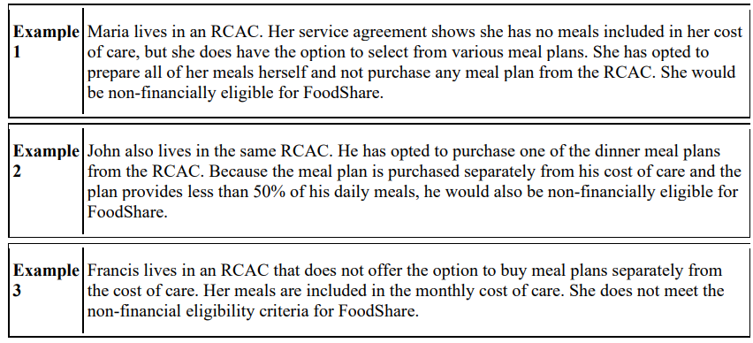
Operations Memo 22-22
Date of Death Verification Through State Vital Records
Presented by: Kathy King
Release Date: October 14, 2022 / Effective Date: October 29, 2022
Effective October 29, 2022, a real-time data exchange with the Wisconsin Vital Records Office will be implemented to identify DOD information for applicants and members. DOD information from Vital Records is identified through either:
• A definitive match where the Social Security number (SSN) and other demographic information are the same.
• A potential match where the SSN is the same, but the other demographic information is different.
When DOD information received from Vital Records directly matches an applicant’s or member’s SSN and other demographic information, it is considered verified, and a notice of decision is sent to the household.
When DOD information received from Vital Records does not directly match an applicant’s or member’s SSN and other demographic information, another source, such as information from the household or other data exchange information, must be used before the DOD is considered verified.
If the SSA data exchange returns a DOD but Vital Records does not, the 10-day refutation period will continue to be initiated for FoodShare, BadgerCare Plus, Medicaid, and Caretaker Supplement as described in Operations Memo 18-15 Changes to Date of Death Procedures.
Vital Records Data Exchange

This training is now available in the Cornerstone DHS Learning Center.
You can access this course by selecting the Search feature under the Learning tab.

