Process Help Release 22-03
Release Date June 25, 2022

3.15 Temporary absence for Health Care and/or FoodShare
- If the primary person is open for health care or FoodShare and responds that they are not currently living in Wisconsin but are temporarily absent, on the Current Demographics page, update the Currently Living in WI answer to N on the Current Demographics page and the verification to code to NQ and update the responses to the questions “Is a temporarily absent WI resident for HC” and “Is a temporarily absent WI resident for FS” to Y. CARES requires the worker to update the responses dynamically based on the open programs. For example, if only HC is open the FoodShare response is disabled.

3.16.1 Returned Mail with a Forwarding Address
- If the agency receives returned mail that provides a forwarding address located outside of Wisconsin, workers must do the following:
- Attempt to contact the primary person to determine if they no longer reside in Wisconsin or if they are temporarily absent for health care or FoodShare. If the worker is unable to contact the member follow the next steps
- Enter the forwarding address as the alternate mailing address in the Mailing Address section on the General Case Information page. If Child Care is open, enter a ? in the Address Verification field on the Case Information page
- If health care is open, on the Current Demographics page, update the Currently Living in WI verification field to Q? to pend health care (Child Care pends if open).
- If the primary person responds and reports they are a resident of another state and not temporarily absent for health care or FoodShare, on the Current Demographics page update the Currently Living in WI field to No and “Is a temporarily absent WI resident for HC” and “Is a temporarily absent WI resident for FS” to N for the programs that are open. If Child Care is open, update the Address Verification field to NQ on the General Case Information Page.

71.6 Out-of-State FS Benefits
- The Out-of-State FS Benefits page allows workers to add information about a FoodShare member's out-of-state TLBs and additional month benefits to their current Wisconsin FS Clock. It is scheduled when the "Has any individual ages 18 to 49 received SNAP benefits from another state from January 2022 to the present?" question is answered Yes on the FoodShare Gatepost page.
- To add information for an individual, the worker will:
1. Choose the household member from the individual dropdown and select Go.
2. Complete the State Information questions, including where the individual received SNAP benefits, and if that state reported the individual receiving TLBs.
- To request verification, select ?/Q? and run eligibility to send a verification checklist.
- If the information is not verified, select NV/QV.
- If the information is verified, select Verified.
3. If the member received benefits from more than one state, select Add Another State.
4. The clock information and benefit months display based on the information entered. Workers can update the system status for each month as required.
- Time Limited Benefit
- Met Work Requirement
- Additional Month 5. Repeat for all applicable individuals in the household. This updates the member's TLB information on the FS Clock page.
4.1.9 Early Renewals for Child Care
- When the worker attempts to initiate an early Child Care renewal prior to Adverse Action of the 11th month, a yellow banner is displayed, which includes what the worker must read to the parent to inform them of the potential impact the early renewal may have on their Wisconsin Shares Child Care subsidy amount. Parents also see a similar message in ACCESS when initiating an early renewal following the second Saturday but prior to Adverse Action of the 11th month.
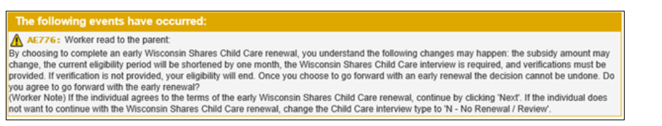
- If the parent does not want to complete the early Child Care renewal, the worker must explain to the parent the other options that they have for completing the renewal:
- The parent must call back to the agency after the Adverse Action date to complete their timely Child Care renewal and interview.
  - The parent can wait to contact the agency after the Adverse Action date to complete the Child Care interview, at which point the Child Care renewal will also be timely rather than early.
  - The worker can schedule a date and time after the Adverse Action date to call the parent to complete the Child Care interview.
  - The worker can tell the parent the date after Adverse Action so the parent can resubmit the Child Care renewal through ACCESS Renew My Benefits. Note: If the early renewal is completed, which includes the interview and all verification, prior to Adverse Action of the 11th month prior to the renewal month; this will shorten the current Child Care certification period to 11 months. This could result in the Assistance Group (AG) moving to a different copayment period earlier than 12 months. The new certification period would begin the month after the Child Care program eligibility is confirmed, and the next renewal date would be set for 12 months from the early renewal month. If the early renewal is initiated prior to Adverse Action of the 11th month of the 12- month Child Care eligibility but the interview and all verification is not submitted until after Adverse Action of the 11th month, then the Child Care renewal will be considered timely rather than early. The parent will not lose one month of eligibility

EVFE
- Added new sub-section on FEIN information mismatch and updated language. The EVF and EVF forms have been updated in how the employer is asked to answer hours worked by the employee.

