**Operations Memo 23-03**

**Updates to BadgerCare Plus Annual Income Eligibility Determination Policy**

Presented by: Melissa Dybas

**Effective Date: February 25, 2023**

This Ops Memo announces changes to the “gap filling” process, that it will become automated instead of manually determined.

The process of determining expected annual income eligibility for Badgercare will be determined systematically for parents, caretakers, and childless adults whose income is over the monthly income limit. The eligibility will be a 12-month rolling certification period instead of ending on December 31st. The rolling certification period can start in any month of the year. Members can keep their certification period even if their eligibility determination goes from monthly to annual income when they report changes.

*Example:*

*Keisha applies for health care on June 15, 2023, as a household of one. She has earned income of $300 per month from a part-time job. She is determined eligible for BadgerCare Plus starting June 1, 2023. Her renewal date is May 31, 2024. On October 3, she reports that she had an increase in hours at her job and she is now earning $1,200 per month. She is over the monthly BadgerCare Plus income limit for a group size of one, but she is still under the annual income limit. Keisha continues to be eligible for BadgerCare Plus under gap filling rules. Her renewal date continues to be May 31, 2024.*

Members open under gap filling rules are no longer required to reapply to have their eligibility determined. Instead, they can complete a renewal like other Badgercare programs.

Because 12-month certification periods often extend over two calendar years, DHS will collect expected annual income at the beginning of the new year, starting in January 2024. Members whose eligibility was established under gap filling rules must respond to the Expected Annual Income Letter:

* If the member’s expected annual income continues to be at or under the annual income limit, BadgerCare Plus will continue.
* If the member’s expected annual income is above the annual income limit, BadgerCare Plus will be terminated following adverse action rules (assuming they are not eligible for BadgerCare Plus under monthly income rules or any other category of BadgerCare Plus or Medicaid).
* If the member does not respond, BadgerCare Plus will be terminated following adverse action rules due to failure to provide information.

Since documentation of future annual income may be difficult to obtain, verification of expected annual income is not required. However, workers must validate the reported income using all available information. Members with cases open under gap filling rules are required to report if their annual income goes above 100% of the FPL.

**Operations Memo 23-04**

**Change in the Verification Due Date for BadgerCare Plus, FoodShare, Medicaid and**

**Caretaker Supplement**

Presented by: Kathy King

**Release Date: February 10, 2023/Effective Date: February 25, 2023**

Policy:

This Operations Memo provides a change to the verification due date set to at least 10 days from the date when the verification checklist (VCL) is mailed to the household for ongoing cases.

Effective February 25, 2023, applicants and members will have at least 20 days to provide verification

when it is required to determine eligibility for FoodShare, health care, and CTS. If the 20th day falls on a

weekend or holiday, the due date will be set to the next business day. These changes only apply to

FoodShare, health care, and CTS.

For FoodShare cases, in instances when a complete SMRF is submitted at the end of month 7 and verification is required, the verification must be provided by the end of month 7 even if that gives the

member less than 20 days to provide verification. If the member does not provide verification by the end of month 7, a new application must be submitted. When a complete renewal is submitted at the end of month 13 and verification is required, the verification must be provided by the end of month 13.

**Note:** There is no change to FoodShare interview timelines or the 30-day application processing time

frame.

See **Ops Memo 23-J1** for the Summary of Tax Year 2022 Maximum Tax Credits with Income Eligibility Limits. Reminder that these tax credits are disregarded for W2, CC assistance, BC+, Medicaid and FS.

**CARES Bulletin - Special COVID Unwinding Edition**

Presented by: Kathy King

**Renewal Redistribution/Health Care Continuous Eligibility**

Healthcare members open on or after March 18, 2020, through March 31, 2023, will maintain continuous eligibility until a renewal occurs. Renewals will be redistributed over 12 months. The updates to CWW are occurring the weekend of February 18, 2023.

How it works:

Health care renewals will be redistributed from June 2023 through May 2024. Renewal dates for all health care assistance groups will be aligned on a case. For cases with combined health care, FoodShare or Child Care, the health care renewal date will be aligned with the FoodShare or Child Care renewal date, when possible, to reduce the renewal burden and mitigate an early renewal request for health care.

There are two exceptions to this distribution approach:

* Extensions (MAGM and MAGE) will not have renewals assigned to June or July 2023.
* To address a PERM error, most cases with CHIP children who are over 18 years old and other health care assistance groups open on the case will have renewals assigned to June or July 2023. Process these renewals as usual. If the renewal is processed and the CHIP child, over 18 years old, is no longer eligible, they will receive a notice that they must re apply on their own.

With renewal redistribution, the diary date for disability redeterminations will be updated to correspond with the member’s next renewal date (after renewal redistribution). Diary dates will not be updated when that date is greater than the renewal date (post redistribution).

To assist in processing future renewals, cases stuck in renewal/review mode will be updated to ongoing mode as long as:

* No unprocessed ACCESS submissions are linked to the case (AFB, RMC, RMB, AAP)
* All pages in the driver flow are completed (except confirmation)

**Note:** Work items will not be updated when the case mode is updated.

The new Health Care Continuous Eligibility Tracking page in CWW tracks the Continuous Eligibility Begin Date (CEBD) and the Continuous Eligibility End Date (CEED) which are important to ensure COVID temporary policies are correctly applied and to prevent negative actions prior to the member’s renewal. This page is accessed from the Post Eligibility section of the Navigation menu.

On February 18, 2023, Health Care Continuous Eligibility Tracking pages were created for all health care cases with at least one household member enrolled on or after 3/1/2020.

* The CEBD for these health care cases will be 3/1/2020.
* The CEED for these health care cases will be the redistributed (new) renewal date for the case.

Health care cases opened between February 20, 2023, and March 31, 2023, will have Health Care Continuous Eligibility Tracking pages created with the effective date of their continuous eligibility. For example, a case confirmed eligible for health care on March 2, 2023, with eligibility effective February 1, 2023, will have a new Health Care Continuous Eligibility Tracking page with the CEBD of February 1, 2023. Workers will not have to complete any different processing to ensure continuous coverage.

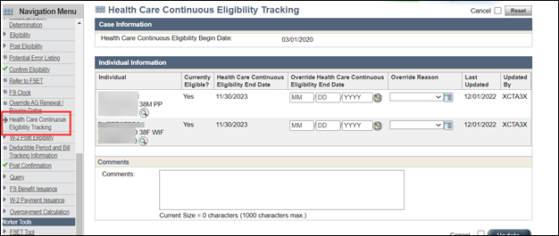

If a member wants to voluntarily complete an early renewal, workers should encourage members to wait until they receive their renewal packet about 45 days before it is due.  Members who renew earlier than their scheduled renewal month could lose coverage sooner than they would if they wait until their scheduled renewal date. If a member wants to complete an early renewal, they must be informed that their eligibility may be impacted by the early renewal. If a member chooses to do an early renewal, the worker must add a case comment.

If an early renewal results in a closure or reduction in benefits, the member cannot change their mind.

If workers process health care renewals on or after 2/18/2023, and the member is no longer eligible, health care ends and the CEED is updated. The negative health care action banners on the Confirm Eligibility page will no longer display.

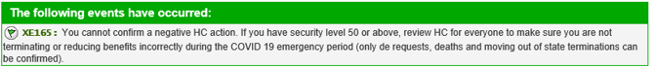

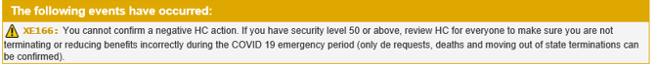

The CWW Case Summary page will be enhanced with an indicator labeled “Health Care COVID Policy Case” to help workers identify continuously eligible cases. This indicator will not be displayed for cases with a health care filing date on or after April 1, 2023.

