Alerts
Alert Information:
- Alerts are generated to inform you that you may need to take action on a case. Some alerts are informational only while others indicate that action is required.
- Alerts should be accessed daily and used as a tool to manage your case load.
- By working your alerts on a regular basis, you will increase the accuracy of the benefits that you issue.
- To access alerts, use the CARES mainframe, they are not available from within CWW. Some alerts will be displayed as Action Items in CWW.
Accessing System Alert in HOD:
- To find the alerts menu:
  - NEXT TRAN- MNSA
  - PARMS- Leave blank
  - Press ENTER
- To find all system alerts for a worker/Team:
  - DESIRED FUNCTION- 01
  - USER ID- X--###
  - Press ENTER
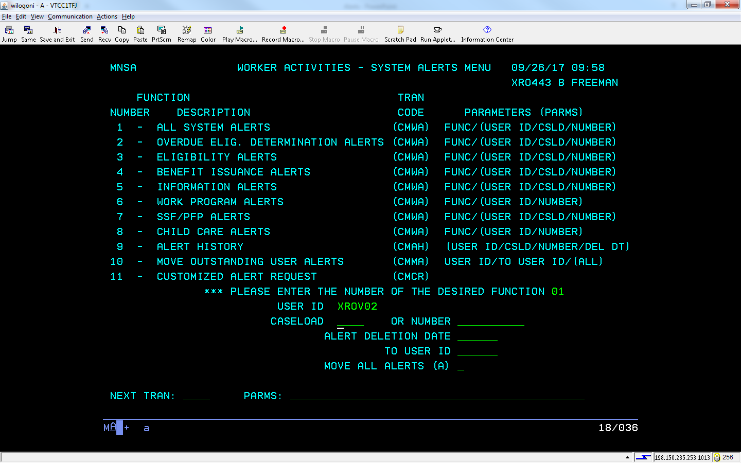
Anatomy of an Alert:
- NUMBER- Case number or PIN
- SHORT NAME- Last name if individual or case head
- ALRT CODE- Alert code/number
- ALERT MESSAGE- Alert text
- DATE DUE- Date the alert should be processed by
- PRY- Priority of the alert (1-Critical, 2-Very Important, 3-Important, 4-Least priority, 5-Informational)
- Use F7 to page back and F8 to page forward. You may also use the scroll function on your computer mouse to move through the alert pages.

Alert Help Text:
- For alert help text (when available) in CWW:
  - On the Navigation Menu under Worker Tools, select Reference Tools and then Alert Code Help Text Search.
  - Enter the alert code and select Search
  - If available, the alert text will appear for the alert in question. This will provide you with:
    - Program that generated the alert
    - Why the alert was generated
    - Worker action required
Deleting an Alert:
- Once action has been taken on an alert it must be deleted.
- You have two options for deleting an alert:
  - In HOD- enter an asterisk in the SEL field and hit ENTER. This will delete the alert from both HOD and the case in CWW.
  - In CWW- the alert shows under ACTION ITEMS. Check the box and select CLEAR CHECKED ACTION ITEM(S) to delete the alert in CWW and HOD

How to Narrow by Team and Alert Code:
- To get to the Customized Alert Screen:
  - NEXT TRAN- CMCR
  - PARMS- Leave blank
  - Enter
- To search by team and 1-3 alert codes at a time:
  - USER ID- XROV##
  - ALERT CODE- Enter 1-3 alert codes.
  - Enter
Check Alert History for Deleted Alerts:
- While on the SYSTEM ALERTS MENU (MNSA)
  - DESIRED FUNCTION- 09
  - USER ID- X---###
  - Enter
- A list of deleted alerts will show by case number.

