BRITS Desk Aid

What is BRITS?
- Benefits Recovery Investigation Tracking System
Accessing BRITS
- BRITS can be accessed from two places:
- The Case Summary page of the case you would like to refer by selecting the blue hyper link.
2. From the Gateway page by selecting the BRITS icon.
- You will then be prompted to login using your CWW user ID and Password.
- Once logged in, you will find the Create Referral page
- From the Create Referral page you will be able to enter Overpayment Referrals/Claims and Front End Verification Investigations (FEVS).
Entering an Overpayment Claim
- Once you have determined that an overpayment of benefits has occurred, you will enter a Claim Investigation referral into BRITS. To do this, you must follow these steps:
1
Select the appropriate office number in the Program Gatekeeper Office section.
Enter the Case Number in the appropriate field. This will populate the primary person’s name, case office, county of residence and case worker.
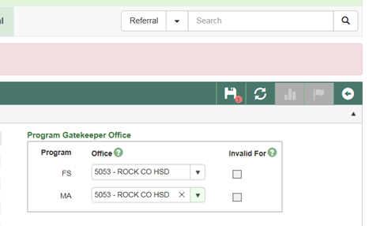
2
Update the following:
- Referral Type: Claim Investigation
- Referral Source: How was the overpayment found (SWICA, Discrep, etc.).
- From Date: First day of the overpayment timeframe.
- To Date: The last day of the overpayment timeframe or leave blank if this date has not yet arrived.
- Investigation Reasons: Select reasons for the overpayment.
3
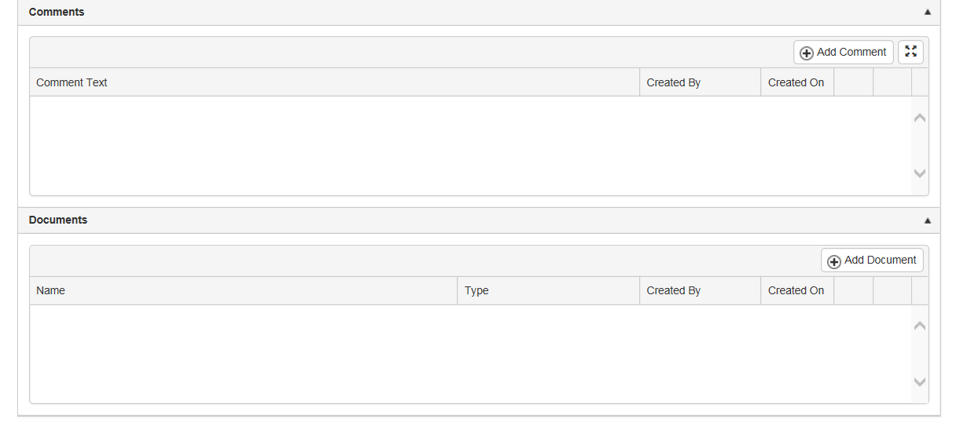
4
Select ADD COMMENT to open the Add/Edit Comment box to the left.
Enter a detailed comment as to how the overpayment occurred, how it was discovered, how it was verified, the time frame & programs effected and the date of discovery.
Select UPDATE when complete.
You may also add supporting documents using the ADD DOCUMENTS button just below the comments section. .
When you have completed steps 1-4, save your entries by selecting the SAVE icon. This will generate the BRITS referral tracking number.
The BRITS referral tracking number should be entered into the CWW case comments.
5
Entering a Front End Verification Investigation (FEV)
- IF you find client information questionable and believe that the case warrants a visit from our investigative firm, you should enter a Front End Verification referral. To do this, you must follow these steps:
1
Select the appropriate office number in the Program Gatekeeper Office section.
Enter the Case Number in the appropriate field. This will populate the primary person’s name, case office, county of residence and case worker.
Update the following:
- Referral Type: Front End Verification
- Referral Source: How was the overpayment found (SWICA, Discrep, Child Support, Client Reported Questionable, etc.).
- Investigation Reasons: Select reasons for the overpayment.
2

3
4
Select ADD COMMENT to open the Add/Edit Comment box to the left.
Enter a detailed comment as to why the investigation is necessary as well as what information you would like verified.
Select UPDATE when complete.
You may also add supporting documents using the ADD DOCUMENTS button just below the comments section.
When you have completed steps 1-4, save your entries by selecting the SAVE icon. This will generate the BRITS referral tracking number.
The BRITS referral tracking number should be entered into the CWW case comments.
5

