Entering Overpayment Referrals into BRITS—Desk Aid

- Entering an overpayment referral into BRITS is called creating a “Claim Investigation”. The entries are similar to those used to create a FEV or Fraud Investigation referral.

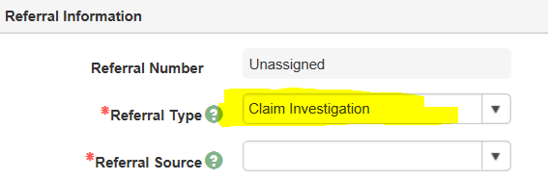

- Do not create a referral as Agency Error unless you have checked policy and spoken to your supervisor and are positive it’s agency error and not a client error. We do not have security clearance to void agency error claims created by mistake. They have to be sent to the BRITS helpdesk to be voided out.
  - Reminder: Per FS policy 7.3.23., we do not do overpayments on closed FS cases unless the overpayment amount is $125 or more.
  - Remember to check for GAP Filling before entering a BC+ overpayment claim.
  - When doing a SWICA, if the customer would still have been eligible for BC+ but with a premium, that means there is an overpayment.

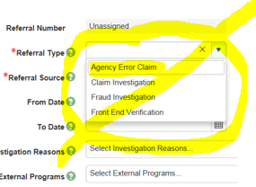

- To enter an old date as the overpayment timeframe, follow the pictures below. Click on the hi-lighted areas to move through months/years/days.
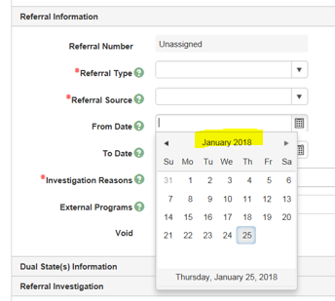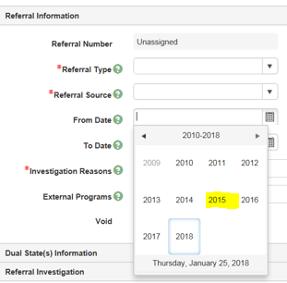

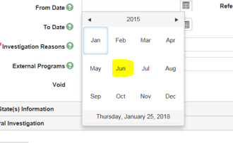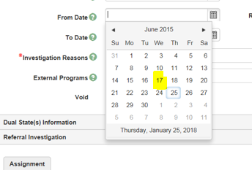

- Enter a comment about the overpayment and reference the date you entered the case comments in CWW. You must enter the date of discovery, the programs that have an overpayment, and the overpayment timeframe.
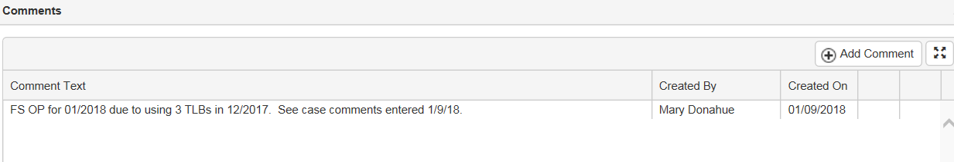

- If there is already an open claim investigation for the case, perhaps for a SWICA from an earlier timeframe, you will get an error message (see screenshot below). If this happens, you can still enter comments on the existing BRITS referral (you can find this number by searching under the case number in BRITS). If it is for the same error reason, like SWICA, just add the additional timeframe that an overpayment is needed for.

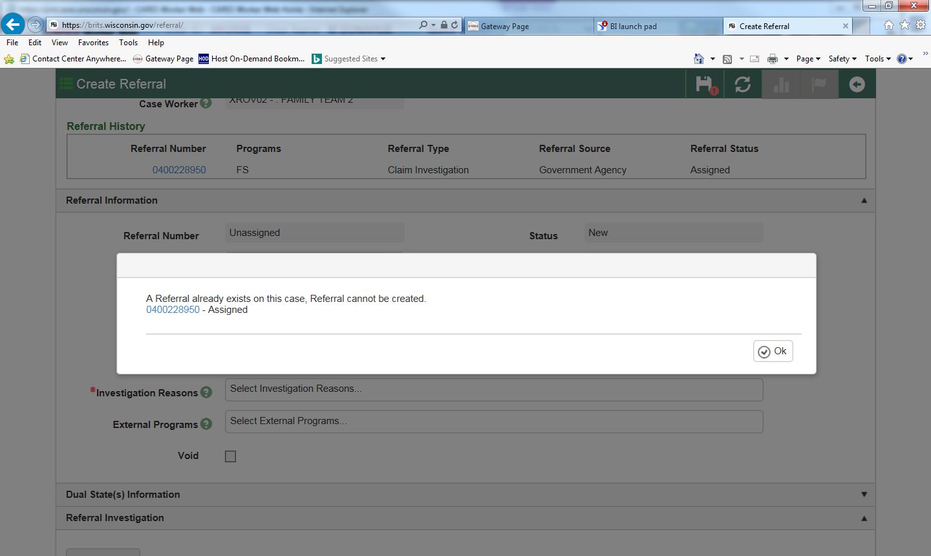

- If you are creating a claim based on the out of state FS usage report, you need to open up the Dual State(s) section to enter the other state(s) from the drop down menu.

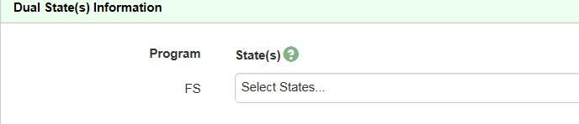
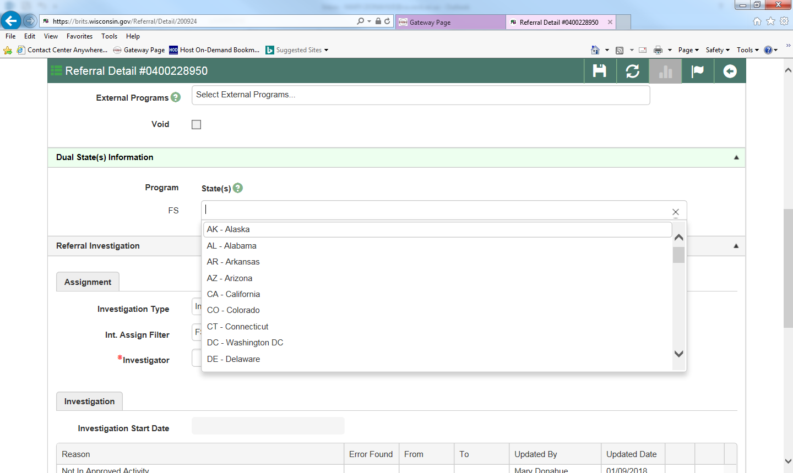

- If you need to create a FEV referral and the overpayment claim has not been done yet, you cannot enter any new referrals in BRITS. For Rock County: If this happens, send an email to the overpayment specialist at overpaymentreferrals@co.rock.wi.us with the subject line “Priority OP” and marked as high priority. The overpayment will be processed so the FEV can be entered.

- Using FDSH wages and SWICA wage matches to calculate overpayments
  - The FDSH information can only be used as verification of current income for FS if completing a health care application or renewal and the member agrees with the current income shown (OM 14-50 and 15-16). The FDSH information cannot be used for calculating FS overpayments. If there is no other verification source available for the FS overpayment, the SWICA wages can be used for the FS overpayment (OM 15-11). However, most employers who use Equifax (the Work Number) will only verify income through Equifax, so agencies may need to request the verification directly though Equifax (not FDSH). (Ref. WAPAF Calculating FS Overpayments Questions and Answers 4/18/16)

- For Rock County: For State QC or IMQA overpayments, continue to send an email to overpaymentreferrals@co.rock.wi.us with the subject line “Priority OP” and marked as high priority. Include the BRITS number in the body of the email.

- Scan any related documents for the overpayment into ECF. If you feel comfortable uploading them to BRITS you may do so. Documents uploaded to BRITS automatically show up in ECF.

- Confidential cases in CWW are also confidential in BRITS. You must make the case not confidential in CWW in order to enter, and work on, a BRITS referral. Once the referral is entered, you must change the case back to confidential in CWW.

- The cost avoidance form will still be used. The Gatekeeper in each County needs it completed to enter the post investigation information into BRITS.

01/25/18 MD

