Basic Training:
General rules for Counting Support
- Child Support (CS) is always counted under the child(ren) for whom it is ordered
- Child Support income follows the child to all cases they appear on. If a child is residing with both parents in a shared placement, and each parent has a case, the child’s child support income counts on both cases.
- If the custodial parent and non-custodial parent reside together with the child, we disregard the income and the expense. You would still build the income and expense pages, but you would budget zero and make a screen level comment explaining why.
- Child support arrears paid through the child support agency on behalf of an adult child are counted as income to the individual it is sent or paid to. If the payment is sent directly to the parent, it is the parent’s income. If the payment is sent directly to the adult child from the child support agency, it is the adult child’s counted income.
- Current and arrears CS income is counted- if received by the assistance group
- CS Income/expenses are not included in the budget for MAGI cases but are included in the budget for EBD MA cases. Please see MEH 15.4.14 Child Support and MEH 15.7.2.1 Support Payments for more information.
- Use the following codes when entering Child Support income (PH 62.2.6)
  - CSCC-Child Support Current
  - CSFC- Family Support
  - CSMC-Maintenance
*** Any other codes that appear in the drop-down list in CWW are obsolete.
Budgeting Support Income
- Check the CWW CS Query first. Do NOT go into KIDS unless referred by a CWW query banner to do so, or if the parent disagrees with the CWW query amount, or if you see an anomaly and need to research the amounts.
  - If the CWW CS query provides an average, enter it on the appropriate child’s page. Include the months that are in the average in your screen level comment. The CWW CS Query date range is the past three months.
  - If the CWW Child Support Query gives you a notice banner at the top, act on what it is telling you. Most likely it will direct you to KIDS for either the Current Support amount or the ARREARS amount. You must include in your case comment that you were directed to go to KIDS by this banner.
  - Sometimes the CWW Child Support Query banner tells us to go to KIDS for the ARREARS Amount and the page provides us with a Current Support (CSUP) average. We would use the CWW provided CSUP average and go to KIDS to determine if there is any Arrears (CUSTA) that should be budgeted.
- If we do not use the average that is provided by CWW we need to document clearly in case comments why it was not used. This would be very rare.
- If the payment is made for more than one child:
  - Divide the amount by the number of children it’s intended for.
  - Build Unearned income page for the amount of child support for each child including in the order.
  - If the custodial parent is included in the ordered amounts, enter the portion intended for them.
- In KIDS- The default date range is the last two months-you will need to enter the correct date to use for the average:
  - Example: Our application date is 11/4/2021. We would look back at August, September, and October child support payments. We would enter 08/01/2021 in the “Date From” field.
- KIDS paths used to determine Child Support average
  - The first step in KIDS is to see if the custodial parent is receiving any Child Support payments. Use fast path 02, 05, 16 to total up the payments received. Please note: There maybe multiple court case numbers.
  - After reviewing totals from 02, 05, 16, we need to find out what type of payments they are (is it CSUP? CUSTA? A combination of both?). To find this out we use fast path 02, 05, 06. Once you have determined the type of Child Support received and the countable portions, use the KIDS Child Support/Arrears Budgeting Aid to help you determine the monthly average. **Note: We do not total the amounts on 02, 05, 06 to determine the countable income. This page is used solely to determine what parts of the payments listed on 02/05/16 are countable, as there maybe amounts that would not be budgeted listed.

Budgeting Support Expense
- Child Support Expenses: Allow only court ordered expenses
- Build a separate child support expense page for each order.
Deduction Type | FoodShare 4.6.5 | Medicaid (EBD only not BCP) 15.7.2.1.1
CSUP (Court ordered obligated amount for current support) | YES | YES
CUSTA, CUSTAI, AFDCA, AFDCAI, CPPSA, FCARA, FCARAI, WWPSA (Arrears support) | YES | NO
Non-Court Ordered Payments | NO | NO  **Exception: Non-court ordered support payments are included only if they are paid to an institutionalized spouse or a minor child who is living with a non-legally responsible relative (NLRR)
USGNA and ASGNA (Lying in Costs) | NO | YES (see MEH 15.7.2.1.1)
CBT (Court Costs for Blood Test) | YES | NO
FRD, CPS and CVS (Annual receipt and disbursement expenses) | NO | NO
**CS Expense is NOT allowable for MAGI cases YES= Allowable for program NO=Not allowable for program

KIDS Logon Directions
- Open Host on Demand (HOD) as you normally would.
  - In the ENTER SELECTION field- type in CICSP330 and hit enter.
  - Enter your User ID (XRO###) and mainframe password, hit enter. (Groupid is left blank)
  - You will see a black screen with white text displaying your last access to the system. Type: “KASE” and hit enter.
  - The screen will then prompt you to hit PF11 (F11 key on the top of your keyboard).
  - You are now at the KIDS main menu.
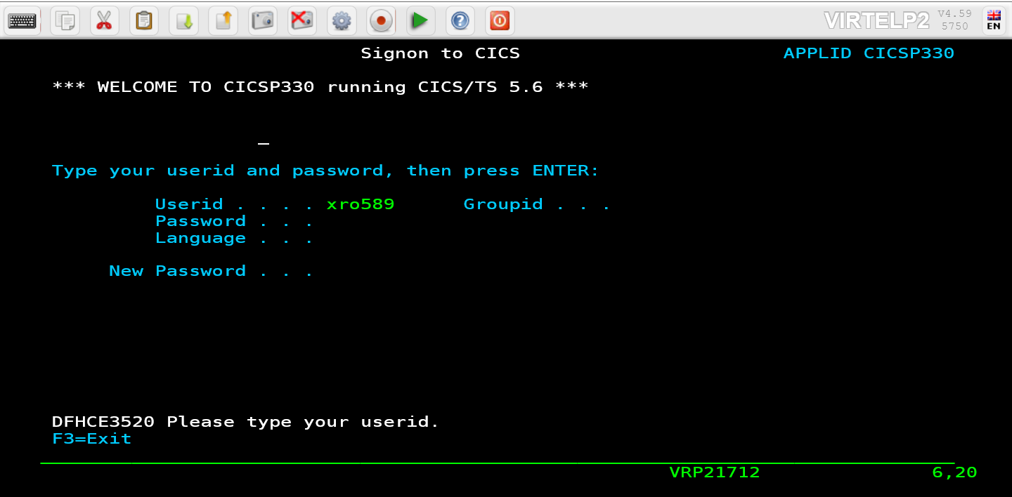
KIDS Fast Paths
- 02,05,16 Disbursement Summary
  - The screen below shows the disbursement only data by participant and case number. It shows payments made to a participant by court case number. We total amounts on this summary to budget as income.
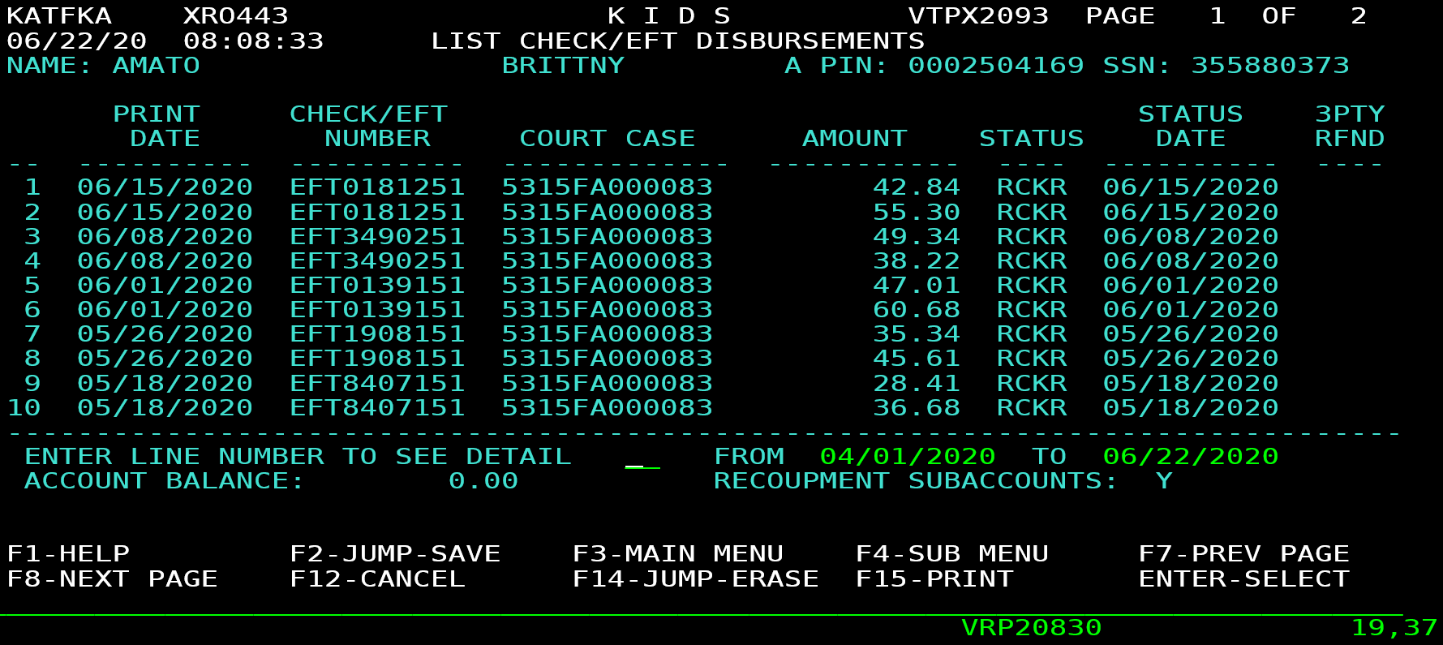

- 02,05,06 Case Account Statement
  - The screen below shows the breakdown of whether the payment is current support, arrears, a fee, etc. You can also use it to view and to quickly navigate to other pages to see the current court order, the debts and the current debt balances for a case account.
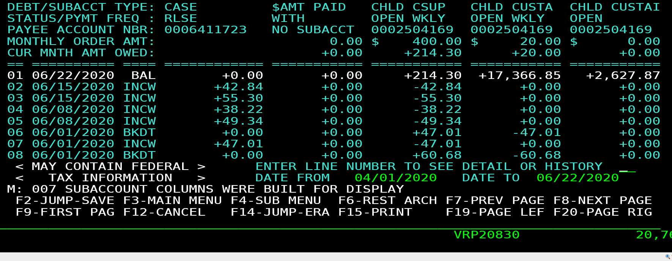
- 02,01 Participant Data Submenu (search using name or SSN)
  - 02,01,01- Provides parent name, SSN, DOB, etc.
  - 02,01,04- Provides parent address and phone.
  - 02,01,08- Provides parent income source.
  - 02,01,24- Provides a list of non-cooperation sanctions by KIDS case number.

- 02,02 Case Information Submenu
  - 02,02,03- Provides a list of Good Cause Claims
  - 02,02,04- Provides comments of CS works by KIDS case number.
  - 02,02,07- Provides a list of all KIDS case numbers associated with a participant.

- 02,05,05 Participant Account Statement (rarely used)
  - This screen shows all of the money passed through a participants account. The money listed has either
been paid or received by the participant depending on their role in the case.

CWW and Budgeting
- If CWW provides a 3-month average and
  - The monthly amounts are comparable with each other
    - Then budget that average and enter case and screen level comments.
  - The monthly amounts are not comparable with each other (Example: Aug $56, Sept $238, Oct $245)
    - Look in KIDS for an explanation of these amounts. You might find that the CS order was changed.
- If CWW provides a CSUP average but presents a banner to go to KIDS for CUSTA average – we will use the CWW provided CSUP average and follow the below steps to determine what to budget for CUSTA.
  - First- check fast path 02,05,16 to get a list of the amounts the CP has received.
  - Second- review fast path 02,05,06 to find out the breakdown of those payments (reminder: you are looking at CUSTA only because that is what the banner directed).
    - Has the CUSTA been received in each of the three months to be used in your average?
      - If YES, then determine an average of the CUSTA and budget it.
      - If NO, query to see if the CUSTA stopped and restarted. Determine if we would use the ordered amount. Usually, we assume CUSTA will continue if it was received in the 2 most recent past months or the most recent past month AND a balance of CUSTA due remains.
- If CWW presents a banner indicating that an average cannot be completed for CSUP and/or CUSTA-This will be discussed in more detail in Advanced CS training:
  - First- check fast path 02,05,16 to get a list of the amounts the CP has received.
  - Second- review fast path 02,05,06 to find out the breakdown of those payments.
    - Start with the first payment to determine:
      - Is it CSUP?
      - Is it CUSTA?
      - Is it a combination of both?
        - If CSUP and CUSTA were paid in each of the 3 months, budget both.
        - If CSUP was paid in each of the 3 months but CUSTA was not, determine if CUSTA should be budgeted (we assume CUSTA will continue if it was received in the 2 most recent past months or the most recent past month AND a balance of CUSTA due remains).

Advanced Training:
Frequency is important:
- Things to evaluate when determining countable Child Support:
  - Is it regular and predictable? Received regularly in a predictable pattern and consistent amounts
- Is it fluctuating?
- Received regularly but the amount is inconsistent.
- Received irregularly but the amount is consistent.
- Is it Irregular and unpredictable?
- Received with no predictable pattern or regularity and having no consistent amount.
  - Example: Arrears payments and Tax Intercepts
      - Tax Intercepts: Per Agent Reminders dated 4/26/18 regarding Tax Intercepts: Clarification was recently received on budgeting CS tax intercept payments. If you are calculating CS income using KIDS and the client has received a tax intercept payment in one of the last 3 months, you only budget the portion of the tax intercept that would be equivalent to the monthly amount owed (or is regularly being paid) to them.
        - If the client should receive a monthly arrearage amount of $50 and they get a tax intercept payment of $500, you only count the $50 when calculating the average income.
Is there an anomaly?
- If there is something inconsistent or irregular with payments, if so, review the months prior to the 3-month range and consider the following:
  - Are they catching up due to minimal payments in a prior month?
    - Example: Month one shows $100, Month 2 shows $0 and month 3 shows $200. When averaged, the total for all three months equals the monthly ordered amount.
- Has there been a change in the order?
    - Example: When you look in KIDS, a new order was established. You can use the court ordered amount if it appears, they are receiving it.
- Is the arrears balance almost paid?
    - Example: You find in KIDS that there is a $25 balance on the arrears. The total ordered arrears payment is $10 weekly and has been consistently being paid. The arrears would not be paid going forward for very long, so we would need to assess if they should be budgeted prospectively.
- Is there a pattern of lump sum payments?
    - Example: The NCP pays one large purge payment every April & October in connection with court proceedings. This has occurred two years in a row. We would average the amount received over the 12-month period of January-December. This would be divided by the number of children in the order and budgeted accordingly.

Child Support Expense and Social Security or Unemployment Compensation
- If child support is deducted from Social Security or Unemployment payments, we still need to count that part of the income as unearned income. To do this you will build an Unearned Income page for Other Income; with the amount of the child support that is being withheld. You will also build a child support expense page to count the child support as a deduction. See FSH 4.3.4.2 #6
How to determine if CUSTA should be budgeted
Note-In all of these examples, the month in which the worker is looking at the CS is November (Average of Aug-Oct).
- CUSTA payments received
August $25
September $10
October $0
*In this instance the CUSTA would not be budgeted since no payments were received in October (the most recent of the past 3 months).
- CUSTA payments received
August $25
September $10
October $20
*In this instance the CUSTA would be budgeted because it was received in all 3 months.
- CUSTA payments received
August $20
September $0
October $25
*In this instance, review KIDS to determine if the CUSTA would be budgeted using the COURT ORDERED amount since payments have restarted.
Determining countable CSUP and CUSTA
- In all of these examples, the month in which the worker is looking at the CS is November (Average of Aug-Oct).
- KIDS shows the below; then average and budget both CSUP and CUSTA
Month | CSUP | CUSTA
August | $243 | $22
September | $198 | $20
October | $225 | $25

- KIDS shows the below, then we would check for a possible pattern, but if no pattern of missing payments and no payment received in the last 30 days, CSUP/CUSTA would be $0.
Month | CSUP | CUSTA
August | $225 | $25
September | $198 | $20
October | $0 | $0
- KIDS shows the below, review KIDS for the ordered amount and budget ordered amount.
Month | CSUP | CUSTA
August | $0 | $0
September | $0 | $0
October | $243 | $0

- KIDS shows the below, review KIDS to determine if a new order/new payment started in August, if so budget only the average of the two months (September and October) as that this what is expected to continue.
Month | CSUP
August | $124
September | $248
October | $248

- KIDS shows the below, review KIDS for a longer period of time, such 6 months.
Month | CSUP
August | $132
September | $0
October | $125

After reviewing the last 6 months in KIDS, you find that the NCP pays every other month, you will then budget CSUP over 6 months. (0+118+0+132+0+125)
Month | CSUP
May | $0
June | $118
July | $0
August | $132
September | $0
October | $125

Manual References:
FoodShare Handbook (FSH) 4.3.4.2 Counted Unearned Income #12 & #13
FoodShare Handbook (FSH) 4.6.5 Child Support Payment Deduction – this section contains multiple examples
FoodShare Handbook (FSH) 4.3.4.2 #6 CS Expense and Social Security or Unemployment Compensation
Medicaid Handbook (MEH) 15.4.14 Child Support (Unearned income)
Medicaid Handbook (MEH) 15.7.2.1 Support Payments (Deductions)

