Vinelink is used to verify prisoner or incarceration status. Vinelink can be found at www.vinelink.com
“CCAP” or Wisconsin Circuit Court Access could be used to find drug felonies or to check for a new address when returned mail is received. CCAP can be found at https://wcca/wicourts.gov/index.xsl
CWW data exchanges for Unemployment, SOLQ (SSI/Social Security), Citizenship/ID and Birth Query can be found in “Worker Tools” in the Navigation Menu under “Data Exchange” and then “Data Exchange Query”
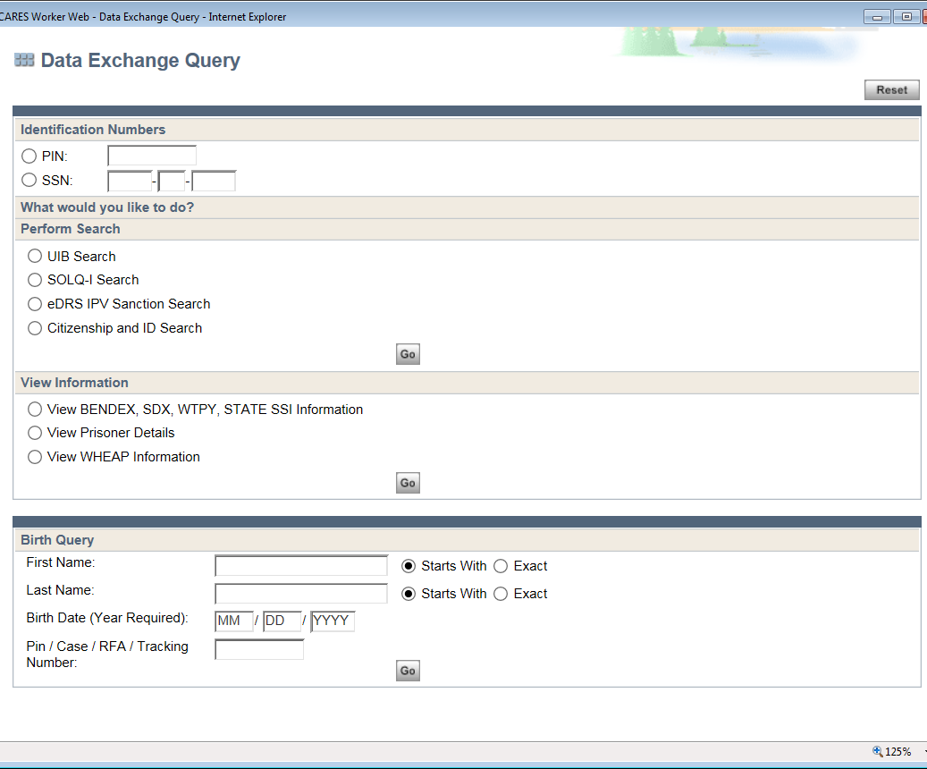
Citizenship/ID Search is used to verify citizenship or ID for a client. Please review Process Help 44.2.2.12 for further assistance.

“BQ” or Birth Query is used to verify ID and citizenship for anyone born in Wisconsin.
This query can also be found on the Permanent Demographic page in CWW.
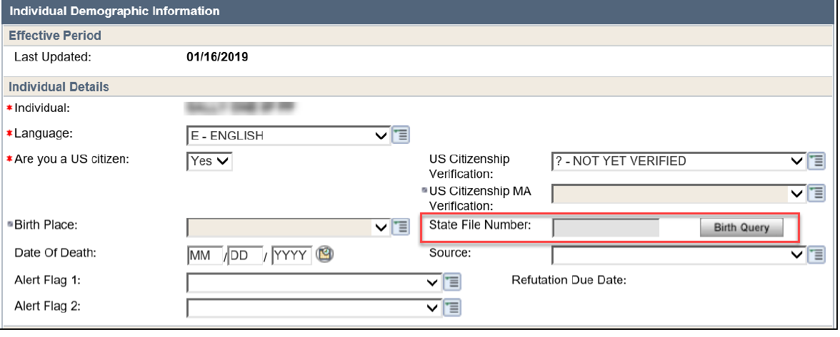

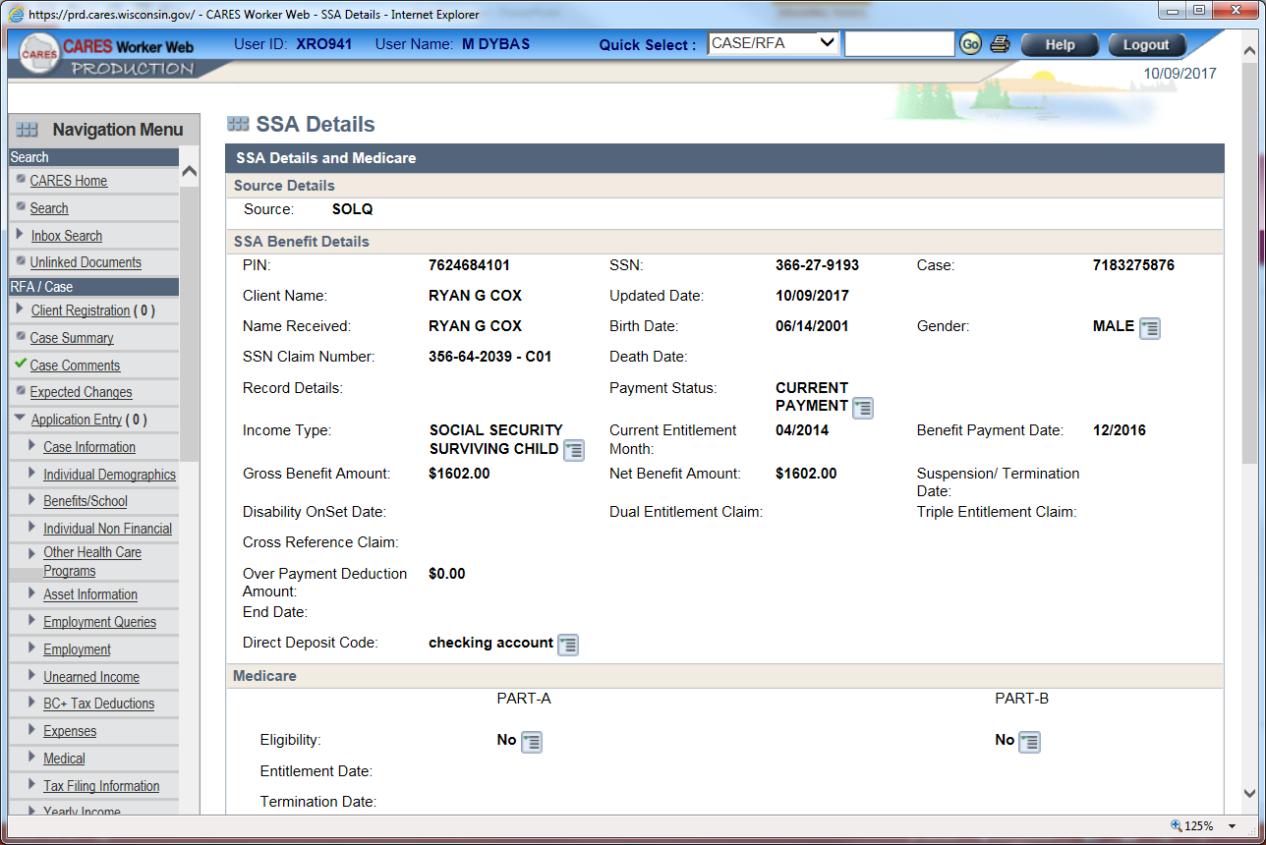
SOLQ is used to verify Supplemental Security Income, Social Security Income and Disability Query.
Type of payment and payment amount
Top of the SSA Details and Medicare page

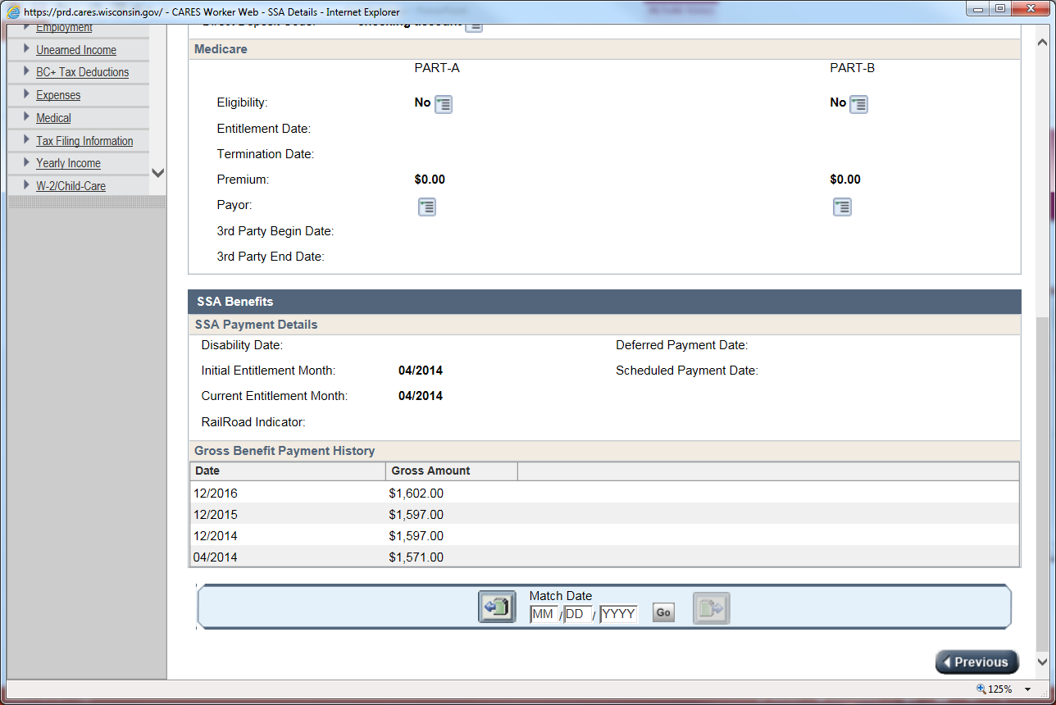
If Medicare is being received it would be listed here
Bottom of SSA Details and Medicare Page
“UIB” or Unemployment Insurance Benefits are used to verify Wisconsin unemployment payments. Once you’ve selected the UIB Search, the following screen will appear.
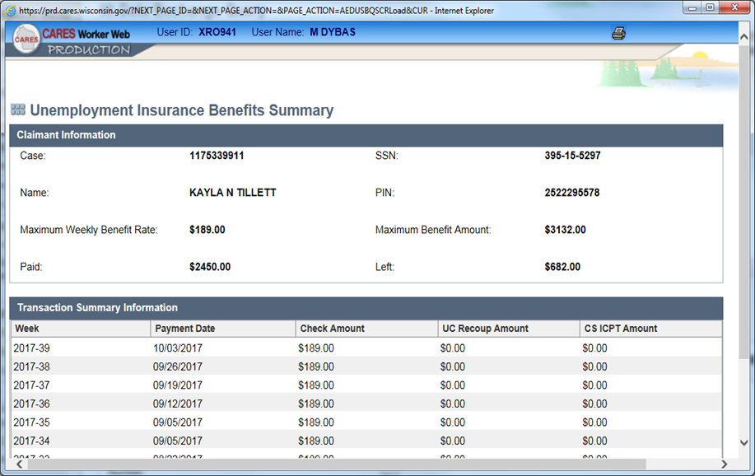
Clients Name

Voter Registration Website can be used to verify Wisconsin Residency. This information can be found using https://myvote.wi.gov Select My Voter Info and enter client’s first/last name and date of birth
“WHEAP” or Wisconsin Home Energy Assistance Program is used to verify if the client has received a WHEAP payment in the current month or the past 12 months. WHEAP can be found in CWW, in the Data Exchange Query. 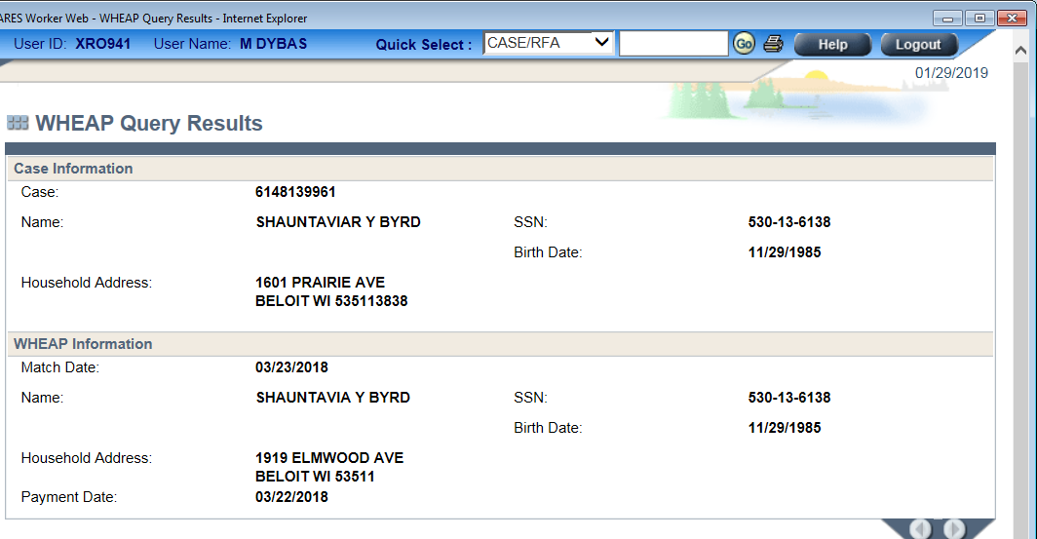

“DMV” or Department of Motor Vehicles website is used to verify Wisconsin Residency. The DMV website is https://trust.dot.state.wi.us/ecdl/home.do Enter the client’s information and click “I’m not a robot”
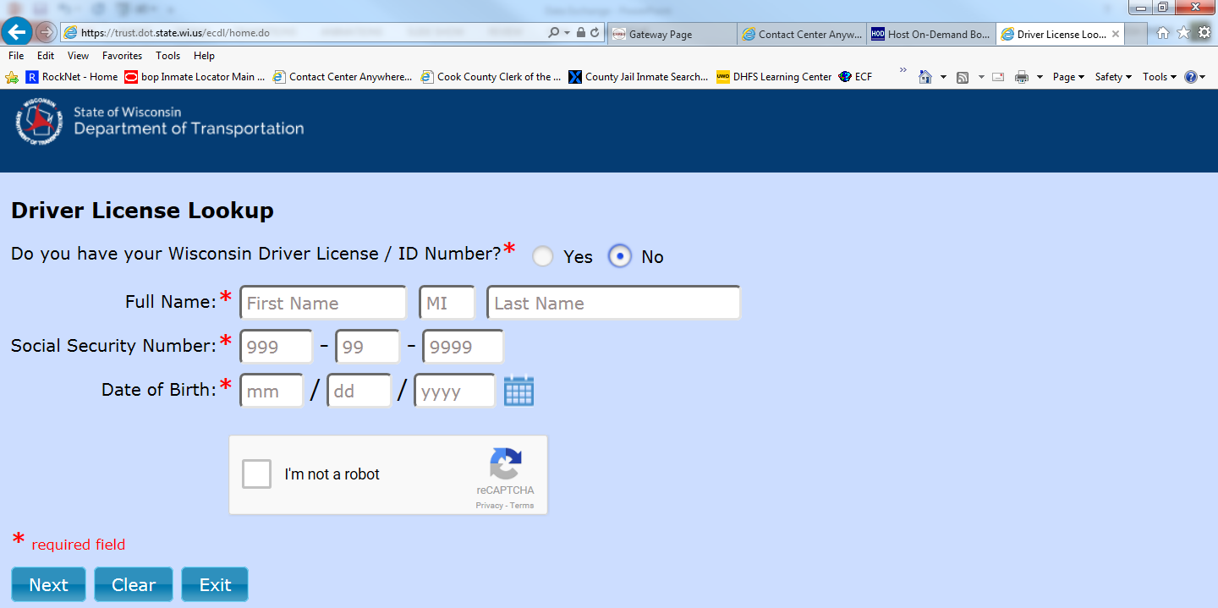
If the Driver License information reflects that the client has a valid Wisconsin Driver License, then update the current demographic page for Residency Verification and/or Identity Verification using the MV-Division of Motor Vehicles Data Exchange.
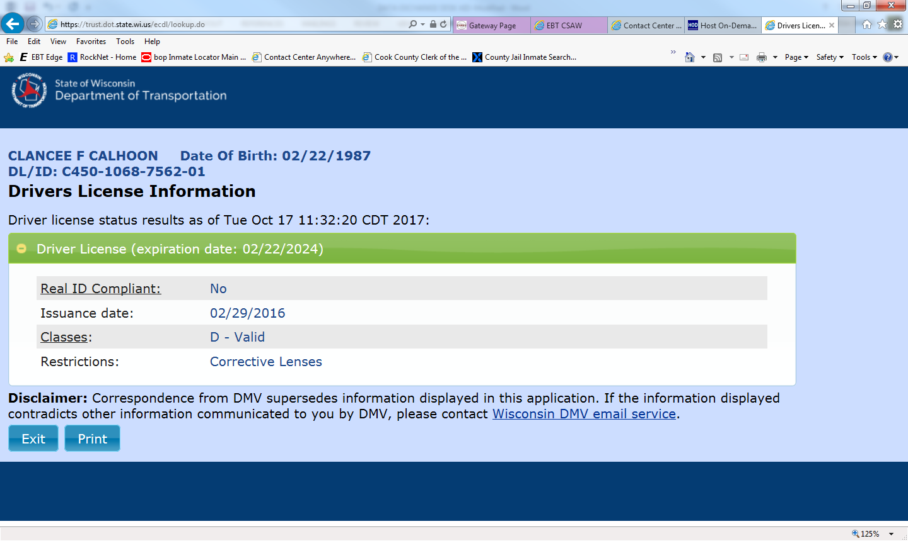
This area will include client’s name, DOB and Driver License Number.

