Cornerstone Self-Registration
IM workers should self-register for Cornerstone by clicking on the County Self-Registration link below.
- https://widoa.csod.com/selfreg/register.aspx?c=%255e%255e%255e6VHpAFGaKfyoFPQrMJAwig%253d%253d

After clicking the link, IM workers will be taken to the Cornerstone Self-Registration page. Once at this page, IM workers should enter in their First Name, Last Name, and Email Address.
IM workers will also need to select a Division to be associated with by clicking on the icon.
After clicking on the icon, a pop-up box will appear where IM workers will need to click on the + sign next to County Program.

After clicking on the + sign, a county program list will appear, IM workers should find IM Agency on the list and click on it to select it.
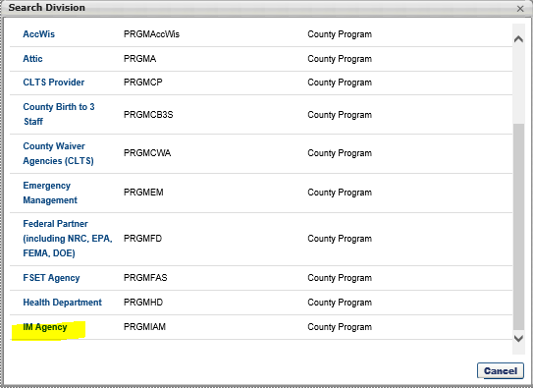

After selecting IM agency, IM Agency will populate into the Division field on the Cornerstone Registration page. IM workers should enter in their County by selecting it from the dropdown field and enter in their position title.
IM workers will enter in a new password and confirm the password on the screen. Please make note of your Cornerstone password in a secure place for future use.
The IM worker must acknowledge that they are not a robot by clicking on the checkbox and then clicking log in.
The User ID for Cornerstone is the workers email address, and the password is the password that the worker creates when registering.

