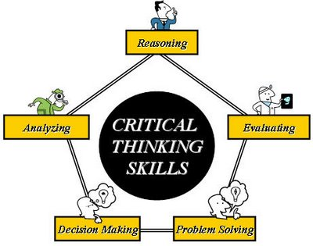
While completing any case work or making changes on a case, here are some things to consider; before, during and after your actions on the case.

- Before you take action on the case, decide what you think should happen to the benefits as a result of the action you want to take.
  - For example: A change report was received indicating that the clients rent has increased. I’m expecting that the FS allotment could change when I update the rent expense page. I’m not expecting HC to be impacted by this change.
- After you took action, did the benefits come out like you expected?
  - For example: The rent increased by $100, I updated the rent expense screen. The FS allotment increased. The HC remained the same.
- What programs were open before you took action?
- What programs are open after you took action?
- Are any programs closing after you took action?
- If open, did the FS allotment remain the same?
  - If the allotment changed, what caused the change?
  - Is a supplement needed for FoodShare?
- If the HC program (assistance group type) has changed, what caused the change?
  - For Example: The client reported new employment, their increased earned income moved them from MAGA to MAGM.
- Does the case need to be run with dates for Health Care?

