To Schedule an Appointment:
-From the Navigation menu, go to Worker Tools
-Select Client Scheduling
-Select Search
-Select Available Slots
The below screen will then be viewable.
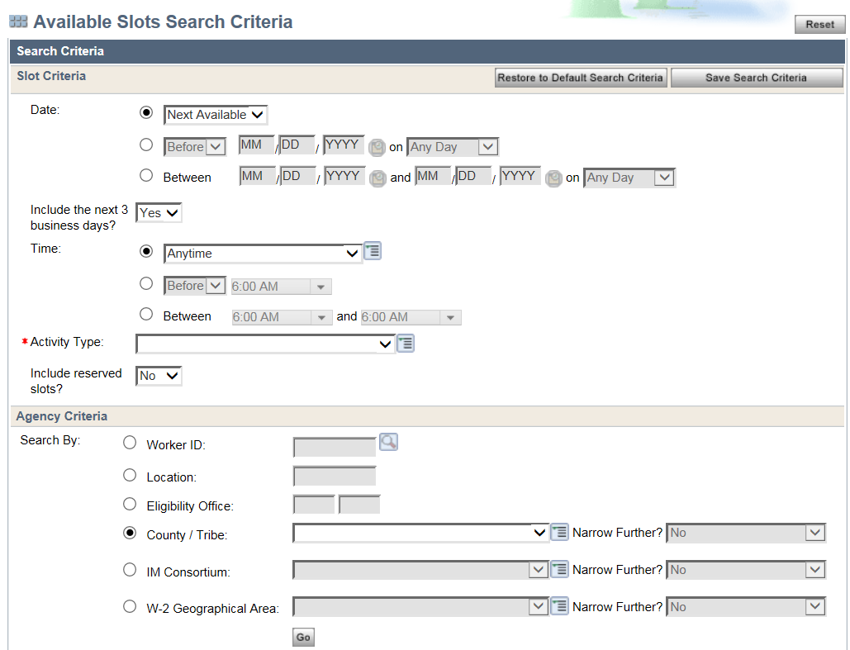
Agency Criteria
Slot Criteria

From The Slot Criteria | From the Agency Criteria:
Select Next Available, unless the client specifies a date or day that works best for them, then you can use the options to enter the client’s request. | Select County/Tribe: Crawford, Grant, Green, Iowa, Jefferson, Lafayette, or Rock County.
Mark “Include the next 3 business days?” YES. | Mark “Narrow Further?” as “Yes, by an active team.”
Time: Anytime, unless the client specifies what time frame they need. | Then select the active team you need to schedule with; Childcare, EBD, LTC, Family or Spanish. Click Go.
Select Activity Type- EO: Eligibility Review in Office,  RP: Eligibility Review via Phone, IF: Intake in Office or  IP: Intake via Phone. | Once you click go, you will get a list of available appointments. Once the client selects the appointment date/time that works best for them, select it and click go and the Appointment Details screen will be viewable.
From the screen shown below, enter either the Case or RFA number and click go, the information in the Individual boxes will auto populate.
-Select the program that that interview is for: FoodShare and/or Child Care.
-Review the Appointment Detail information with the client, if everything is correct, select “Save and Continue” and click next.
-Once you click next you will be taken to the calendar that you scheduled the appointment on. Document the appointment in Case/RFA comments.

To Cancel an Appointment:
From the Navigation Menu, go to Worker tools
-Go to Client Scheduling and select Search.
-Go to Appointments/Walk-Ins
- Enter the Case/RFA# and click Go

From the below screen you will click the magnifying glass.
From the below screen you will select “Cancel Appointment” and click “Next” this will cancel the appointment. Please update case comments to reflect that the appointment was cancelled.
