When a case is failing incorrectly while running with dates an override is usually needed. Note: you cannot do an override on a premium case.
Example: When running with a 2/1/18 date you receive an 077 failure code for MAGC when the renewal has already been completed and the program should open. Your screen in CWW will look like this:
In HOD you will need to do the following:
- Update the individual overrides for each person in the category and sequence.
  - To do this, enter in the trans code of AIOE and the parms of CASE#-- ENTER
  - The screen below will appear. Hit F8 until you find the correct program and sequence (in this example MAGC/01)

  - You will need to update the following sections on the AIOE screen:
    - ELIGIBILITY RESULTS OVERRIDE—change this from an F to S
    - REASONS OVERRIDE—these should be left blank
    - OVERRIDE REASON CD—enter as SYS
    - IS OVERRIDE APPROVED? (Y/N)—enter Y and hit enter
    - AIOE will then show the CQ COST SHARE OVERRIDE in RED—delete this by hitting end.
    - Your screen should then read as the example below. Press ENTER.
****If there are 2 people eligible in the category, you will need to complete this step for each of them.
- You will then need to enter in a group override for the category and sequence.
  - To do this, enter in a trans of AGOE and parms of CASE#-- select enter.
  - The screen below will appear. Hit F8 until you find the correct program and sequence (in this example MAGC/01)
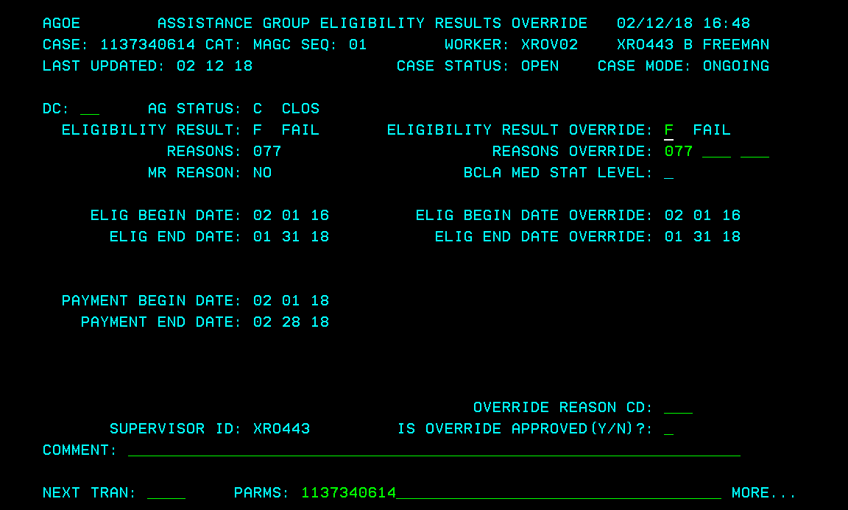

  - You will need to update the following sections on the AGOE screen:
    - ELIGIBILITY RESULTS OVERRIDE—change this from an F to S
    - REASONS OVERRIDE—these should be left blank
    - OVERRIDE REASON CD—enter as SYS and press enter.
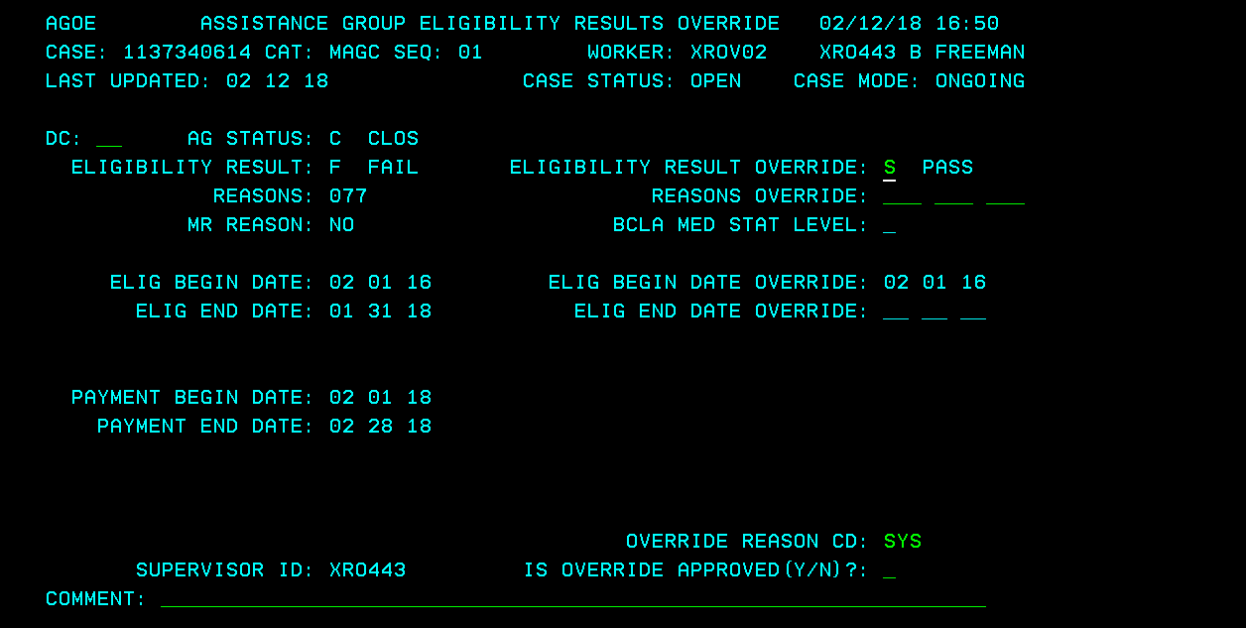
  - You will then need to enter AGOE in the trans again and select enter. You will need to update IS
OVERRIDE APPROVED? (Y/N) to Y and hit enter
- Return to CWW CONFIRM ELIGIBILITY screen.
  - Check the CANCEL box and select PREVIOUS
  - Then select NEXT. If the override held you should be able to confirm the program open and would not need to mail a manual NOD nor complete a manual cert unless client needs immediate attention.
Stop TFS from opening incorrectly
- Prior to confirming TFS (Transitional FS) open, complete the following steps on the Group Level Overrides (AGOE) screen in HOD.
  - Enter in a trans of AGOE and parms of CASE#-- select enter.
  - Hit F8 until you find the correct program and sequence for FS.
  - Update the following sections:
    - REASONS OVERRIDE—Delete the 544 code and
    - OVERRIDE REASON CD—Enter SYS and hit enter.
  - You will then need to enter AGOE in the trans again and select enter. You will need to update IS
OVERRIDE APPROVED? (Y/N) to Y and hit enter
- Return to CWW CONFIRM ELIGIBILITY screen.
  - Check the CANCEL box and select PREVIOUS
  - Then select NEXT. If the override held you should be able to confirm the program open and would not need to mail a manual NOD nor complete a manual cert unless client needs immediate attention.

