Frequently Used Resources
DWRC Address
ES Mail: 1717 Center Ave, Ste. 600 (apt field), Janesville, WI 53546-2800
Homeless Mail: 1717 Center Ave, Ste. 650 (apt field, Janesville, WI 53546-2800
DropBox (to find desk aids)
Login: RockChangeCenter@co.rock.wi.us
Password: 2020SCC

Southern Consortium | Phone: 1-888-794-5780 Fax: 1-855-293-1822
CDPU Address | PO BOX 5234  Janesville, WI 53547-5234
Member Services (Forward Health) | 1-800-362-3002
HMO Enrollment | 1-800-291-2002
Quest Card Services | 1-877-415-5164
Social Security | 1-877-850-7826 (Press “2” then press “0” for the operator)  EIN: 396005736
BadgerCare Premiums | 1-888-907-4455 Agency only: opt. 3 Customer: opt. 1
WHEAP | Statewide: 1-866-432-8947 Rock Co only: 608-363-9200
Senior Care | 1-800-657-2038
Third Party Liability (TPL) | 608-243-0676 (#1)
Provider Services (for Dr and Pharm) | 1-800-947-9627
Marketplace/Healthcare.gov | 1-800-318-2596
Public Asst. collections Unit (PACU) | 1-800-943-9499  PO BOX 8938  Madison, WI 53708-8938
Veteran’s benefits | Statewide: 1-800-827-1000 Rock Co only: ext 5552
WI Community Resources | Dial 211
Child Care Resource and Referrals | 4C’s 1-800-750-5437  (Rock, Jefferson and Green)  Parenting Project 1-800-267-1018  (Crawford, Lafayette, Iowa and Grant)
Forward Service EA Application | 1-800-771-8420
BadgerCare Plus Premium Payments | BadgerCare Plus (with coupon)  C/O WI Dept of Health & Family Services  PO BOX 93187  Milwaukee, WI 53293-0187  BadgerCare Plus (w/o coupon)  C/O WI Dept of Health & Family Services  PO BOX 6648  Madison, WI 53716-0648
Report IM Fraud | 1-877-865-3432
Report CC Fraud | 1-877-302-3728
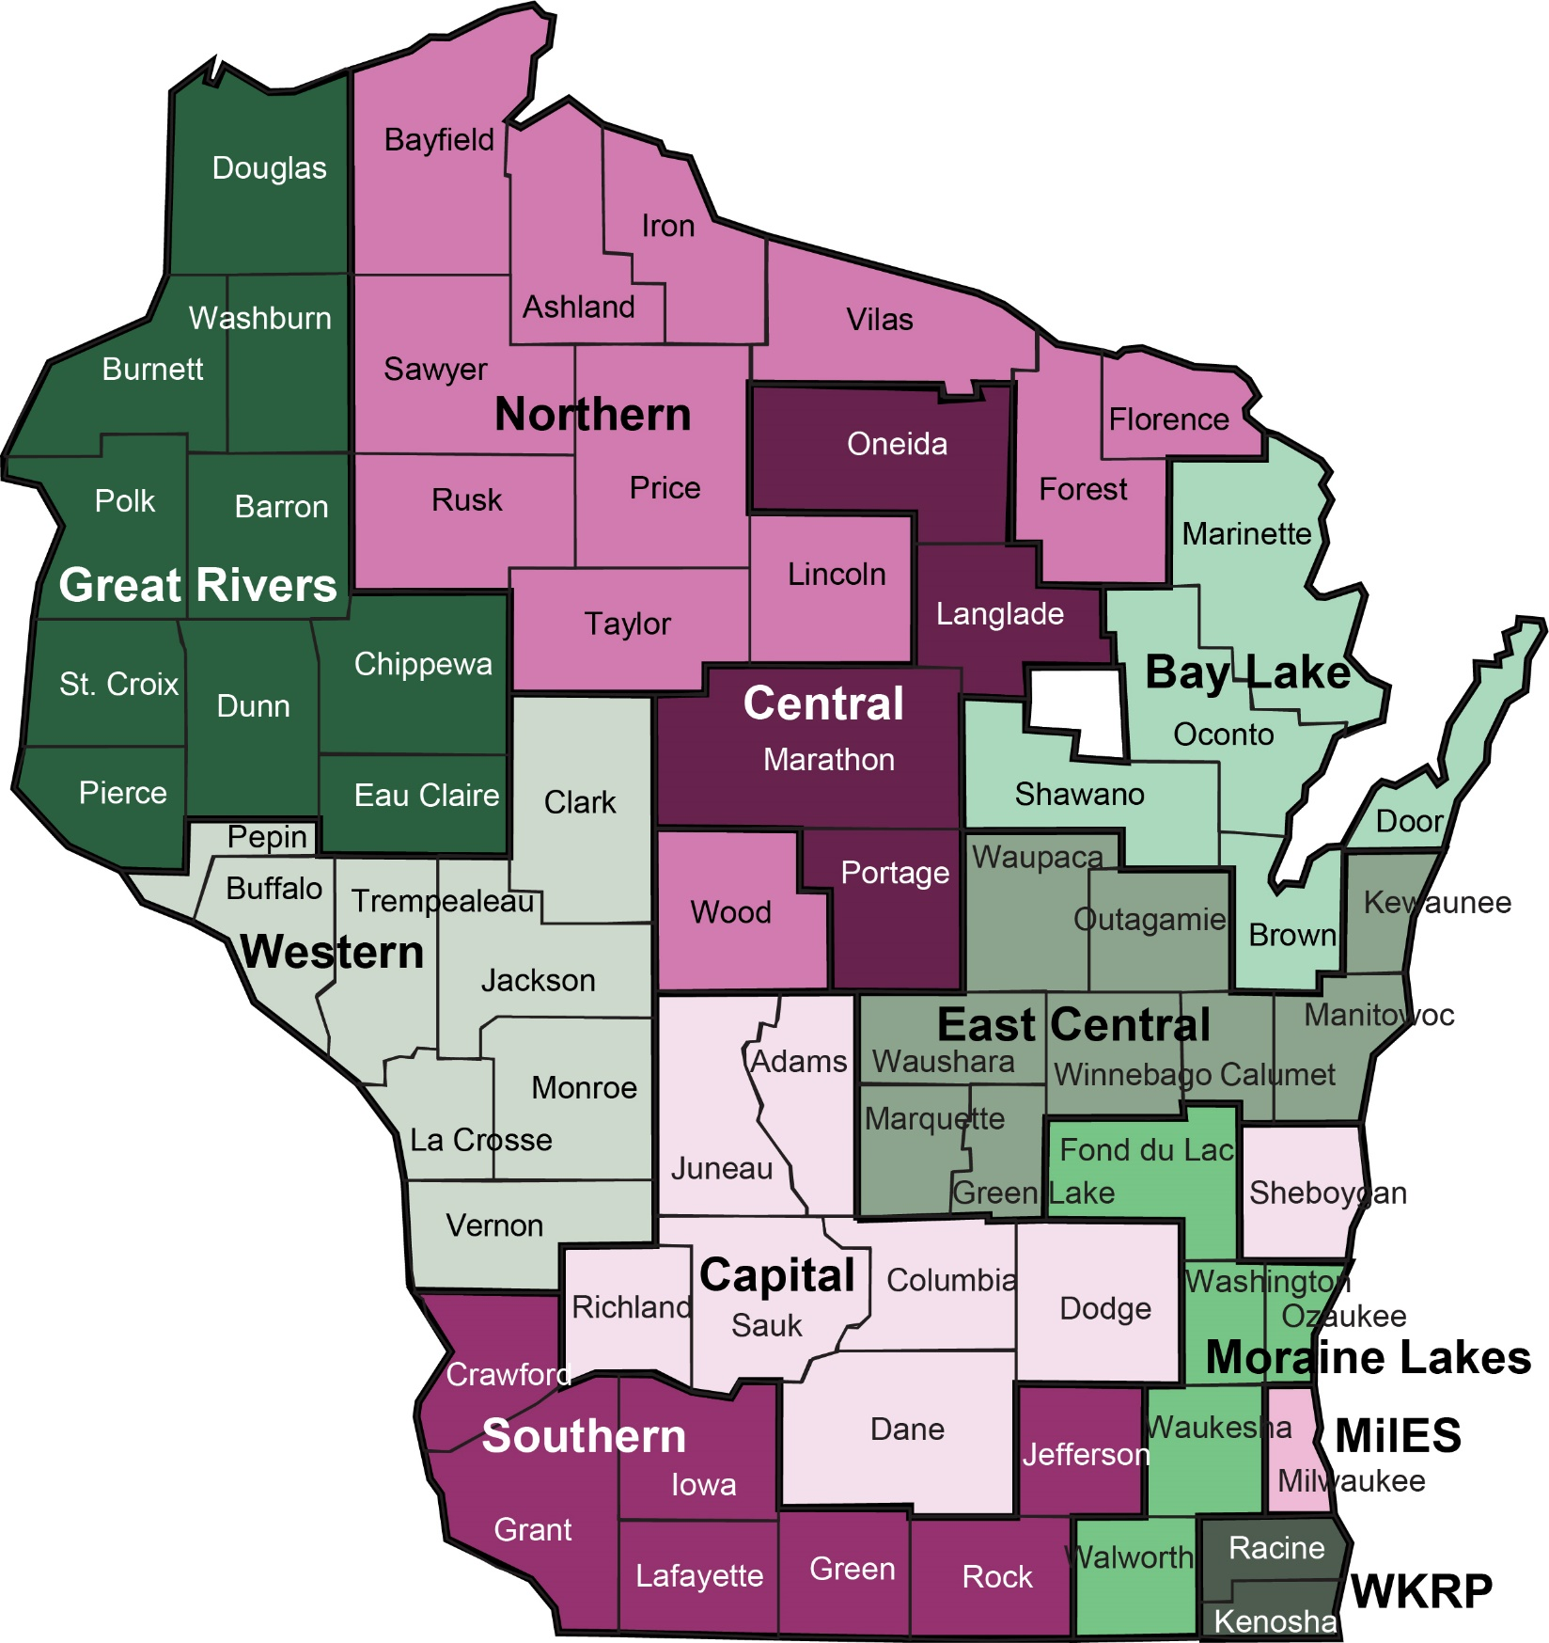

Bay Lake 888-794-5747
Capital 888-794-5556
Central 888-445-1621
East Central 888-256-4563
Great Rivers 888-283-0012
Milwaukee 888-947-6583
Moraine Lakes 888-446-1239
Northern 888-794-5722
Southern 888-794-5780
Western 888-627-0430
WKRP 888-794-5820

