How to Process Alert # 373

- Worker Receives Alert # 373-Recv Benefits in Other State:
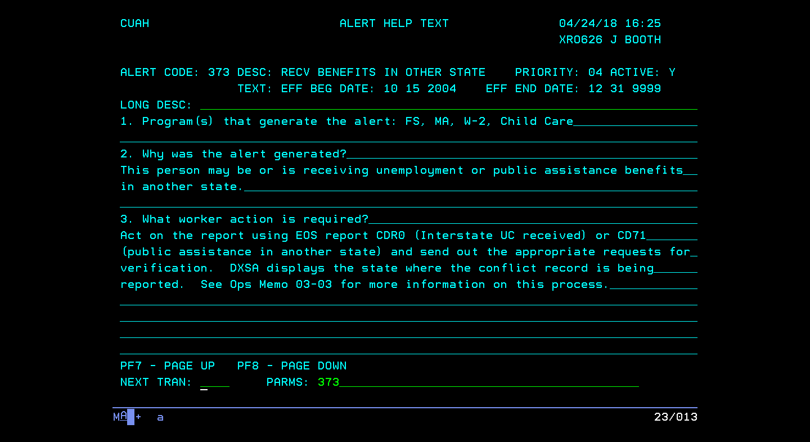
- Worker Reviews the Bendex Conflict Report by County (CD71):
In this example, the customer is potentially receiving other Public Assistance benefits in Illinois.

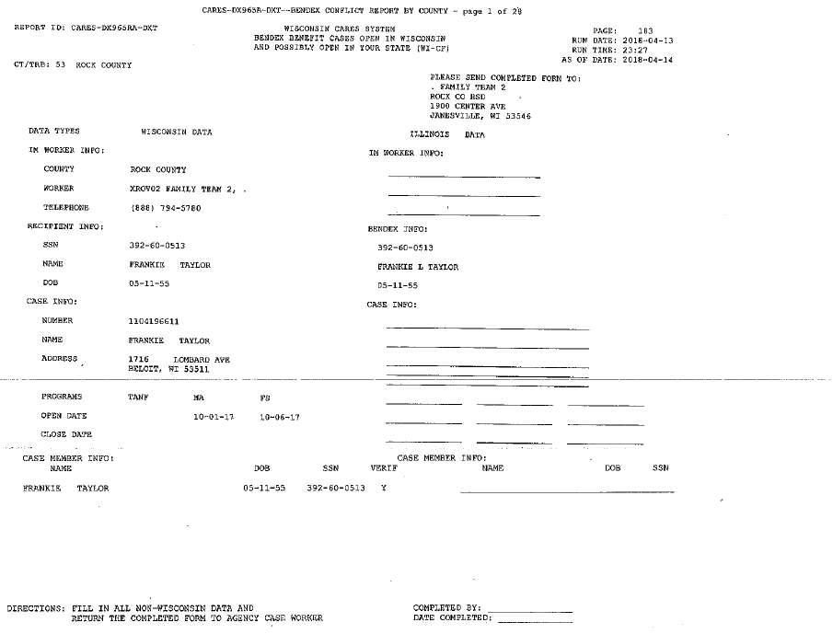

- Worker mails cover letter and the Bendex Report to state listed on Report.
Note: the list of address for the other states can be found on the Out of State FS Directory

- Worker Reviews UCB-Interstate UCB by County Report (CD70):
In this example, the customer is potentially receiving UC in Iowa.

- The Worker mails cover letter and Interstate UCB Report by County to the state listed on the report.
Note: the list of addresses can be found in PH 44.6 Appendix D: To find another state’s Unemployment contact information: http://www.servicelocator.org/OWSLinks.asp

