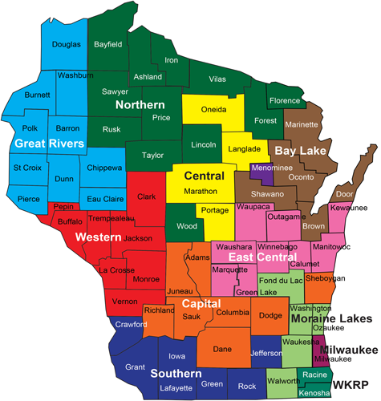

Moraine Lakes – 888-446-1239

Northern – 888-794-5722

Southern – 888-794-5780

Western – 888-627-0430

WKRP – 888-794-5820

Bay Lakes – 888-794-5747

Capital – 888-794-5556

Central – 888-445-1621

East Central – 888-256-4563

Great Rivers – 888-283-0012

Milwaukee County – 888-947-6583