Instructions for Accessing Drop Box
To replace our current IMSC portal, we will be using Drop Box. To access Drop Box:
- Please go to www.dropbox.com
- Click Sign In, displayed in the upper right corner of the screen.
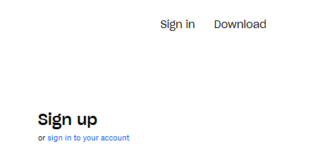
- Enter the user ID: rockchangecenter@co.rock.wi.us
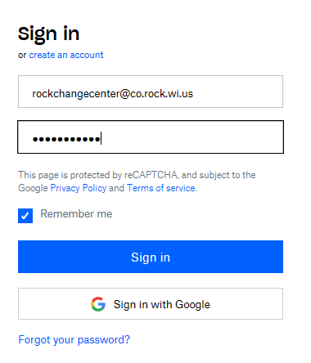
- Password is 2020SCC

- On the home page, the IMSC folder shows under “Starred”
- Select the folder to display a list of folders.

- Select the folder you wish to view to display the documents. 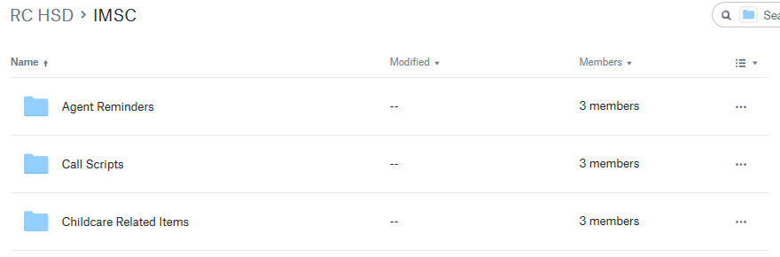

- Select the document you wish to open. 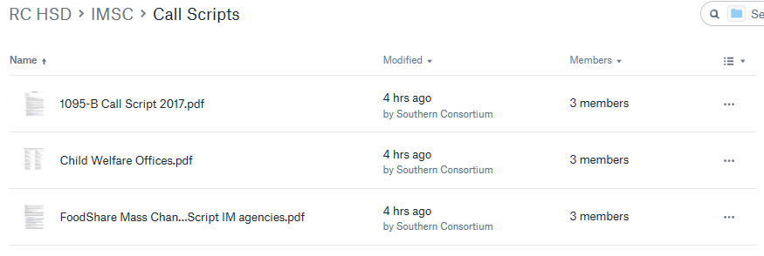

- Once you have clicked, the document will display.
- In the upper right hand corner, you have the option to Download the document
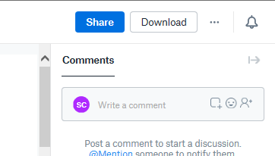

- Clicking download displays a banner at the bottom of the screen with options for opening or saving the document.

- Click save as and select the area you wish to save the document

- When finished, click the SCC logo in the upper right hand corner.

- Select Sign Out
