Invalidating in BRITS

A program can only be invalidated on certain types of referrals in BRITS.
If you are creating a data exchange referral (like SWICA) you can invalidate programs. If you are creating a “standard” referral (FEV or FRAUD) you cannot (only a gatekeeper can invalidate programs on those referral types).

This is for FEV/FRAUD and only a gatekeeper can invalidate programs. Please enter a note in your comments if you think a program should be invalidated.
**Note it says Invalid For which is different from the example on the next page.
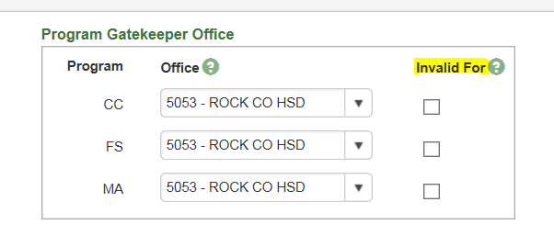
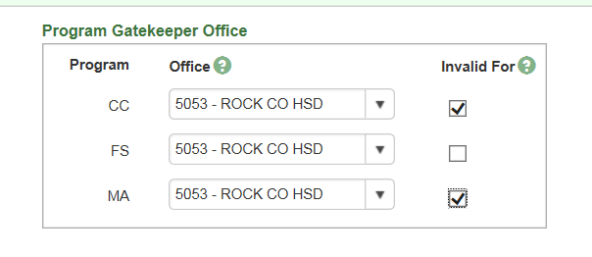

Only Data Exchange (DX) and Additional Front End Verification (FEV) referrals have the ability to filter a program on a referral. The process for filtering marks the program as not active for this investigation. The Filtered function for a program area must be selected to filter a program.

The worker creating this type of referral has the ability to invalidate programs.
**Note it says DX Filter. That is different from the example above.
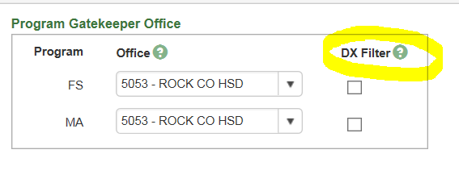

MD 032818

