KIDS Logon/Off Cheat Sheet

- Logon to Host on Demand as you usually would:
  - Open Host on Demand
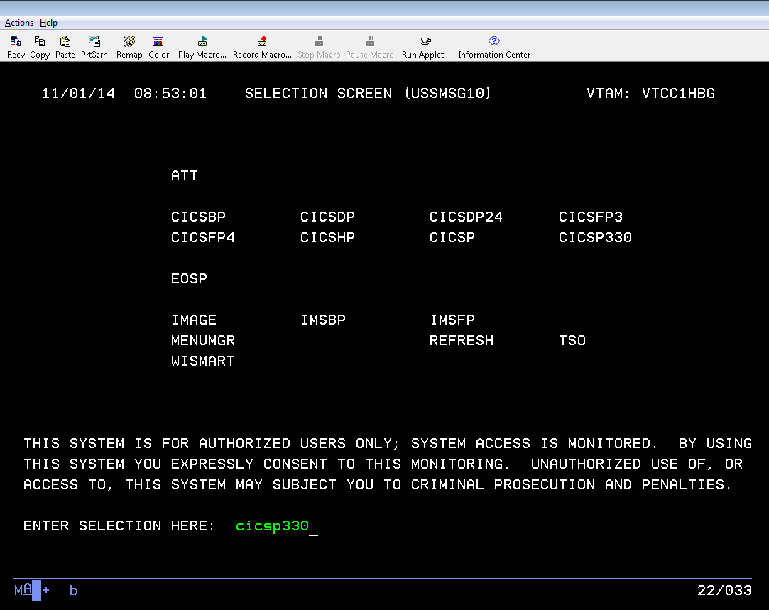
  - You will see:

- Type in CICSP330 in the “Enter Selection Here” field at the bottom of the page and hit enter
- Enter your User Id (XRO###) and CARES mainframe password

- You will see a black screen with white text displaying your last access to the system. Enter “KASE”

- Hit PF11 key >> This is only required the first time you log in on any given day.
- You are now at the KIDS main menu

Logging Off KIDS

From any screen in KIDS, you can log off using the following steps:
- Press F3
- Exit the Screen

