Medical Assistance Deductible:

- Ineligible for MA only because of excess monthly income (MEH 24.2)
- Can be backdated up to 3 months prior to the month of application
- Six month deductible period (MEH 24.3)
- Monthly overage x 6 = Deductible amount
- No MA certification until deductible is met
- Meets deductible by using medical and remedial expenses (MEH 24.7.1)

Monthly Overage Computation:
Gross earnings
Subtract (-) $65 & ½ disregard (Gross earnings - $65/2 = Countable income + $65)
Add (+) Gross unearned income
Subtract (-) Child support/maintenance
Subtract (-) $20 disregard
= Net Income

Net Income minus (-) 100% FPL = Monthly Overage

Deductible = Monthly Overage X 6

Countable Costs (MEH 24.7.1.1):
- Medical Expenses – services or goods that have been prescribed or provided by a professional medical practitioner regardless of whether the services or goods are covered by Medicaid (i.e. deductibles, co-pays, bills for services not covered by Medicaid)
- Remedial Expenses – services or goods that are provided for the purpose of relieving, remedying, or reducing a medical or health condition (i.e. Case Management, Day care, housing modifications, etc.)
- Ambulance service and other medical transportation
- Medical insurance premiums paid by a member of the fiscal test group
- Medical bills paid by a party not legally liable to pay them
- Medical services received at a Hill-Burton facility
- In-kind payments
- Medical or remedial expenses that are paid or will be paid by a state, county, city, or township administered program that meets the conditions detailed in MEH 24.7.1 #3
- SeniorCare Enrollment Fees

Conditions:
- Still owed sometime during the current deductible period
- Paid or written off sometime during the current deductible period
- Paid or written off sometime during the deductible period that immediately precedes and borders on the current deductible period
- Paid or written off sometime during the three months prior to the date of application
- Past medical bills incurred for someone the client is legally responsible for if that individual could be counted in the client’s group

Notes
- Need current verification of the expense and liability, including date of service
- For Medicare recipients, can’t apply the expense until the Medicare EOB is received
- Expense cannot be counted if already used to meet a prior deductible which resulted in MA certification
- Income changes prior to MA certification will change the deductible amount.
- Can prepay all or part of the deductible
- Call Center – Prior to using AGMD to set the deductible, check that assets have been requested and verified. Enter a ? on Other Assets and add text stating, “Please submit verification of any assets you may have, including but not limited to Bank Accounts, Vehicles, Life Insurance, and/or Burial Assets.”

Setting the deductible

- Check to be sure assets are current.
- Go to HOD. TRAN code AGMD, PARMS Case number
- Establish MA Deductible screen appears

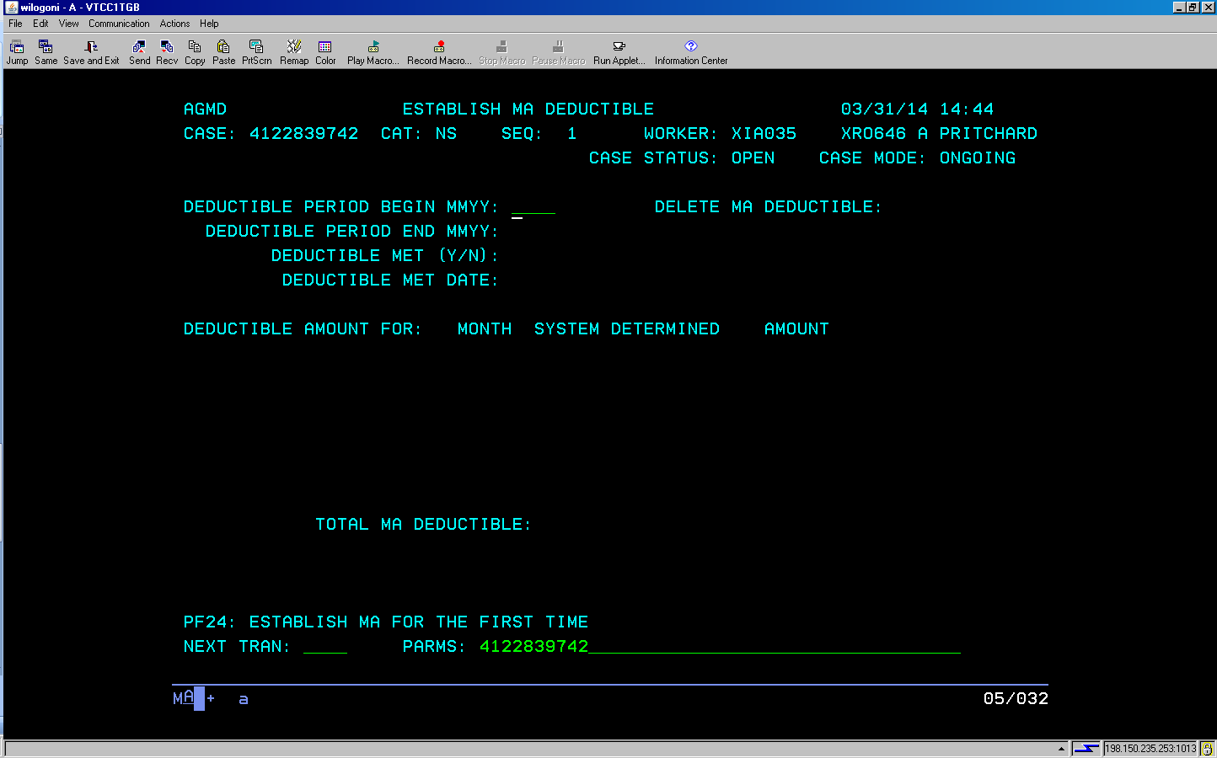
Hit PF24 (shift + F12)
Enter begin month and year

- Overage amounts auto populate.
- Notice auto generates with the amount of the deductible.

