Overpayment Cheat Sheet 08/11/2016

* To find a list of all overpayments associated with a case—in CARES mainframe use TRAN: BVRA with the case number. The referral number, program type, referral period, claim amount and notice date are all listed.
* Copies of all paperwork/manual notices should be in ECF—coded OP.

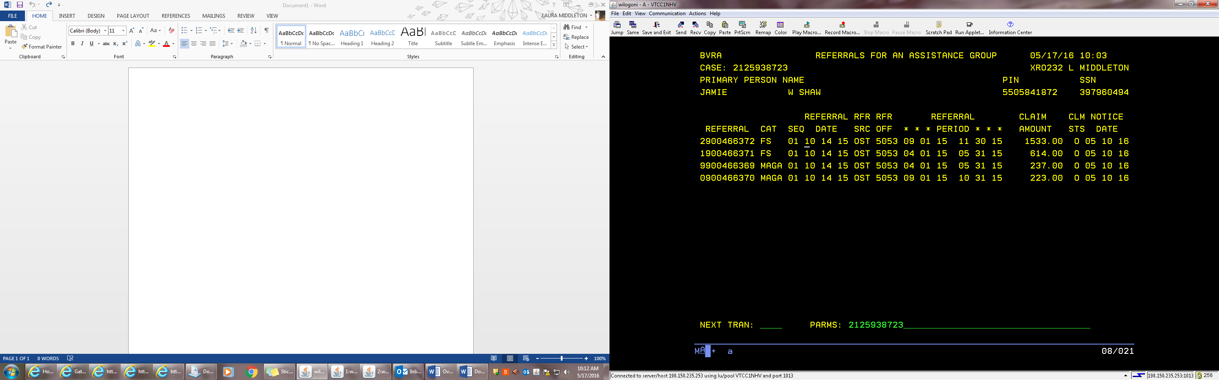

* Overpayment notices get mailed out the next business day after the overpayment is entered.

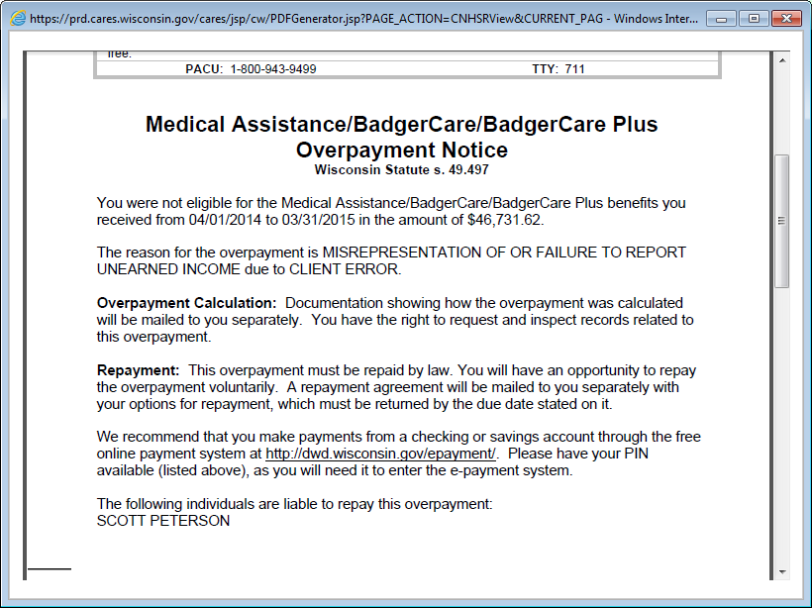

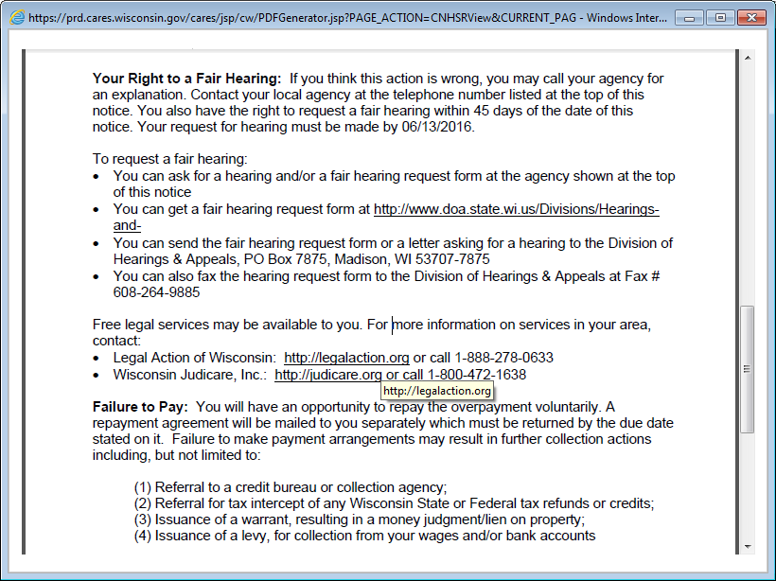

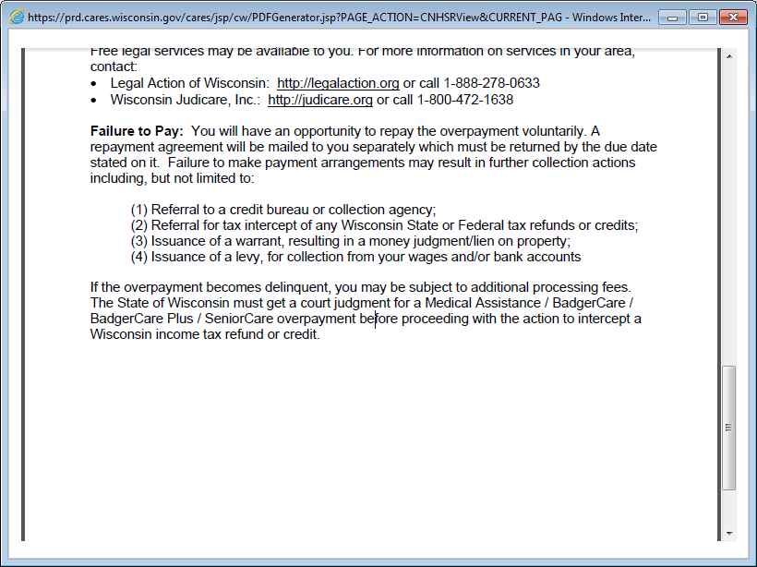

* All Food Share and Child Care overpayments are required to be recovered—even if they are due to agency error.
* We cannot recover agency error overpayments for Medical cases.
* If the overpayment is a total overpayment (or based on SWICA averages), **the client should be encouraged to send in their pay stubs or payroll printout for recalculation**….this could reduce or eliminate the overpayment amount.
  + In Rock County, if you are working documents and find that the client sent in their paperwork for the overpayment, please assign the documents to xro232.
* Liable individuals: For FS, all adult household members included in the group (or who should have been included) are liable for the overpayment. Liable individuals on a claim can be seen on CARES screen **TRAN: BVCL and parms are the referral or claim number.** This includes adult children over age 18. The State does not care who it recovers the funds from, so payments will not be split down the middle or averaged over the number of liable people.
* Overpayments follow liable individuals when they move to other cases. **Example:** Fred and Wilma have a FS overpayment of $300. They are both liable individuals on the claim. Fred moves out of Wilma’s home and into Barney and Betty’s home. Fred is added to Barney’s FS. Fred’s liability to the overpayment on his case with Wilma will cause a recoupment out of Barney’s FS case. (Ref FSH 7.3.1.2 Liability)
* Payment related issues: Refer the client to contact the Public Assistance Collection Unit (PACU) for all payment related issues such as payment arrangements, repayment agreement questions, late or missed payments. **The PACU phone number is 1-800-943-9499.**
* If the overpayment documents come back as returned mail with a forwarding address, re-mail the CWW-generated notices as well as the manual forms from ECF and document that you did so in case comments.
  + Do not generate a duplicate to be sent to the client as it will be mailed to the old, incorrect address on the notice.
* The Repayment Agreements do not get mailed out until the first business day after the first of the following month (in case callers state they haven’t received this yet).

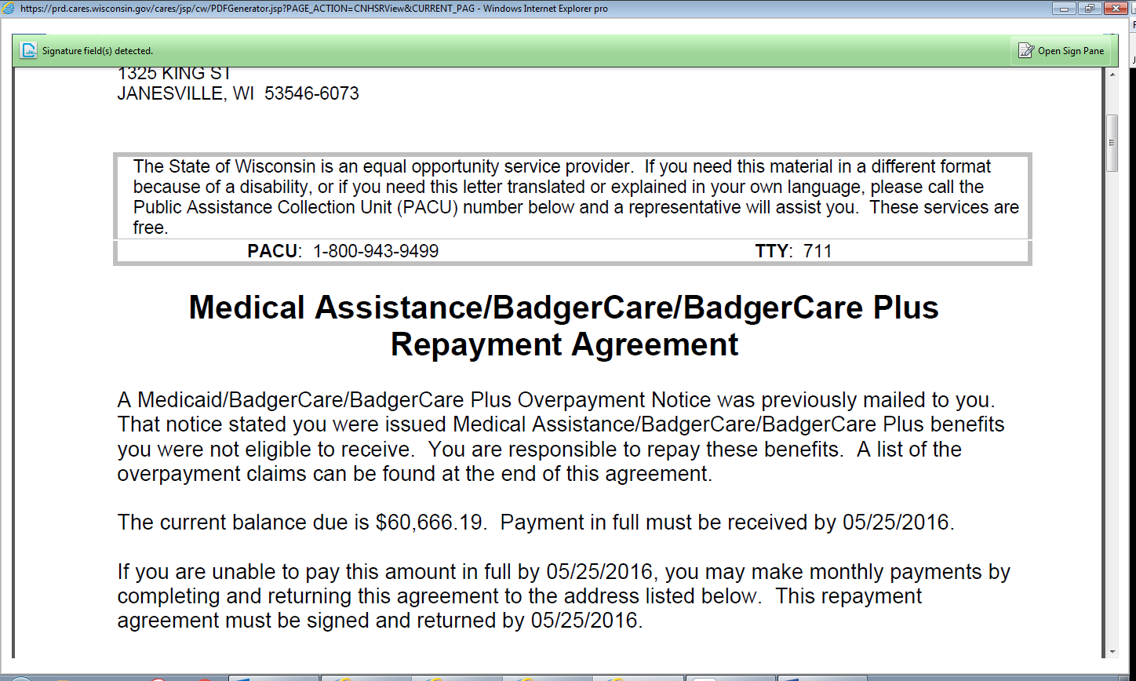

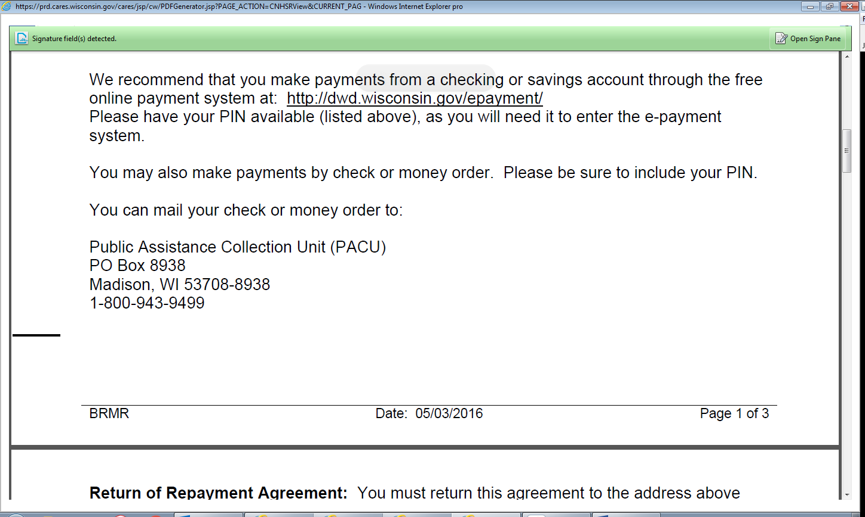

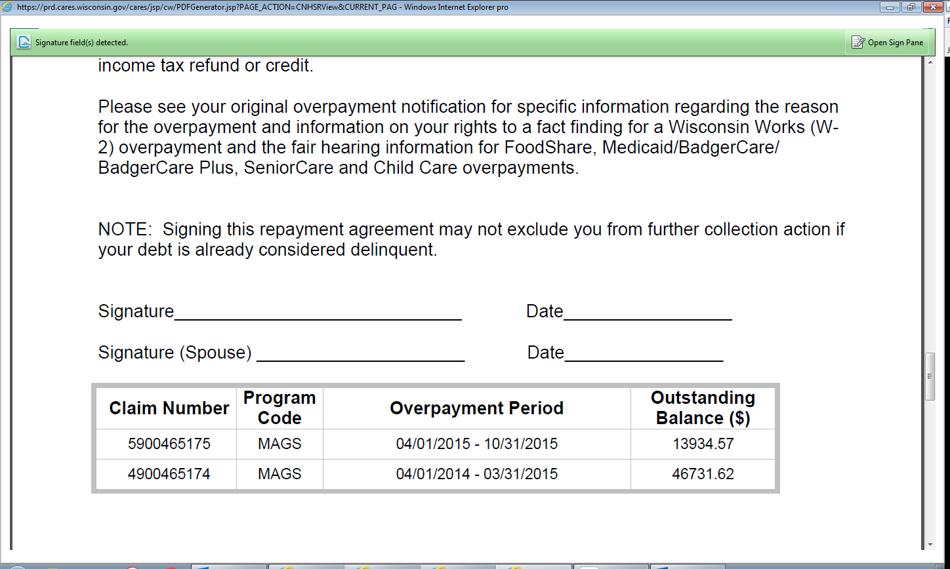

MA Overpayments

A Medical overpayment is calculated as follows: “If the case was ineligible for BC+, recover the amount of medical claims paid by the state and/or the capitation rate. Use the Forward Health interChange data from the Total Benefits Paid by Medicaid Report(s). Deduct any amount paid in premiums (for each month in which an overpayment occurred) from the overpayment amount.” *(Ref. BC+ Handbook, App. 28.4.2).*

What this means:

* Most BC+/MA overpayments are calculated using the Forward Health Total Benefits Paid screen. The agency is required to recover the Net Paid Medicaid **and** Net Capitation payments. These amounts are added together to determine the amount over paid. These add up quickly in many cases.

\*\*\***Net Paid Medicaid** is the amount that the State paid out for services that the client actually received—doctor visits, prescriptions, surgery, etc.

\*\*\***Net Capitation** is the monthly HMO premium the State pays for the client to have the medical coverage.

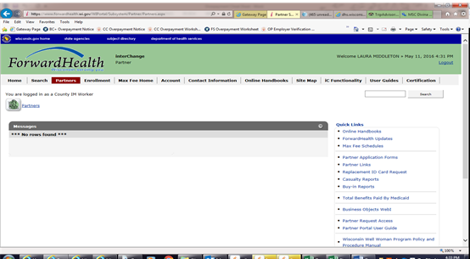



* For the screen shot above, the one month overpayment is $182.25 + $252.52=$434.77
* Premiums the family has already paid for each month of the overpayment period need to be deducted from the total overpayment. So using the screen shot above, if the customer paid $45 as a premium for April, the overpayment is $434.77- $45=$389.77.
* It does not matter if a customer never used the BC+. They are still liable for the overpayment because the State paid out an HMO premium for them to have the coverage. (HMO premium amounts are currently ranging between $155.00--$445.00 per month for adults and $50.00--$70.00 per month for children).
* BC+/MA overpayments are calculated using the actual income. If no income verification is received, it will be entered as a total overpayment. Case comments should be entered to indicate this is the case.

***The client can send in their pay stubs or a payroll printout to request the overpayment be recalculated.

* Adults are liable for their own portion of the overpayment as well as the amounts for any of their children. For example, Barney and Betty have a 1-month overpayment. Barney’s Net Capitation was $440.08. Betty’s Net Capitation was $440.08. The overpayment total is $880.16 but Barney is only liable for his $440.08 and Betty is only liable for her $440.08. If there is also an overpayment for their son Bamm-Bamm they would share liability for it.

**SWICA Reminders**

* BC+ has the lowest income reporting limits. However, being over the reporting limits does not necessarily mean that the case will have an overpayment. Many cases will move into an extension—with or without a premium. Additionally, MAGC has a premium income limit and an income limit. If the case moves to an extension, the overpayment is the *lesser* of the Net Paid Medicaid/Net Capitation payments or the BC+ premium each month.
  + MAGA will move into MAGM with no premium due as long as they are under 133% FPL.