Searching for Alerts
- In CARES Mainframe (HOD), enter TRAN code MNSA and hit enter.
- In the PLEASE ENTER THE NUMBER OF THE DESIRED FUNCTION field, enter a 1 for ALL SYSTEM ALERTS.
- Tab down the USER ID field and enter the XRO*** that you are searching alerts for and hit enter. Example: XROV02 for the Family Team.
  - The alerts for the selected worker/team will show in order of due date with either a case number or pin number.
    - Alert Help Text can be found by entering a pound sign (#) on the line to the left of the alert and hitting enter. To return to the alert listing from the alert help text, hit PF2.
    - To delete an alert from the system, enter an asterisk (*) on the line to the left of the alert and hit enter.

Searching for Documents
- Documents that have yet to be processed can be found on the assigned team’s dashboard under the DOCUMENTS category. To find the current documents to process, do the following:
1
- Expand the DOCUMENTS category by selecting the + symbol.
- Expand the RECEIVED section by selecting the + symbol.
3
2
- Click on the hyper link under TOTAL.
- Once the Results page has populated, select RECEIVED DATE to sort the documents from oldest to newest. You would then select the blue hyper link under the ACCESS/RFA/CASE section to pull up the case/document for processing.

Searching for Applications and RFA’s
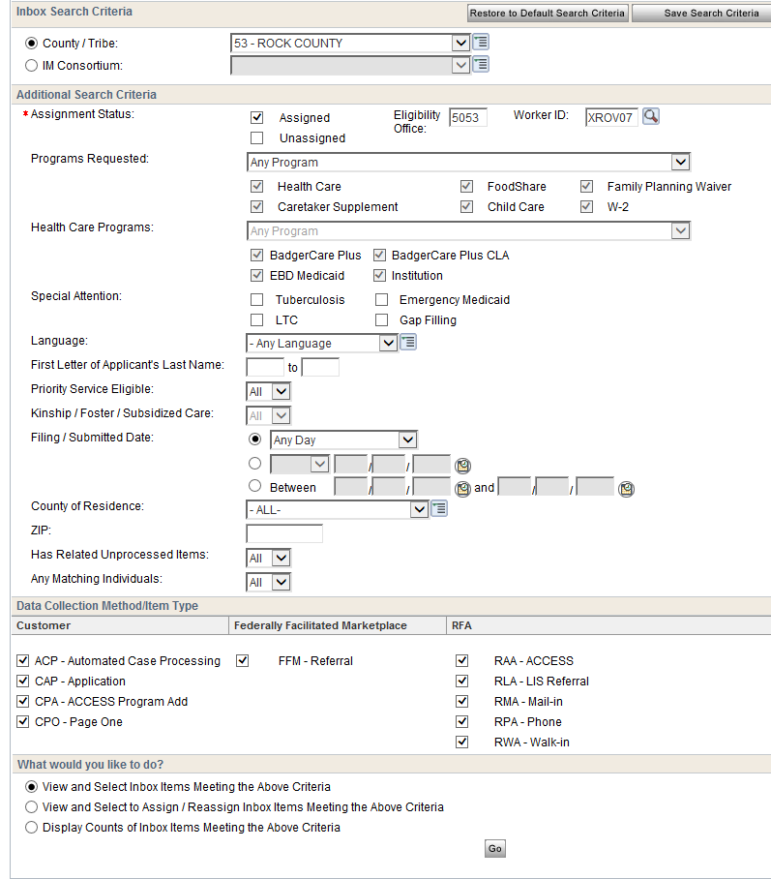
Note: you can select “save search criteria” to save your selections for the next time you come to the page.

1
4
3
2
In CWW, navigate to the Cares Worker Web Home page.
- In the SEARCH section of the Navigation Menu, select INBOX SEARCH and then select RFAs/Applications/Cases.
- In the INBOX SEARCH CRITERIA SECTION, select Rock County as the County/Tribe.
- In the ADDITIONAL SEARCH CRITERIA section, check Assigned, enter ELIGIBILITY OFFICE as 5053 and the WORKER ID as XRO*** (example: XROV02). **Leave all of the other sections checked as they appear on the page.
- Select the radial button for View and Select Inbox Items Meeting the Above Criteria and click GO.

Searching for Changes, SMRFs and Renewals
Note: you can select SAVE SEARCH CRITERIA to save your selections for the next time you come to the page.

1
In CWW, navigate to the Cares Worker Web Home page.
- In the SEARCH section of the Navigation Menu, select INBOX SEARCH and then select Changes/SMRFs/Renewals.
- In the INBOX SEARCH CRITERIA SECTION, select Rock County as the County/Tribe.
- In the ADDITIONAL SEARCH CRITERIA section, enter the WORKER ID as XRO*** (example: XROV02) and the INBOX ITEM TYPE as Renewal, Change or SMRF (whichever you are searching for).
- Select the radial button for View and Select Inbox Items Meeting the Above Criteria and click GO.
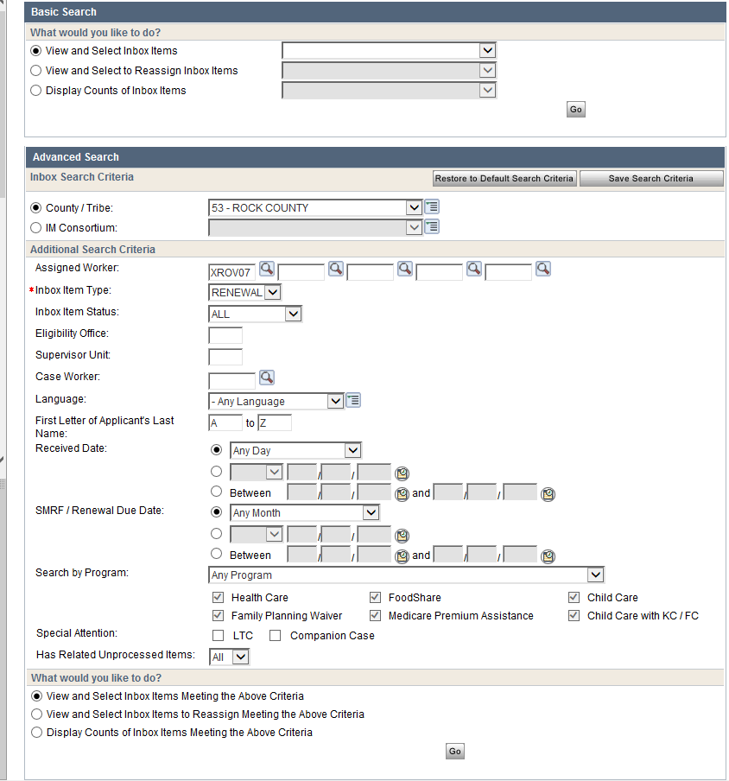
4
2
3

Searching for Discrepancies
- Discrepancies can be found on the Team Dashboard under the category of Discrepancies.
- Within the Discrepancies tab you can view a breakdown of Not Started, Waiting for 3rd Party Verification and Waiting for Customer Information. Each of these subsections will show a breakdown of the type of discrepancy (IM Prisoner, IM SOLQ-I, IM SWICA and IM UIB).
- Select the appropriate blue hyperlink for the discrepancy type you wish to view/process. A list of all cases with this type of discrepancy for the team selected will show.

