AGENT Reminders May 25, 2023
General:
- When customers call SCC, workers should query the case to check to see if the customer is due for any renewals. There have been instances lately where customers called in and reported changes and were due for SMRF or renewal and these were not completed.
- If a member is with an advocate and they (the advocate agency) have a translator that is NOT family but someone that they believe is an appropriate translator and the member is ok with using them (including sharing PHI/PII or HIPAA Information), then the IM agency can move forward with the conversation. IM Agencies should document in case comments that the member agreed to using the advocate agency’s interpreter.

It is not recommended to use a friend/family member as a translator. However, if the member wants an adult friend/family member to act as a translator, the IM agency must read the following statement to the member:
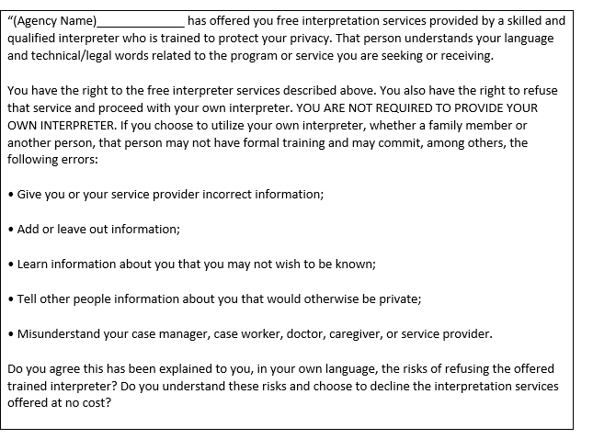
- If overpayment documents come back as returned mail with a forwarding address, re-mail the CWW-generated notices as well as the manual forms from ECF and document that you did so in case comments.
- When someone is open for Long Term Care programs and FoodShare, their cost share needs to be entered under a Medical Expense page using the OP-Out of Pocket Med/Remedial code. Review the budget to determine the cost share.
Navigate to the Budget pages and select the Community Waiver budget. Review the budget for the cost share amount:
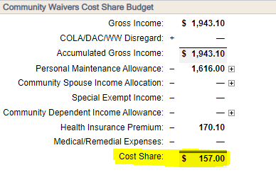

Reminder: workers not trained in LTC should not be updating these cases.

FoodShare
- As part of DHS COVID-19 unwinding activities, IM agencies were given the option to waive the interview for FoodShare applications and renewals that meet specific criteria and are filed on or after June 1st.
The Southern Consortium has agreed that we will NOT be taking this option. Workers should continue to complete interviews on all FoodShare applications and renewals.

