- As part of the COVID-19 Unwinding, agencies are required to waive the interview for FoodShare applications and renewals that meet specific criteria and are filed on or after June 26th, 2023.
- Agencies must continue to offer an interview to any person that requests one, including face to face interviews.
- The end date for this waiver will be communicated at a later date.

Policy
- A FoodShare interview will not be required for applications or renewals for FoodShare filed on or after June 26, 2023, if the primary person’s identity has been verified
- RFAs created with the minimal information to set a filing date: name, address, and signature (ex: F-16019A FoodShare Wisconsin Registration paper form or a “Page One” as listed in Process Help 2.3.1) will still require the interview in order to get the information needed to process the request
- Individuals who call in to apply for or renew FoodShare benefits are required to complete an interview

Processing Instructions:
- Any FoodShare Interviews that are waived must be coded as T-Telephone, and the FoodShare Hardship Reasons page must be coded ‘Waived Interview’.
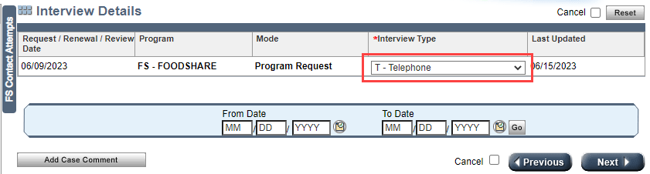
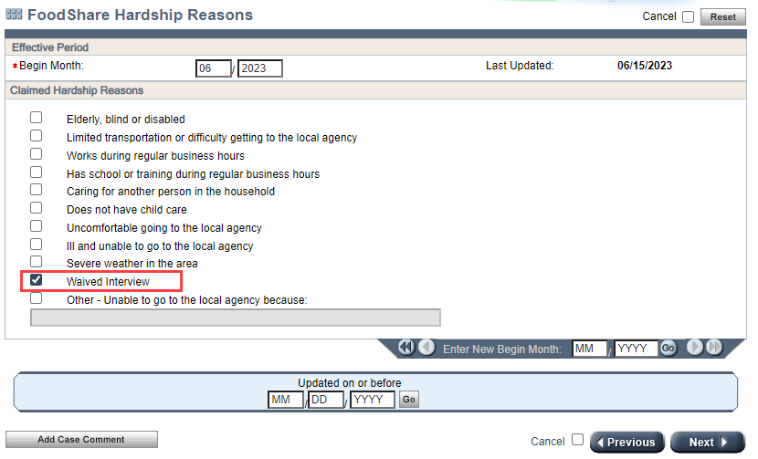

- Process through the application/renewal, updating all screens as appropriate and querying available resources to attempt to verify reported information
- If any verification is required, pend the case using normal processes.
- Workers must contact the household if there is any unclear or conflicting information reported on the application or renewal that needs clarification or when more information is needed. Workers must make every attempt to verify household circumstances through data exchange matches or existing verification documents.
  - If there is information that requires a clarification call, the worker must make 1 attempt to reach the household to obtain clarification. If the member is reached, obtain clarification needed, update the case as necessary and proceed to step 5.
  - If the worker is unable to reach the member to obtain clarification of questionable information (including if the member has not provided a phone number), worker must pend the case for loss of contact on the General Case Summary page,
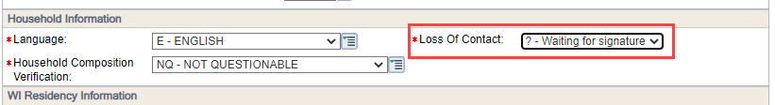
  - Add text to the VCL indicating what type of clarification is needed.
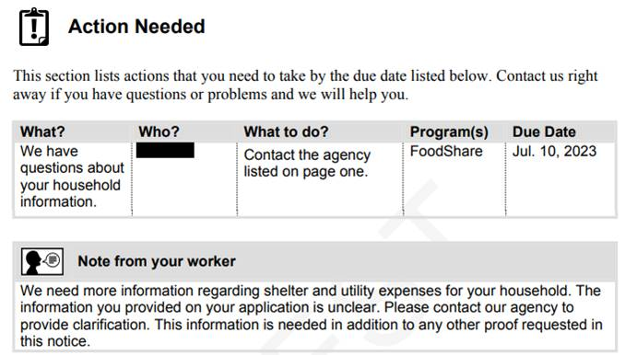
- Worker must complete (applications) or update (renewals) the ‘FS Work Registrant/ABAWD Information’ page for each required member of the household (each required member’s name will appear in the drop-down box for ‘Individual’ on the page):

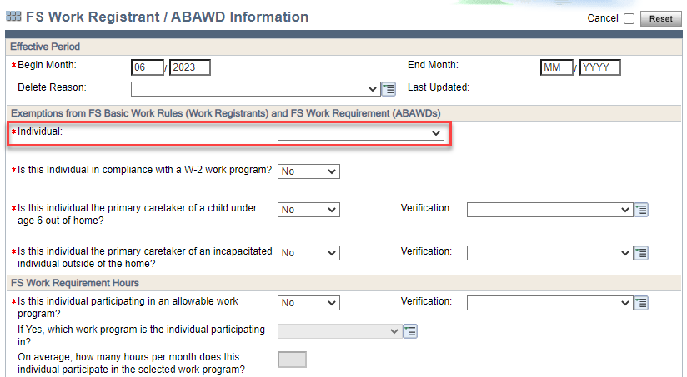
  - If the answer to any of the first 4 questions on the page are blank, worker must update the answers to ‘No’.
  - If the answers are already populated with a ‘Yes’, worker must pend for verification (if not already received).
- Worker initiates eligibility determination.
- Worker must stop at the ‘FS Work Registrant / ABAWD Determination Details Page’ to review the results of the determination. If any member of the household is determined to be a Work Registrant and/or ABAWD, the worker must stop and make at least one attempt to reach the household to complete an exemption screening and read the appropriate script(s) (attached), based on the results of each household member’s work registrant or ABAWD determination. NOTE: This includes Work Registrants/ABAWDS who are coded as ‘Y-DE’ in the TLB Waived field.
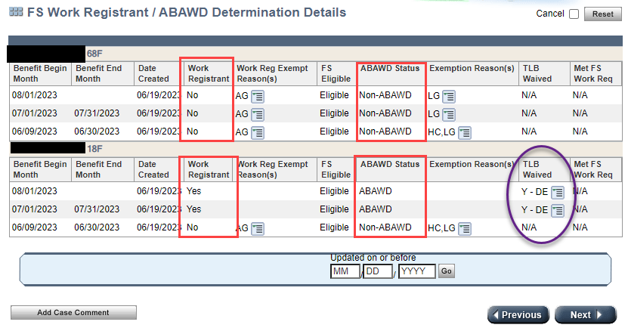

The exemption screening consists of asking the applicant or member about qualifying exemptions from the FoodShare Basic Work Rules and/or the FoodShare Work Requirement that may not be collected through the application process:
- Asking if any of the individuals are pregnant or experiencing chronic homelessness
- Asking the first 4 questions found on the FS Work Registrant/ABAWD Information page for each FS Work Registrant/ABAWD in the household:
- Is this individual in compliance with a W-2 work program?
- Is this individual the primary caretaker of a child under age 6 outside the home?
- Is this individual the primary caretaker of an incapacitated individual outside of the home?
- Is this individual participating in an allowable work program?

If after the exemption screening, any household members are still considered Work Registrants or ABAWDS, the worker must read the correct script(s) (attached) (Note: a copy of the FS Basic Work Rules and FS Work Requirement Script are attached).

The worker must document in case comments that the exemption screening was either attempted or completed and when an oral explanation(s) of work requirements has been read to the household.
In all instances, case comment a summary of the application information and document that the interview was waived.

