AGENT Reminders December 14, 2023
FoodShare
- FS interviews can be waived even if there is no ID verification for the primary person if the primary person’s immigration status is undocumented if all the other requirements are met.
- When a customer reports that they are homeless, the living arrangement on the Current Demographic page must be updated to reflect that in order for them to be exempted from FSET.
- When a customer is issued expedited FS benefits, they must be offered a temporary Quest card if they do not already have a card. Agents should be asking the customer if they currently have a Quest card. If they do not, the agent must let the customer know that they are eligible to receive a temporary Quest card and refer them to call their local agency. This conversation must be documented in case comments.
Healthcare
- Under MEH 2.9.2: we do not need a new signature within 30 days of a denial:
- If the person applied for health care and the IM agency denied the health care application 30 or fewer days ago, they can re-request health care without submitting a new application or a new signature. The date of the new health care request is the new filing date.
- If an application is denied because required verification is not received by the due date, but verification is later received within 30 days of the application denial date, the IM agency must consider this as the person re-requesting health care. In this situation, the person does not also need to contact the IM agency to directly re-request health care nor is a new signature required.
A new signature for healthcare is only required when:
If the person applied for health care and the IM agency initially denied the health care application (or the only health care eligibility on the case is an unmet deductible) more than 30 days ago, the person must submit and sign a new application to re-request health care, regardless of the other non-health care programs the person is enrolled in.

General
- Please remember to enter all of the income from the fields in CWW for self-employment. There have been instances lately where some of the expenses, such as depreciation, were not entered.
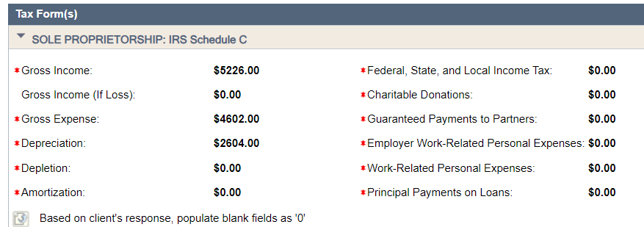
- When the “Gross/Net SS Discrepancy” is received the following action must be taken:
Resolve by calling SSA and determining what the discrepancy is (supplemental insurance premium, child support expense, etc.).
Example: SSRE for Bob shows a Gross Benefit Amount of $1342.60 and a Net Benefit Amount of $1100.00, for a difference of $242.60. Of the $242.60, $144.60 is deducted for a monthly Medicare Part B premium, leaving a discrepancy of $98. The agency calls SSA to inquire about the difference and is told that it is a supplemental insurance premium of $98 monthly.
Depending on what it is, add an “other income” unearned income screen and an expense screen.
Example: In reference to Bob’s $98 discrepancy, the worker would build an unearned income screen for SSRE (if not already built) for the net amount of $1100.00. A second unearned income screen would be needed for Other for the $98 discrepancy. The worker would also build a Medical Coverage page to enter the supplemental insurance coverage and monthly premium of $98.
***SS overpayment recoupments are not counted as income or as an expense.
- Best practice when working a case is reading case comments before you start working on it. Additionally, a case comment should be entered when you start processing something on a case, example: processing document, processing renewal, etc.. This helps prevent multiple workers processing the same item.
- Please remember to ask customers if they have any other questions when closing a call on SCC. This is something that the state QAs us on.

