Forward Health

Revised 02/21/24- JB/MD

Forward Health Desk Aid
Table of Contents

Page | Topic
3 | Logging in to Forward Health
5 | Setting your preferences
7 | BadgerCare premium information
9 | What HMO am I in?
11 | CTS information
13 | Why does pharmacy or clinic say I have no coverage?
16 | Other Insurance showing up in Forward Health
17 | Forward Health Cards - Issuing a replacement card
20 | Manual Certifications
24 | Phone Numbers
Logging In To Forward Health

Log in to Forward Health from the Gateway page. Select IM Agencies

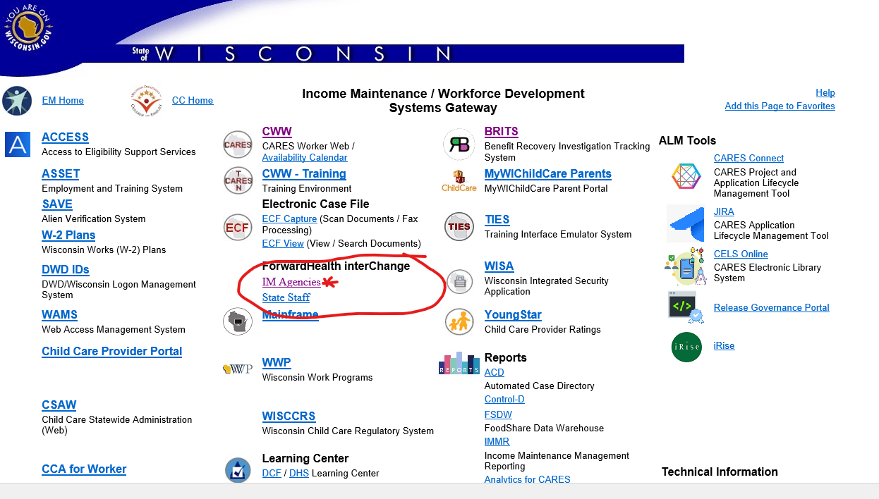

The next screen is this one. Enter your username and password.

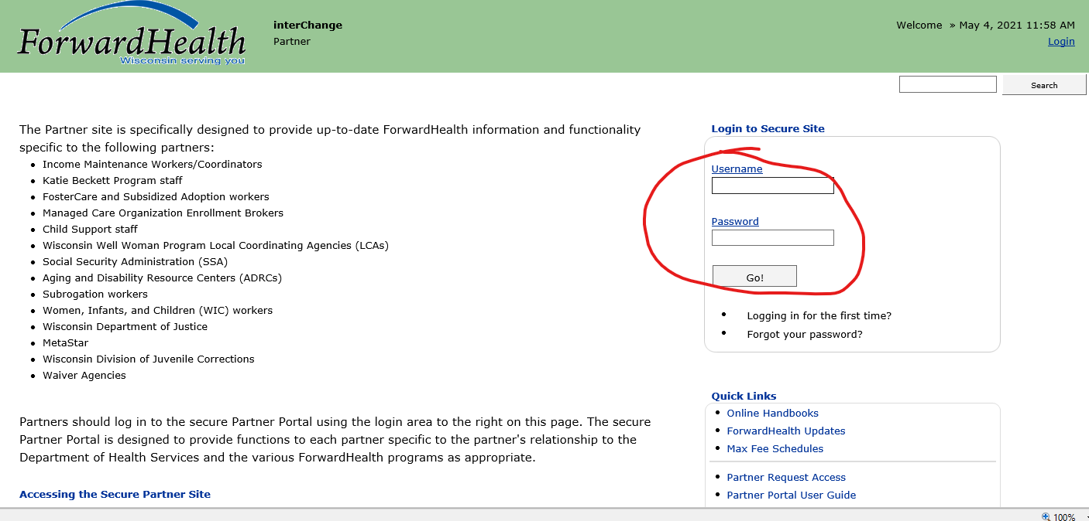

The next screen looks like this:

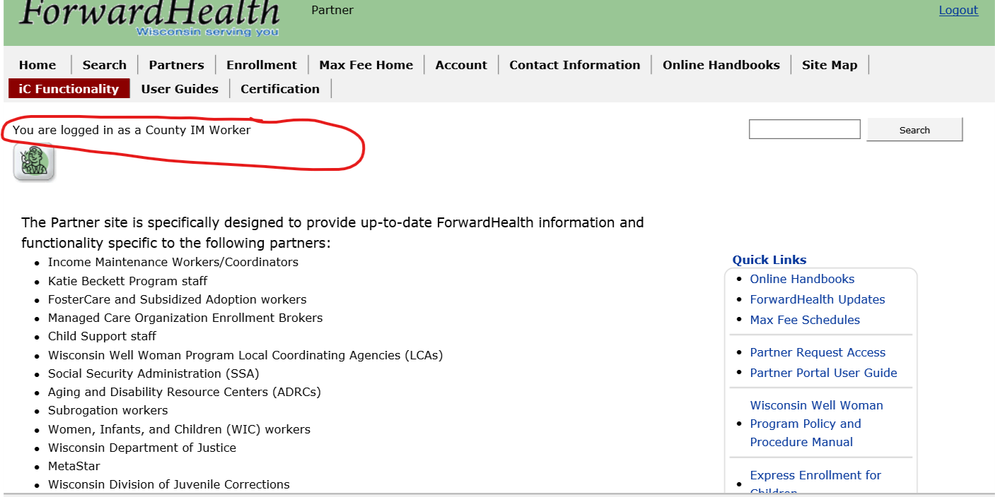

Click on iC Functionality

Almost all client information will be found by going to IC Functionality.
When you select IC Functionality, you will be taken to this menu:
The areas marked above are the sections most often utilized when searching for information.

Setting Preferences

Set your preferences!

You can customize your iC page to display what you would like to have displayed every time you open Forward Health. This saves time from clicking different sections to open.

- Bring up a case in iC. Click on Open Tab, then on Member. Check the Benefit Plan and Member ID Cards boxes. These sections will now automatically open every time you log into Forward Health.

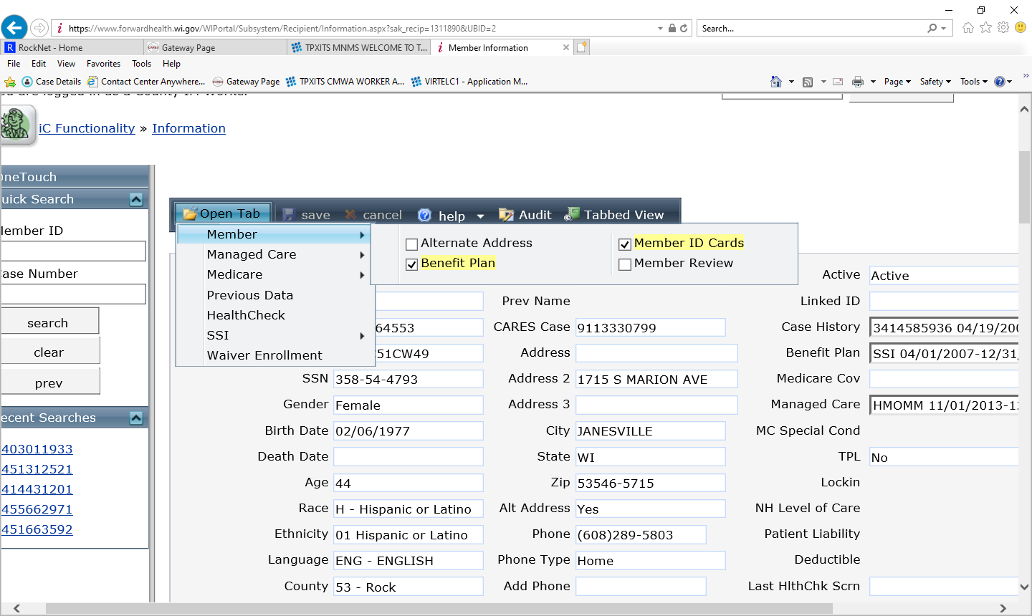

You can do this for each item listed under Open Tab so they automatically open everytime you search a case. See example below:
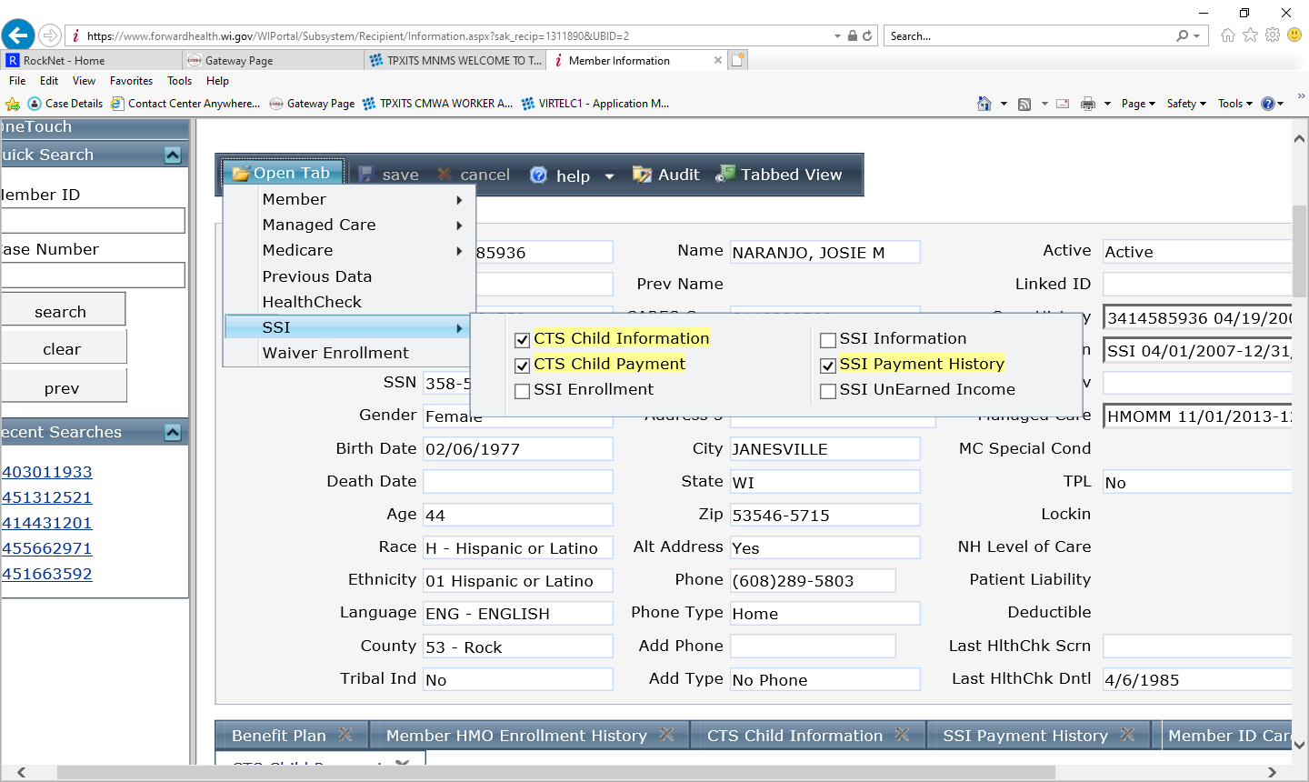

Save the case number and return to the search menu. Go back into the case to make sure your preference sections have opened.

Some preferences you may consider saving are below:
Member tab:
Benefit Plan
Member ID Cards
Managed Care tab:
Member HMO Enrollment History
SSI tab:
CTS Child Info
CTS Child Payment
SSI Payment History

Note: EBD workers may wish to set additional preferences

BadgerCare Premiums

Where do I find the MA ID number?

In CWW, under Query, click on Case Member Search. The MCI ID/MAID number is listed next to each person on the case

Was the premium paid?

- Select IC Functionality
- Select Premium Collection
- Enter the case number
- Enter the benefit month as 01/2019 (or select a date range)
- Click Search.

Click on benefit line to narrow search and see specifics of payment.

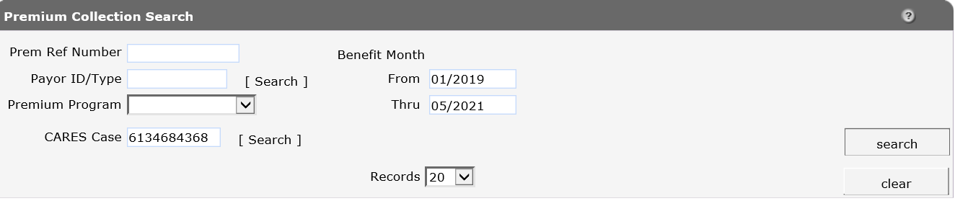

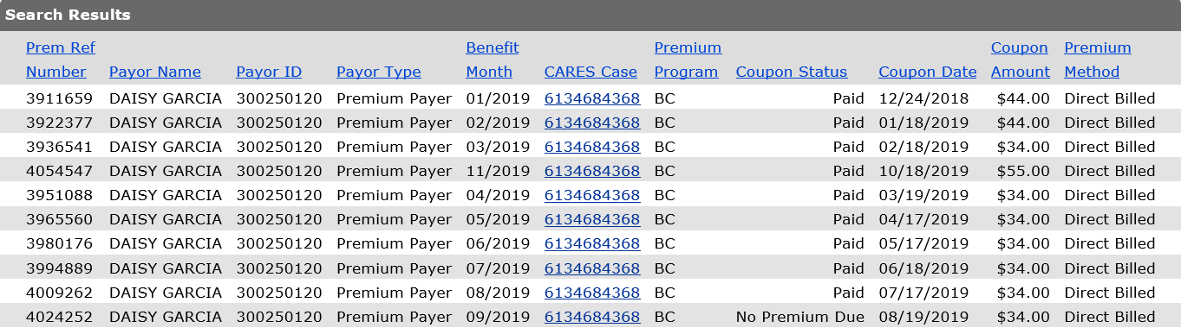

NOTE: If you cannot see the premium has been paid in the Portal but the client states the payment cleared their account, call the Premium unit at 1-888-907-4455 option 3.

Was the premium coupon mailed out?

Select IC Functionality and then select Premium Collection in the financial section. Enter the case number and the benefit month (format is 01/2019). Double click the month in question and the following screen opens up;

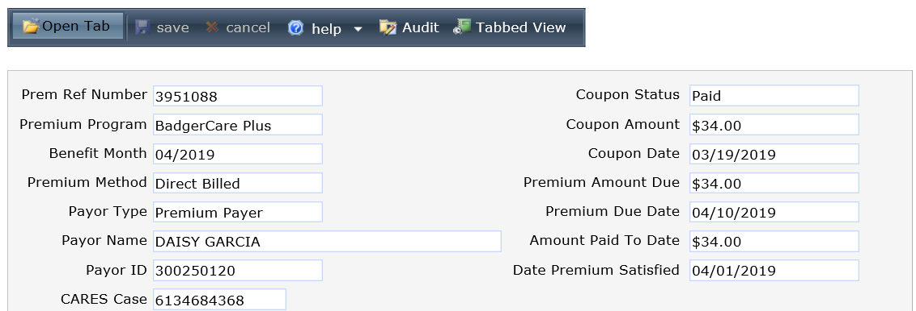

The red arrow shows the date the coupon was mailed to the customer.

What HMO Am I In?

Where do I find the MA ID number?

In CWW, under Query, click on Case Member Search. The MCI ID/MAID number is listed next to each person on the case

What HMO is the case in?

- Select IC Functionality and then select Member Search in the member section. Enter the Member ID# in the Member ID line and hit search. Select Managed Care from the Member Maintenance Section. Then select Member MCO Enrollment History and scroll down to the most current date. The HMO is listed under the MCO Name column.

Select Member MCO Enrollment

History History

Select Managed Care

Find the Managed Care Organization that is active.

To locate HMO Provider information:

Select IC Functionality from the menu bar, select member search, and enter the recipient information.

HMO coverage codes — Certain HMOs cover dental and chiropractic services. To find out whether an HMO covers these services, one of the following codes will be indicated through the Eligibility Verification System (EVS) and pharmacy Point of Sale (POS):
- HMOMB or SSIMB — Dental and Chiropractic services covered
- HMOMC or SSIMC — Chiropractic services covered
- HMOMD or SSIMD — Dental services covered
- HMOMM or SSIMM — Neither Chiropractic nor Dental services are covered

CTS Information

Where do I find the MA ID number?

In CWW, under Query, click on Case Member Search. The MCI ID/MAID number is listed next to each person on the case

What is the status of a CTS payment?

*You will need the MA ID# for the primary person on the case.

You can also find CTS payments in CARES mainframe:
- TRAN CPRC for current CTS
- TRAN CPRB for retro payments and the CTS group

- Select IC Functionality and then select Member Search in the member section. Enter the Member ID# in the Member ID line and hit search.
- Select SSI from the Member Maintenance section and then select SSI Payment History. Enter the benefit month under SSI Payment History section (format 072016).

Enter the benefit month and click search.

Which children does the CTS payment cover?

Follow the steps above, selecting CTS Child Payment instead of SSI Payment History:

- Select the child to display the payments and amount.
The payment month, transaction date, amount paid for the child, and payment status will be displayed when you click on the child’s name.

Why does Pharmacy or Clinic say I have no coverage?

Where do I find the MA ID number?

In CWW, under Query, click on Case Member Search. The MCI ID/MAID number is listed next to each person on the case

Why is the Pharmacy or Clinic saying I have no coverage?

-Enrollment
-Enter Member MA ID
This is the screen Providers see when they query a Forward Health card. Scroll down. System will only show if they have coverage for date of search. You can also put in a date range or specific date to see what the coverage was on that date/timeframe. If there are two lines of coverage showing, provider is to bill the TOP line. The top line supersedes the bottom line (occurs most often switching from FPOS to BC+). The screen also shows the HMO.

Select Enrollment and enter the Member MA ID. The member’s benefit plan and Managed Care Enrollment (HMO) is shown for the date of the search.

This is what the provider sees:

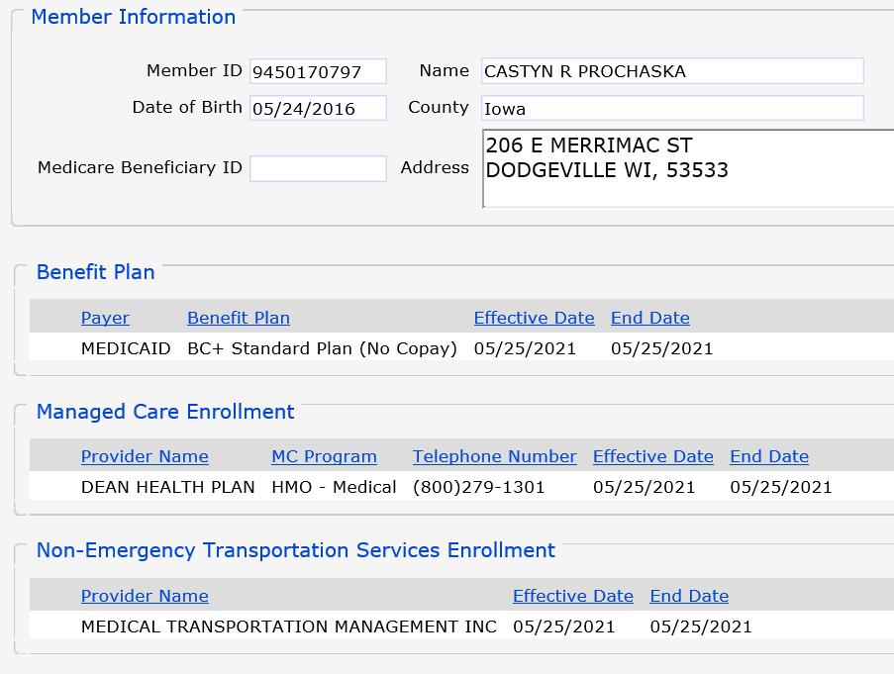

Note: Another place to check is under IC Functionality and then select Member Search in the member section. Enter the MA ID in the Member ID line and hit search. Check under Benefit Plan to see if there is current coverage. If there is coverage, the member can have their provider look in Forward Health for Title 19 eligibility, NOT the HMO website. If coverage was confirmed after adverse action, they may not be in an HMO that month but do have coverage under straight Title 19 (called fee for service).

- Fee-for-service coverage, means they may have BadgerCare Plus or Medicaid coverage and can go to any Medicaid-certified provider but are not yet enrolled in a HMO.

Other Insurance in Forward Health

Where do I find the MA ID number?

In CWW, under Query, click on Case Member Search. The MCI ID/MAID number is listed next to each person on the case

Why is there another insurance showing in Forward Health?

If another insurance is showing up in Forward Health, it may prevent a provider from billing Medical Assistance.

1. Select IC Functionality and then select TPL Search in the Third Party Liability section.

- Enter the Member ID. Search results will show any other coverage.

- Select a provider
- Click Coverage Link. This will show what is covered under this policy. Generally policies will state what the coverage is under that area and will show a numerical code and DRUG. If the information is incorrect, tell the client they must call Member Services at 1-800-362-3002 and request the information be corrected or removed.

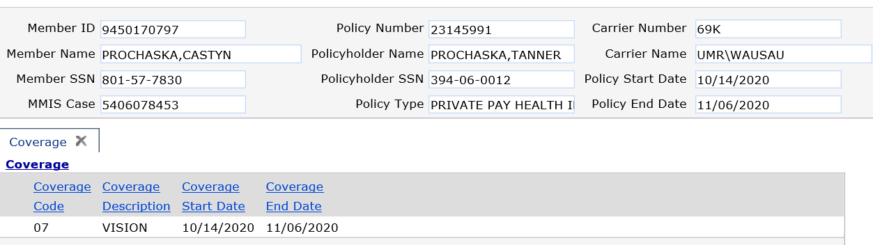

Forward Health Cards

What is the Status of a Forward Health ID Card?

Select IC Functionality and then select Member Search in the member section. Enter the Member ID# in the Member ID line and hit search. Select Member ID Cards from the Member Maintenance section.

Select the card to see the address information. This will show you when and where a card was sent. It will also show you if the card was delivered or returned to Forward health. If it was returned to Forward health, the member must call recipient services (1-800-362-3002) to request the replacement card. Portal will not allow you to issue a new one if the most recent card was returned.

How to Request a Replacement Forward Health ID Card

Select Partners and choose Replacement ID Card Request on the right-hand side of the screen.

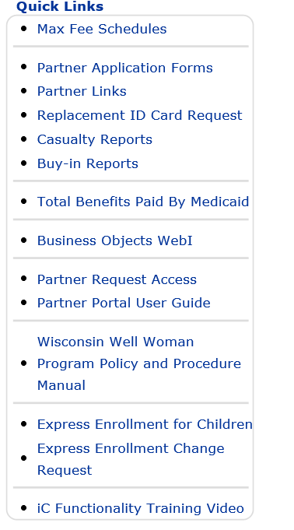

Enter the Member ID # and hit search.

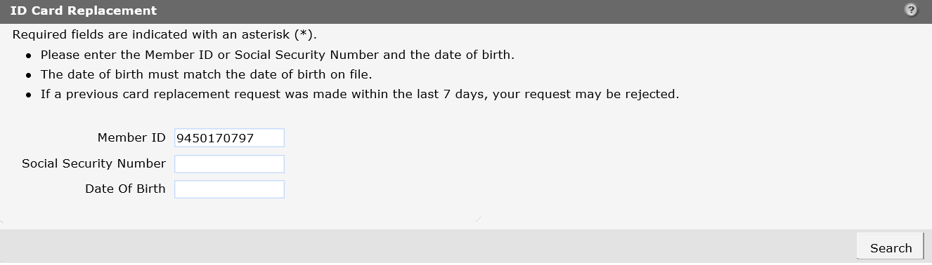

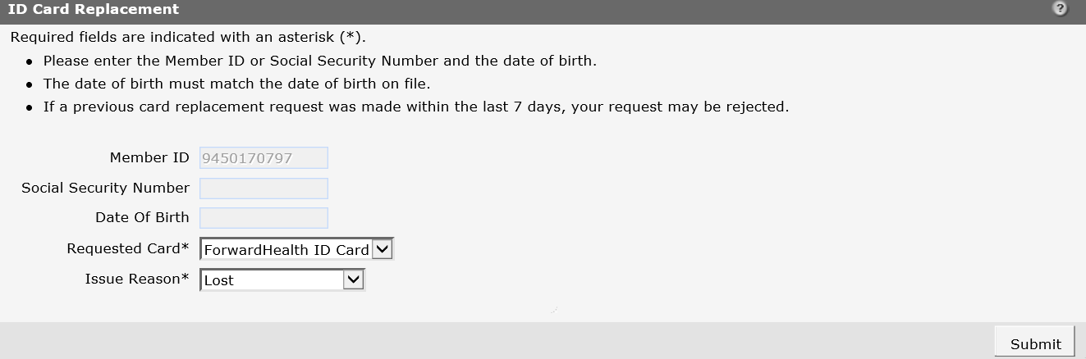

-

Manual Certifications
Manual Certification Desk Aid
Step One
Select “Partner” from the menu bar.
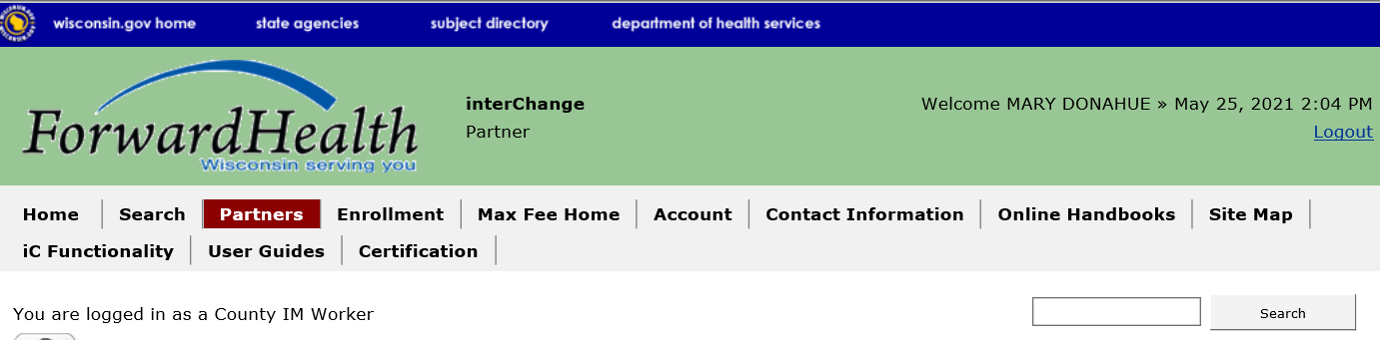
Step Two
Under “Quick Links” on the right side of the screen, select “Partner Application Forms”
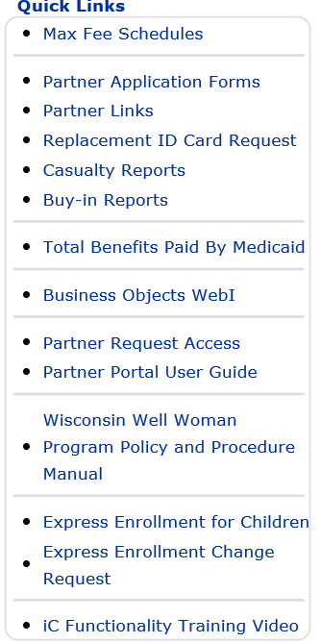
Step Three
Select BadgerCare Plus Manual Certification.

Step Four
Select “Modify or add new member to existing record”. Click next.
Step Five
Enter the casehead MA ID number. Click Next.
Step Six
Enter the Certifying Agency Number (Rock is 053), Certifying Agency Site (00), and your worker ID. Click next.
Step Seven
Select the appropriate individual. The details for the recipient will show in the Case Member and Medical Status Information Section below.
Step Eight
Update to the appropriate medical status code and begin/end dates. Click next.
**See PH 81.5 for a listing of all the medical status codes for all programs.

Step Nine
Review and submit your request.

***For Further information please refer to the Forward Health User Guide ***

Phone Numbers

What is the phone number to HMO Enrollment Specialists?

1-800-291-2002

What is the phone number to Member Services?

1-800-362-3002

