Operations Memo 23-37

Presented By: Janice Pfeiffer

Subject: Issuing Temporary QUEST Cards

Effective Date: December 1, 2023

This memo states IM and Tribal IM agencies must offer FS households who have been confirmed for expedited benefits the opportunity to pick up a temporary QUEST card in person the date their application is approved or the next business day if there is no active QUEST card already associated with the case. For expedited cases where a temporary card is offered the same or next business day, that must be documented in case comments. If there is an active QUEST card and the household states the existing card has been lost, stolen, damaged, or not accessible, the agency must offer the opportunity to pick up a temporary QUEST card in person. When the household comes in for the temporary QUEST card, the agency must assist them with activating and setting up a PIN to ensure the card is ready to use before they leave the agency.

The following issuance policies for temporary QUEST cards must be adhered to by all IM and Tribal IM agencies effective December 1, 2023:

Two forms must be completed before issuing a temporary QUEST card. Completed forms must be
scanned to ECF.
- Form F-02260A Temporary QUEST Card Request – must be filled out and submitted to the IM agency by individual when requesting a temporary QUEST card. This form collects information about the requestor and why they are requesting a temporary QUEST card. The form also requires the requestor to attest that the information provided is accurate and that they agree to follow all rules associated with temporary QUEST cards.
- Form F-02260 Temporary QUEST Card Issuance Worker Checklist – must be completed by the IM worker each time a temporary QUEST card request is received, regardless of whether or not a temporary QUEST card ends up being issued.

Who can request temporary cards & who can process the requests:
- Temporary QUEST cards may be requested by and issued to the primary person on a case, other adult food unit members, authorized buyers, alternate payees, authorized representatives, and other designated representatives that are listed on the case.
- The worker who issues a temporary QUEST card can not be the same worker who most recently confirmed FS eligibility for that case.

New Temporary QUEST card limit:
- Agencies can provide a maximum of one temporary QUEST card per case per rolling 12-month period unless the case meets the criteria for an exception to this limit. Exceptions include:
  - Expedited Issuance: Temporary QUEST cards provided when a case has recently been approved for expedited benefits do not count toward the temporary card limit.
  - Extenuating circumstances: When a case has already reached the limit for temporary QUEST cards, the agency can provide an additional temporary QUEST card if all other temporary card eligibility criteria are met, it is determined that due to unforeseen circumstances an individual no longer has access to their permanent QUEST card to arrive in the mail. Examples of extenuating circumstances include but are not limited to: Requester’s QUEST card was destroyed in a household misfortune; requester left their QUEST card behind when fleeing a domestic abuse situation; requester’s QUEST card does not work and they need to purchase food to alleviate a medical condition.

Two examples are provided in the Ops Memo.

Operations Memo 23-39

Presented By: Janice Pfeiffer

Subject: Wisconsin Shares Child Care Provider Closures

Effective Date: October 27,2023

This memo adds new policy stating that parents may use their subsidy to pay child care providers in the following scenarios and may request a second authorization to a different provider:
- Two weeks per calendar year
- Closures for state government legal holidays

Operations Memo 23-40

Presented By: Kathy King

Subject: Changes to Health Care Administrative Renewal

Effective Date: June 30,2023

Wisconsin has been conducting administrative renewals for the entire household since 2017 if eligibility could be automatically extended by using data sources for everyone in the household.

As of June 30, 2023, DHS will attempt to complete administrative renewals for household members on an individual level instead of household level if all the necessary information for that individual can be verified through a data exchange. So, some household members may have their eligibility determined through an administrative renewal, while other members in the same household must complete a regular renewal to continue eligibility.

DHS will manually maintain coverage for people at an individual level of administrative renewal. DHS is also restoring Medicaid or BC+ coverage for members who lost eligibility in June, July, or August 2023.

Operations Memo 23-41

Presented By: Kathy King

Subject: Private Pay Nursing Home and Group B Plus Waivers Rate

Effective Date: January 1, 2024

Applications being filed on or after January 1, 2024, will use the new rates as follows:
- Daily average nursing home private pay rate is $315.61 to calculate divestment penalty periods.
- Monthly average nursing home private pay rate is $9,599.80.
- Monthly rate for state centers for persons with developmental disabilities is $42,689.79.

Operations Memo 23-42

Presented By: Kathy King

Subject: 2024 Cost-of-Living Adjustment (COLA) for Medicaid for the Elderly, Blind, or Disabled

Effective Date: January 1, 2024

- Institutional Medicaid categorically needy monthly limit for a person in a medical institution income limit is $2,829.
- Categorically needy EBD monthly income limits for group size of 1 is $1,026.78.
- Categorically needy EBD monthly income limits for group size of 2 is $1,547.05.
No change to asset limit.
Medically needy monthly income limit will be updated in early 2024.
See the OPS memo for the new income limits for other EBD and/or Institutional health care areas.

Operations Memo 23-43

Presented By: Kathy King

Subject: Annual Update to Income Thresholds for Determining Whether a Child or Tax Dependent is Expected to Be Required to File a Tax Return

Effective Date: January 1, 2024

2024 thresholds
- $1,300 in taxable unearned income.
- $14,600 in taxable earned income.

Operations Memo 23-44

Presented By: Kathy King

Subject: 12-Month Continuous Health Care Coverage for Children

Effective Date: January 1, 2024

As of January 1, 2024, children under age 19 enrolled in certain health care programs will have 12 months of continuous coverage:
- Starting with the month of their benefit application.
- New certification period at renewal.
- When the child otherwise becomes eligible under a qualifying group.
- When a new child under 19 is added to a case that already has a child with 12 months of continuous coverage.

Children who are already members of an applicable health care program on January 1, 2024, will have a continuous coverage period that extends to their next renewal date.

At renewal, a child must meet the program’s eligibility requirements in order to get a new 12-month period of continuous coverage.

Backdated months at application and renewal do not count toward the 12-month continuous coverage period.

If a child is not eligible at application and ongoing, and only eligible for one or more backdated months, they do not qualify for a 12-month continuous coverage period.

Examples of continuous coverage:
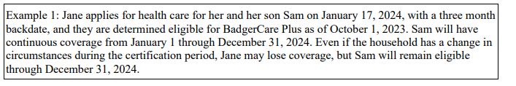
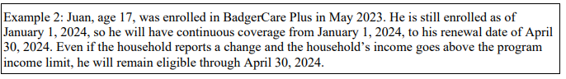
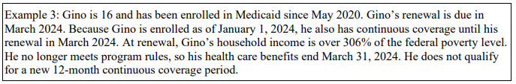

Children under age 19 in these following programs are eligible for 12 months of continuous coverage. These are the most common programs. For a full list see OPS memo.
- BC+
- SSI Medicaid
- Institutional Medicaid
- Home & Community Based Waiver (HCBW) Medicaid (including Children’s Long-Term Support)
- Family Planning Only Services (FPOS)
- Foster Care Medicaid
- Katie Beckett Medicaid
- Emergency Services

Continuous coverage does not apply to children:
- Enrolled under presumptive eligibility.
- Required to meet a deductible in order to enroll in BC+ or Medicaid.

Qualifying children under 19 will only lose health care coverage during their 12-month continuous coverage period for the following reasons:
- The child turns 19.
- The child is no longer a resident of Wisconsin.
- The child passes away.
- The child’s citizenship, identity, or immigration status is not verified within their reasonable opportunity period.
- The child was eligible as a pregnant minor, turns 19, and their postpartum period ends.
- There is a voluntary request for disenrollment from BC+ or Medicaid.

Premiums:
- A child can have a new premium obligation at application or renewal, but they cannot have a new premium once their 12-month continuous coverage period starts.
- Their premium cannot increase during their 12-month continuous coverage period, but it may be reduced if applicable. If the premium is lowered, that new amount becomes their premium cap for the rest of the 12-month period.

- While an individual child’s premium cannot increase during their 12-month continuous coverage period, there may be instances where the household’s total premium amount does increase, like when another child is added to the household and that new child owes a premium.

There is a training video for this in Cornerstone.

