Operations Memo 24-J1

Presented by Kathy King

Received February 29, 2024

Effective Immediately

This memo provides information on the following:
• Tax year 2023 information on tax credits and tax preparation services available to working families in Wisconsin.
• A reminder to Wisconsin Works (W-2) and Income Maintenance (IM) agencies of the importance of notifying program participants of the financial advantages of federal and state tax credits.
• A reminder on how to count federal and state tax refunds when determining financial eligibility for assistance.

Federal tax refunds are disregarded income for: W2, Refugee Cash Assistance Program, Wisconsin Shares Child Care Subsidy Program, BC+, FPOS, Medicaid, CTS and FS.
All W-2 and IM agencies must inform program participants of the advantages of claiming available tax credits and free tax return preparation services in the community.

Wisconsin Homestead Credit is available to low-income Wisconsin residents who rent or own their homes. To qualify an individual must be 62 or older, disabled or have earned income.

Federal Child Tax Credit (CTC) is available to families with a qualifying child. If the amount of the CTC is greater than the income tax a family owes, the family may receive up to $1,600 of the credit as a refund.

Federal Child and Dependent Care Credit (CDCC) is available to families who pay out-of-pocket expenses for the care of children, adult dependents, or an incapacitated spouse to work or look for work. If a family does not earn enough money to owe federal income taxes, or if the family’s CDCC exceeds the amount of taxes it owes, the family can’t benefit from the credit.

Tax Preparation Resources:
Volunteer Income Tax Assistance: To find a VITA site, call 800-906-9887 or use the VITA Locator Tool on the IRS website.
Tax Counseling for the Elderly: Program for taxpayers who are 60 or older. To find an AARP Tax-Aide site, call 1-888-687-2277 or visit the AARP website. For more information about the TCE program, visit the IRS website.
Visit the IRS Tax Scams/Consumer Alerts webpage for more information regarding tax scams a

Process Help Release 24-01

Presented by Janice Pfeiffer

Release Date: February 24, 2024

Effective Immediately

Overpayment Claims Compromise (OCC): new section added
SAVE Responses: Updated and replaced chart with new codes that SAVE may return and that the FFM will send. The codes are automatically updated in CSS. Instructions have been added for workers when SAVE cannot provide third level verification. Additional updates are coming in the PH 24-02 release.
Late Application Processing for FS: A new section has been added for processing FS late applications (within 30 or 60 days of denial).
12-Month Continuous Health Care Coverage for Children: When a child is in a continuous coverage period, the information is displayed in the “12-Month Continuous Coverage” section on the HC budget page. This information will only display when an eligible child has a continuous coverage period, whether or not the coverage is from another case, and the end date of the continuous coverage period. Informational reason code 814 displays when a child’s coverage remains open due to a continuous period and not action is required.
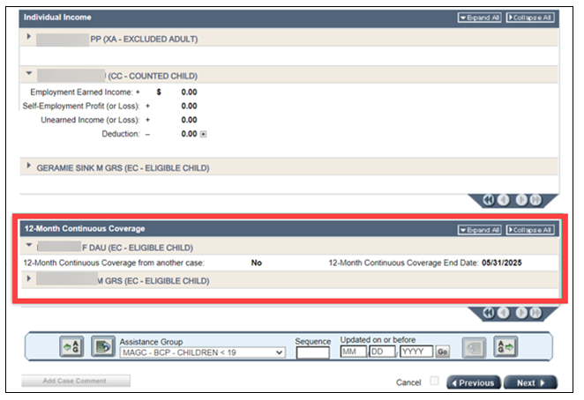
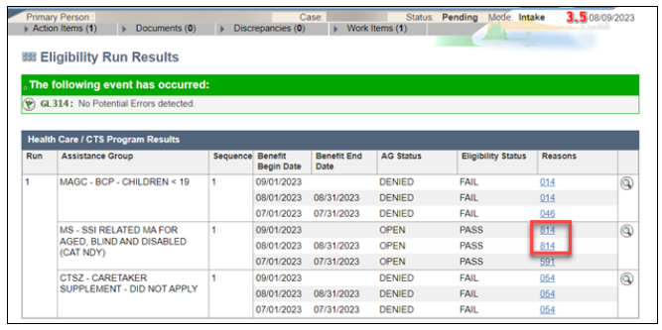
Treatment Needs Question & Optional Health Survey: The information for both were removed.
Incarceration: Updated screenshots and text for enhancements that notify workers of overlapping incarceration start dates or release dates & sync incarceration data across companion cases.
Shared Placement: NEW section & is used for informational purposes only for children under 19 in household; this page(s) will be scheduled when processing a renewal or SMRF. The Shared Placement page is informational only and does not affect eligibility determination for any program. You can add, update and delete Shared Placement screens.
Children do not need to be grouped based on the absent parent (unlike on the Absent Parent page). There is no policy regarding how to use this page.

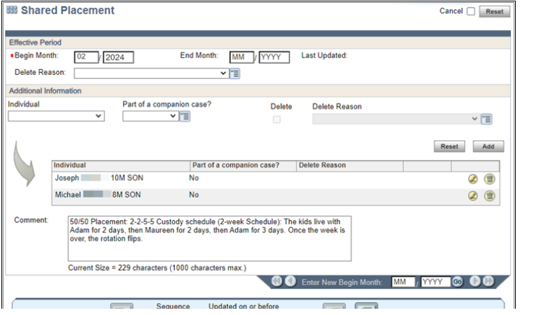

Disability Redetermination: Added instructions to not change the send to DDB referral to NO when a referral has been sent. Added instructions that workers should not remove the diary dates. Updated process for sending disability redetermination to DDB.
Irrevocably Assigned LIFBCs: Updated instructions to add dividends and interest to the cash value of an irrevocably assigned LIFBC.
Backdated Eligibility: Clarified process for running eligibility for backdated months.
Verification of Citizenship: Clarified process for using SAVE for citizenship verification; updated process to use ForwardHealth interchange claims history as verification of birth for citizenship.
FSET Supportive Services: Added new section to include FSET supportive services summary page.

CARES Bulletin – February 2024
Presented by: Janice Pfeiffer
BadgerCare Plus Children’s Premium Compliance Changes – Effective 4/1/24
- BadgerCare Plus children premiums are being reinstated; payment of premiums will no longer a condition of eligibility
- Premiums for children will be charged for future months after proper notice is provided
- If no payment is made by adverse action of the benefit month OR a partial payment is made by adverse action of the benefit month, the remainder of the payment is not owed
- If a payment is made between adverse action and the end of the month, that payment is applied to the next benefit month’s premium
- Members will not enter a restrictive re-enrollment period or be penalized for not paying a premium
- Workers can see a ‘Forgiven’ status next to BC+ children’s premium amounts on the Premium Payment Tracking page for amounts not paid in full by adverse action.
Interview Schedule Notices (ISNs) Modernization
- Effective 2/24/24
- Update has improved language for appropriate tone and readability to improve applicant/member engagement
- Redesigned notice to increase applicant/member awareness of important action needed on case
- Streamlined agency contact information
CWW Case Comment Enhancements
- 2 ½ minute demo: Enhancements to Case Comments
- Flagged case comments are now listed first (no matter the date)
- Workers can flag/unflag case comments
- Change/Renewal type case comments will no longer generate an alert
- 180 days of case comments are available to view in CWW
- New case comment search option – by text (key words)/comment type/date range/hide system generated comments
- Reference PH 46.2 & 46.3

