AGENT Reminders March 14, 2024

General
- On the Case Summary page in CWW, the customer’s next renewal date can be found in the Case Information section.

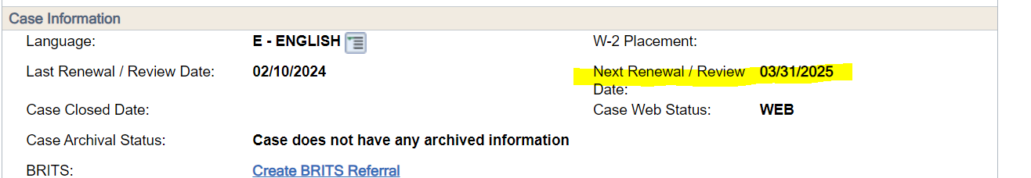

- Spouses listed on a case (and other adults who are receiving benefits on the case) are able to call and receive information about and make changes to the case (including LTC cases). Authorized representative paperwork is NOT needed for this.
- Sometimes we receive an error banner when running a case thru eligibility determination. The error prevents us from completing the process. The banner tells us to click the verify button on a specific employment sequence. Workers often repeatedly go back and hit the verify button and continue to get the error.
The Tip to get past this:
- Go to that employment sequence.
- Remove the FEIN, making note of it because you will be re-entering it.
- Click the Verify Button.
- Hit Enter until you are off of the page.
- Go back to that Employment Sequence page.
- Re-enter the FEIN.
- Click the Verify Button.
- You should now be able to run eligibility to the end.
- Expected Annual Income – EAI screen in CWW Reminders:
- If customer has been employed all of 2024 and EI is put in CWW with begin date of 2-2024, EAI is being calculated for 11 months only instead of 12 months if employment is expected to continue for all of 2024. Workers need to take the monthly amount and multiply it by twelve if the employment started prior to February.
- If customer has been receiving Unemployment all of 2024, you will need to calculate amount already received and then add the amount “left/remaining” per UIB query instead of budgeting for whole year.

EBD/LTC
- When there is a presumptive denied by the DDB, please review the reason. If the reason states that both an urgent need and impairment were not marked and the new form is being used, please have a supervisor send this to PRT.

