PIN: The PIN is a unique identifier like a social security number.
Good PIN: The good PIN is usually the PIN that was originally created, has the most eligibility history on it, and may or may not have the SSN attached to it. This is the PIN that has previously interfaced with other systems.
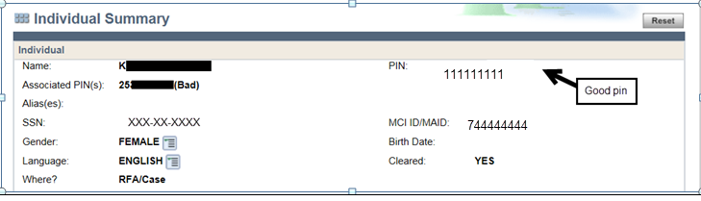
Bad PIN: Any PIN created after the original one for an individual. It usually has the least eligibility history on it.

Uncleared PIN: A temporary PIN created, usually before an RFA is processed that has not been cleared. These do not need to be reported, they have not cleared so they cannot be linked.
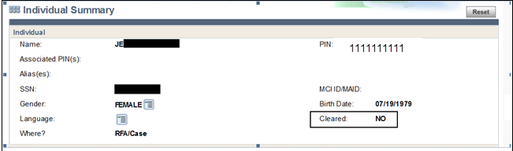

Clearance: When adding a person to a case or processing an application, the worker should first search for that person in CARES to determine if the person is/was known to CARES. If you have an undocumented immigrant without a SSN, and there is a child on the application with an SSN; search with the child's SSN to see if there is an open case or old case. This lets the worker know what PIN number to expect and/or case number when clearing a person or new application. This helps prevent creating new PINs and having to fix/correct problems when new PINs/cases are created, etc. or identify if there is a problem where clearance isn’t providing the correct results.
** If matches are 97% or higher, one of them must be selected. There is no option to create a new individual when matches are 97% or higher.

When multiple potential matches are received consider:
- Was it a typo?
- Was this person known to another case previously?
- Do we have documentation in the ECF, KIDS, previous cases, birth queries or another system that would support using the individual PIN that is matching in clearance?
- Did the person have a name/gender change? Was the wrong SSN entered for the person that clearance is matching to?
- Has the person been adopted and assumed a new name/SSN?
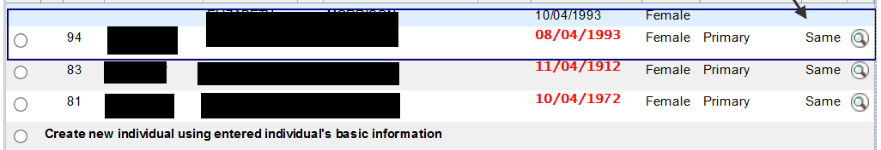
What to do if duplicate PINS are created: The individual with the bad PIN must be completely deleted from any open or pending case. The individual with the good PIN needs to be added.
Send the individual’s name, SSN, case number and both the good and bad PINs to your supervisor to send to DHS Problem Resolution Team to link PINs. Enter a case comment with the individual’s good PIN and bad PIN.
Duplicate PIN created when processing an application: When processing an application, if a bad SSN was provided and a new PIN and case were created for the primary person, the next step will be different based on what has happened.
Benefits have not been issued: When a new PIN was created for the primary person, and the worker finds the correct PIN/SSN that should be used for eligibility, and the benefits have not been issued yet, the worker should close the newly created case and reopen the old case. Before closing the new case, if a bad SSN was entered to a bad PIN created, remove the SSN.
If the original application is from the FFM, be sure to contact the Cares Call Center to enter the FFM referral information on the old case so that a response can be sent once the application is processed.
Benefits have been issued: When a new PIN was created for the primary person, and the worker finds the correct PIN/SSN that should be used for eligibility, and the benefits have been issued, the worker will need to add the good PIN back to the case, change the primary person to the old/good PIN and delete the newly created bad PIN from the case. Approval must be received from the DHS Problem Resolution Team prior to changing the primary person on a case.
If FS has been issued, the agency needs to let the member know they will receive a new card. If that person had a card from another case, they should no longer use it since the benefits do not move from one case to another.

